Name

Mathematics Stage 4
Angle Relationships

Book 1 | Applies angle relationships to solve problems, including those related to transversals on sets of parallel lines | Version: 260420  Feedback:  https://MrDingMaths.com
Contents
Points Lines Rays 3
Labelling Angles 5
Classifying Angles based on Turn 12
Complementary and Supplementary Angles 16
Adjacent Angles 19
Angles in a Right Angle and Straight Line 22
Angles at a Point 28
Vertically Opposite Angles 31
Mixed Practice 35
Perpendicular and Parallel Lines 39
Angles on Transversals 44
Angles on Parallel Lines 52
Problem-Solving involving Angles 59
Writing Formal Reasoning 63
Geometry Problems involving Equations 68
Challenge Exercise 72

Syllabus Content
MA4-ANG-C-01 applies angle relationships to solve problems, including those related to transversals on sets of parallel lines
Apply the language, notation and conventions of geometry
- Use appropriate terminology and conventions to define, label and name points, rays, lines and intervals using capital letters
- Identify and label the vertex and arms of an angle with capital letters
- Use appropriate conventions to label and name angles
- Use common conventions to indicate right angles, equal angles and intervals on diagrams
Identify geometrical properties of angles at a point
- Identify right angles, straight angles, angles of complete revolution and vertically opposite angles
- Apply the terms complementary and supplementary to a pair of angles adding to 90° and 180°, respectively
- Apply the term adjacent angles to a pair of angles with a common arm and common vertex
Identify and describe corresponding, alternate and co-interior angles when 2 straight lines are crossed by a transversal, including parallel lines
- Identify and describe perpendicular lines using the symbol for is perpendicular to (⊥)
- Apply the common conventions to indicate parallel lines on diagrams
- Identify and describe pairs of parallel lines using the symbol for is parallel to (∥)
- Identify and define transversals, including transversals of parallel lines
- Identify, name and measure alternate angle pairs, corresponding angle pairs and co-interior angle pairs for 2 lines cut by a transversal
- Verify and identify corresponding angles and alternate angles as equal, and co-interior angles as supplementary, when a pair of parallel lines is cut by a transversal
- Justify that 2 lines are parallel by using properties of alternate, corresponding or co-interior angles on parallel lines
Solve numerical problems involving angles using reasoning
- Apply the knowledge of angle relationships including angles at a point to find the sizes of unknown angles embedded in diagrams and give reasons
- Apply the knowledge of angles associated with parallel lines to find the sizes of unknown angles embedded in related diagrams and give reasons

Points Lines Rays

- Building Blocks of Geometry
Geometry studies shapes, angles, and their properties.
Points, rays, lines, and intervals are geometry’s building blocks.

Point | Line Segment | Ray | Line
Point A | Segment AB or BA | Ray AB | Line AB or BA
A point marks an exact location in space. | An interval or line segment joins two points. | A ray starts at a point and goes on forever. | A line passes through two points and extends forever.

- Identify line segments, rays, and lines
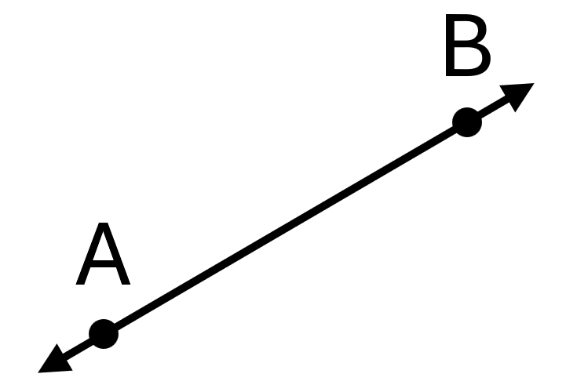  Line AB or BA | 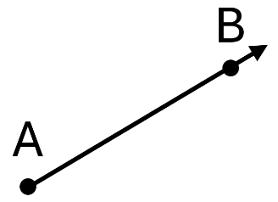  Ray AB |  | 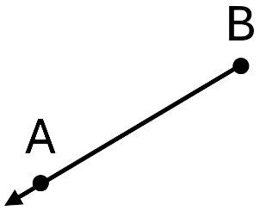  Ray BA |  | 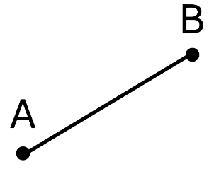  Interval AB or BA |  | 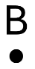  Point B
Identify these geometrical objects.
 |  |  |  | 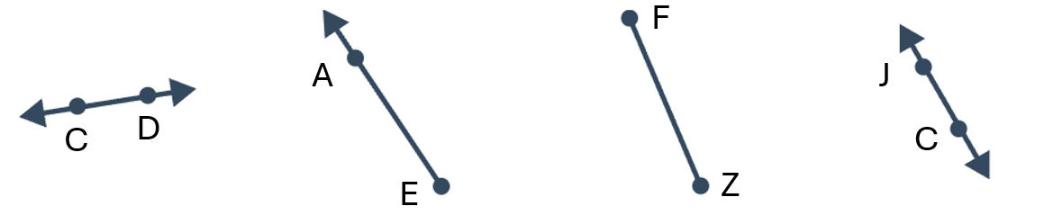
 |  |  |  | 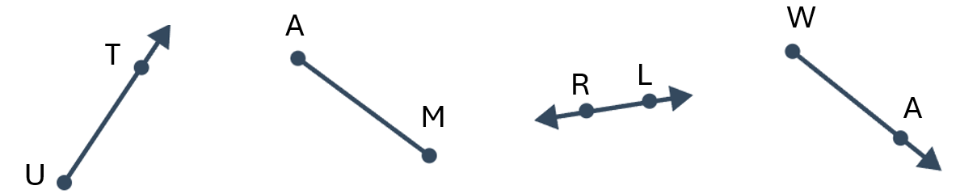

Foundation
- Name these geometrical objects.
Point T | 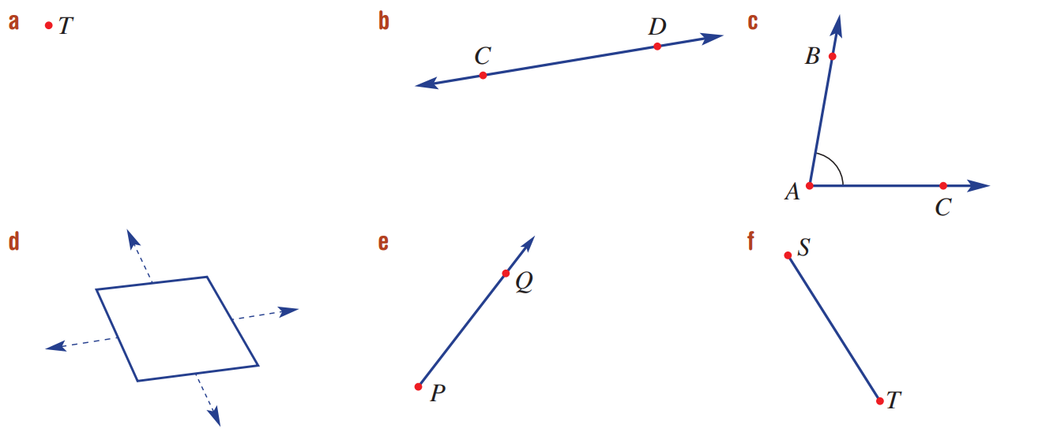  Line CD / DC | 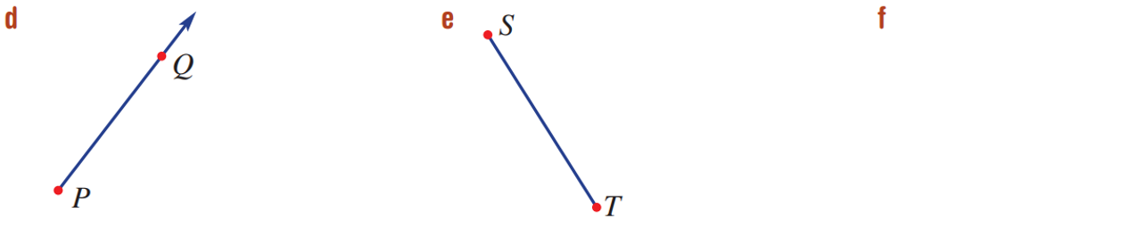  Ray PQ
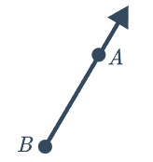  Ray BA | Interval ST / TS | 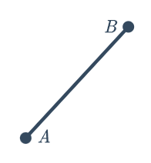  Interval AB / BA

- Draw these geometrical figures.
- Line FG | - Segment BA | - Point C
- Ray ZY | - Ray YZ | - Line BA

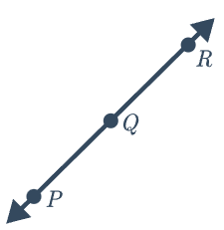
  - Name a ray that is the same as the ray PQ.

Ray PR
  - Joseph says line segment $PQ$ is the same as line segment $PR$. Explain why he is incorrect.

The line segments are different lengths.

Labelling Angles

- Angles
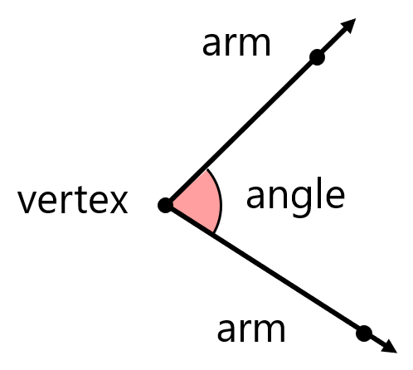
Angles measure the turn between two intersecting lines.
- Lines intersect when they meet.
- The vertex is the point where the lines intersect.
- The intersecting lines are called arms.
- An angle measures the turn between arms.
- We show angles with a curved arc.

- Identify parts of an angle
Vertex: $R$  Arms: $RS,$ $RQ$ | Vertex:  Arms: | 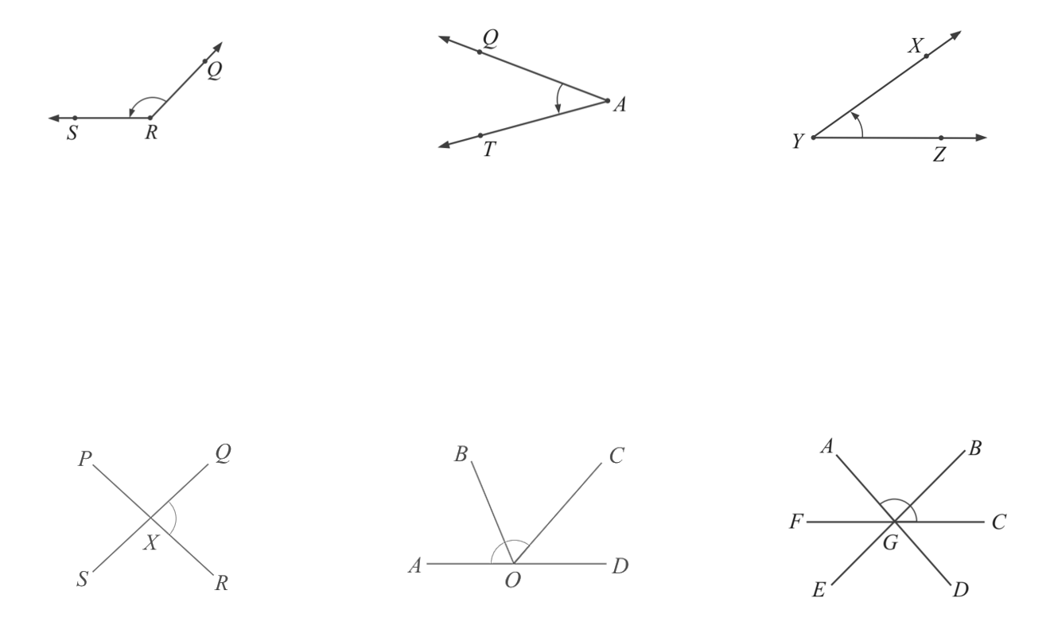  Vertex:  Arms:
Vertex:  Arms: | Vertex:  Arms: | Vertex:  Arms:

- Key Ideas
- An angle forms when two lines ………………………
- The point where two lines intersect is called the ………………………
- The two lines that form the angle are called the ………………………

- Labelling Angles
Label an angle using the angle symbol $∠$ and three points.
Write the vertex as the middle letter.
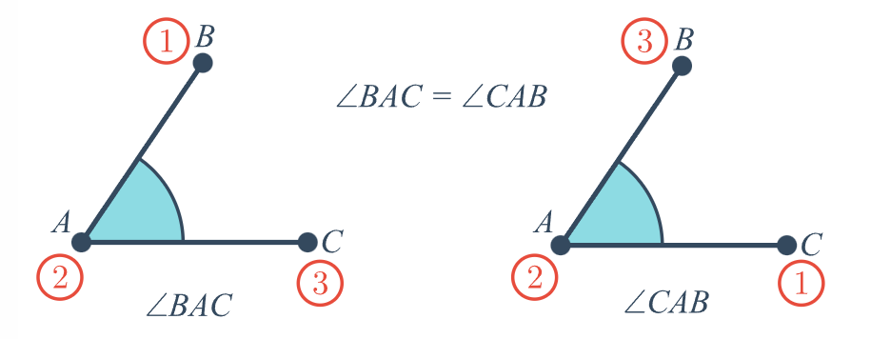
The other two letters mark points on the arms.

- Example Label angles using three letters
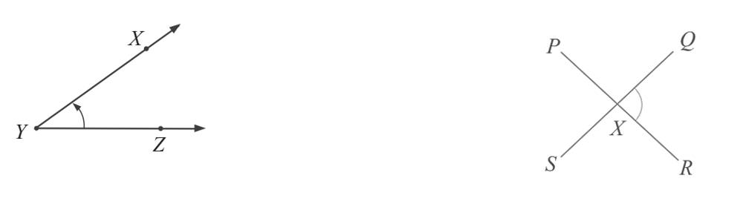  $∠XYZ$ or $∠ZYX$ | When naming an angle with three letters, the ……………… goes in the middle.
$∠QXR$ or $∠RXQ$ | Why is labelling “$∠X$” not clear in this scenario?  There are …………… angles at vertex $X$.

- Guided Practice
Label these angles.
$∠QAT$ or $∠TAQ$ | 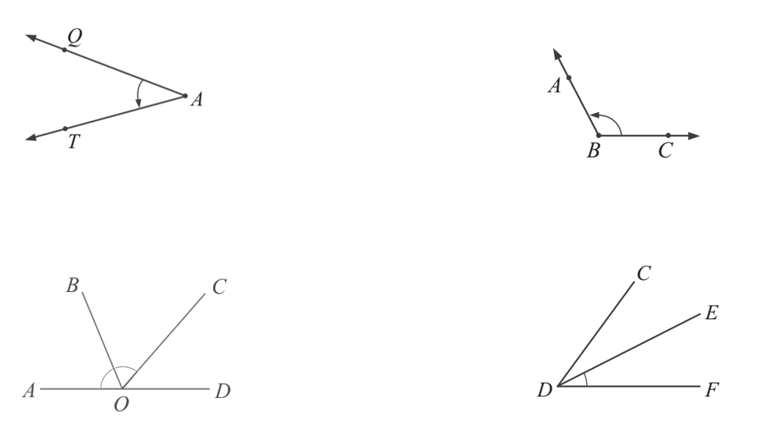  $∠ABC$ or $∠CBA$
$∠AOC$ or $∠COA$ | $∠EDF$ or $∠FDE$

- Key Ideas
- We name angles using …………… letters.
- We get these letters from the two ……………… of the angle and the ………………

Foundation
- Label these angles.
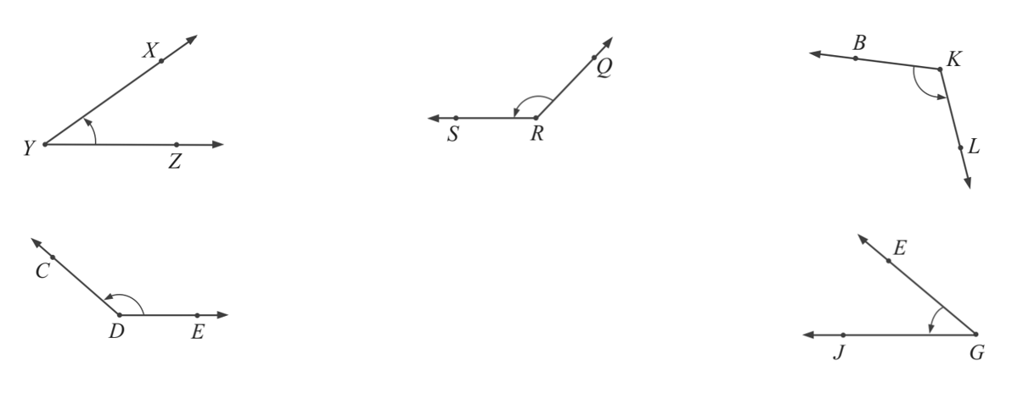  $∠XYZ$ or $∠ZYX$ | $∠SRQ$ or $∠QRS$ | $∠BKL$ or $∠LKB$
$∠CDE$ or $∠EDC$ | 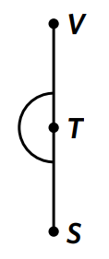  $∠VTS$ or $∠STV$ | $∠JGE$ or $∠EGJ$

- Draw an arc to show these angles on the diagram.
- $∠ABU$  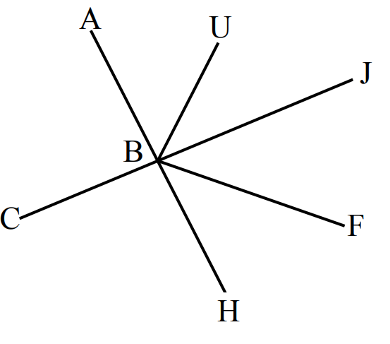  ⌒ | - $∠UBJ$  ⌒ | - $∠CBA$  ⌒
- $∠FBJ$  ⌒ | - $∠JBF$  ⌒ | - $∠ABJ$  ⌒
- $∠ABF$  ⌒ | - $∠ABH$  ⌒ | - $∠FBC$  ⌒
- Reflex $∠FBC$  ⌒ | - Reflex $∠ABF$  ⌒ | - $∠CBJ$  ⌒
- Complete the following to name the marked angle.
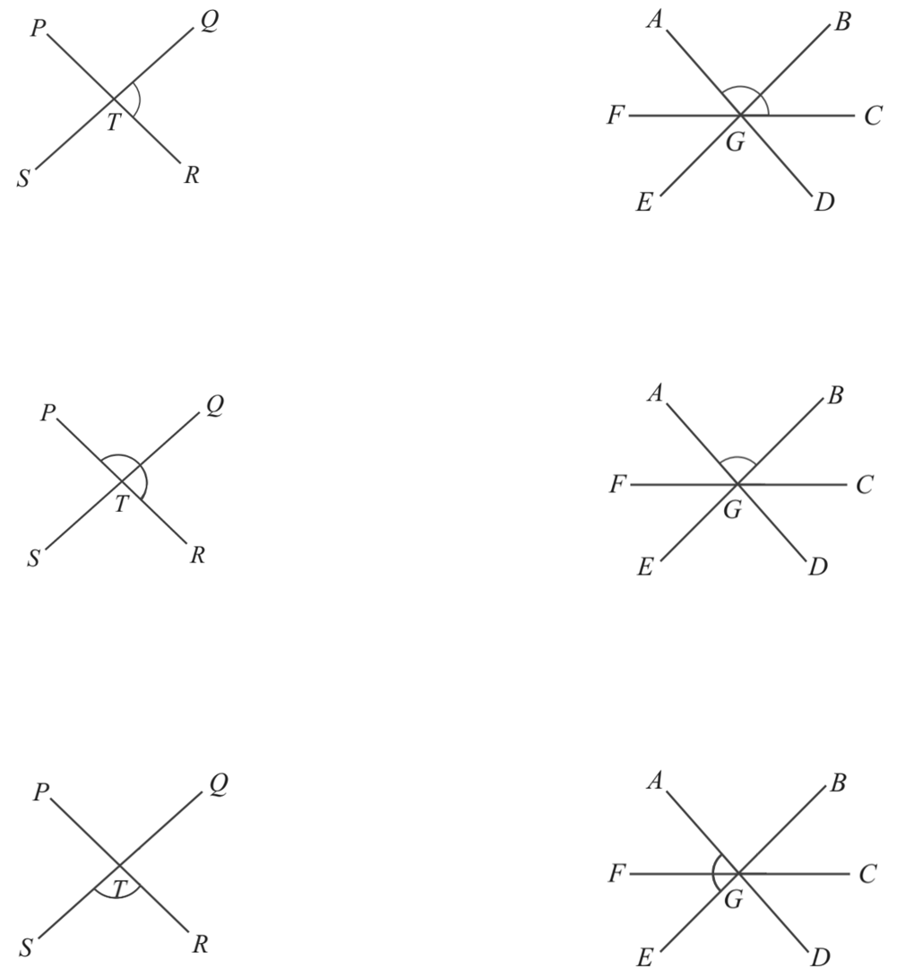  The vertex is ………  The arms are ……… and ………  The angle is $∠$………  $∠QTR$ or $∠RTQ$ | The vertex is ………  The arms are ……… and ………  The angle is $∠$………  $∠AGC$ or $∠CGA$
The vertex is ………  The arms are ……… and ………  The angle is $∠$………  $∠PTR$ or $∠RTP$ | The vertex is ………  The arms are ……… and ………  The angle is $∠$………  $∠AGB$ or $∠BGA$
The vertex is ………  The arms are ……… and ………  The angle is $∠$………  $∠STR$ or $∠RTS$ | The vertex is ………  The arms are ……… and ………  The angle is $∠$………  $∠AGE$ or $∠EGA$

- Draw an arc to show these angles on the diagram.
- $∠PQR$  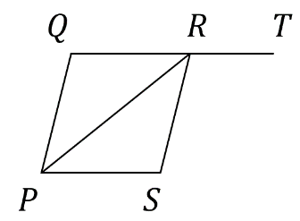  ⌒ | - $∠PQT$  ⌒ | - $∠QPS$  ⌒
- $∠PRS$  ⌒ | - $∠TRS$  ⌒ | - $∠SRQ$  ⌒

Development
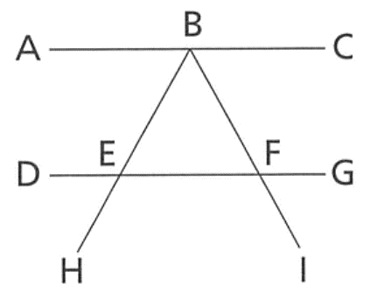
- Label each of these angles on the diagram using $a,b,c,d$
$$a$$
$$b$$
$$c$$
$$d$$
⌒
- $∠GFI$ | - $∠ABF$
- $∠BEF$ | - $∠FEH$
  - Jackson says angles BEF and BEG are the same angle.
Explain why he is correct.

The angle is between the same arms EB and EF
- Name the angles shown by the arc.
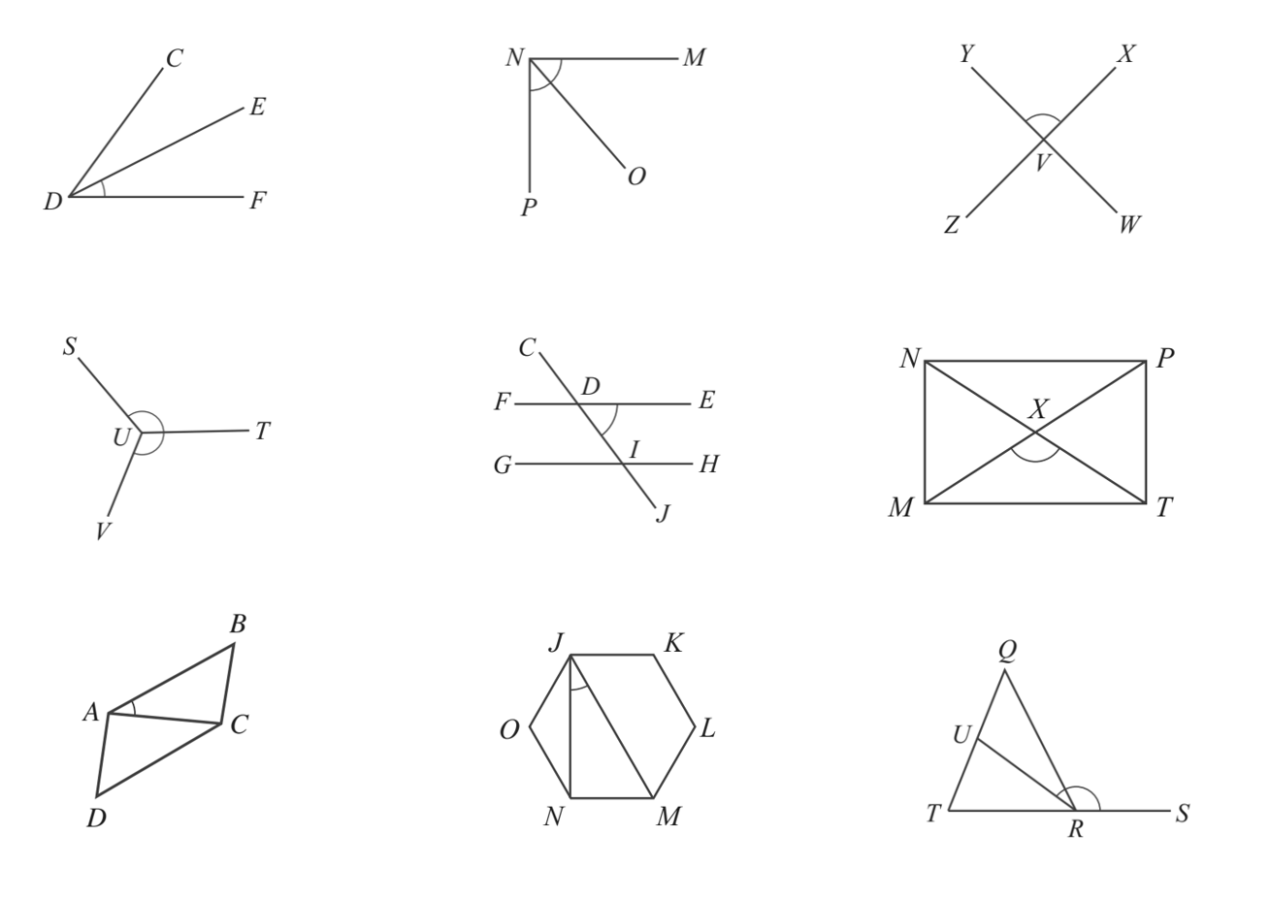  $∠EDF$ or $∠FDE$ | $∠MNP$ or $∠PNM$ | $∠YVX$ or $∠XVY$
$∠SUV$ or $∠VUS$ | $∠EDJ$ or $∠JDE$ | $∠MXT$ or $∠TXM$
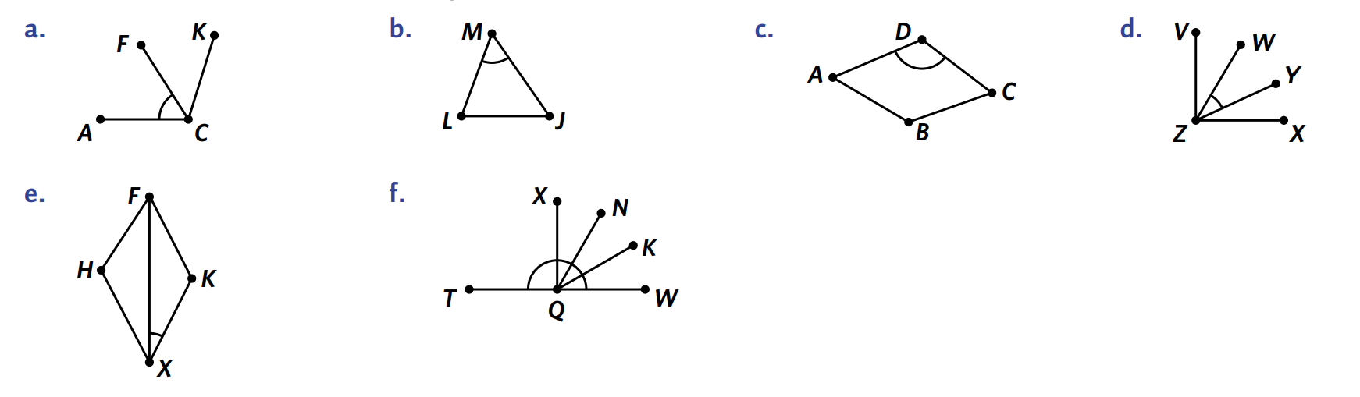  $∠LMJ$ or $∠JML$ | $∠ADC$ or $∠CDA$ | $∠FXK$ or $∠KXF$
$∠BAC$ or $∠CAB$ | $∠NJM$ or $∠MJN$ | $∠URS$ or $∠SRU$

- Mark these angles on the diagram.
- $∠BOD$  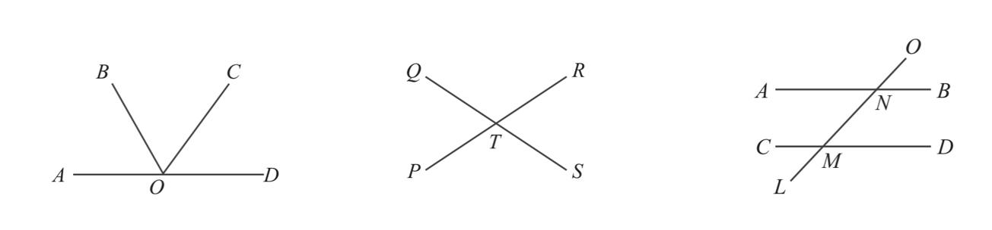  ⌒ | - $∠QTS$ and $∠STP$  ⌒  ⌒ | - $∠ANM,∠MNB,∠CML$  ⌒  ⌒  ⌒

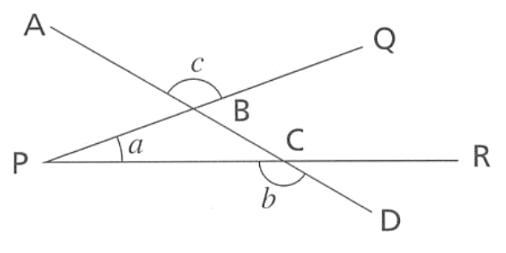
- Give the three letter names of the angles labelled a, b and c.
  - …………………
$$∠QPR$$
  - …………………
$$∠PCD$$
  - …………………
$$∠ABQ$$

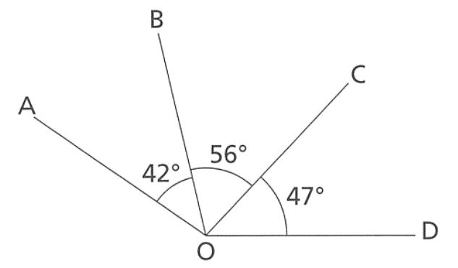
- In the diagram, find the sizes of
- $∠AOB$  42° | - $∠BOC$  56° | - $∠AOC$  98°
- $∠AOD$  145° | - $∠BOD$  103° | - $∠DOC$  47°

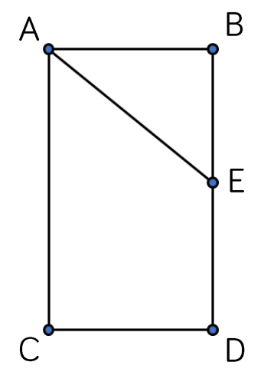
- A geometrical drawing is shown.
  - Name three vertical line segments.

AC, BE, ED
  - Write two different labels for the angle shown.

$∠ABE$ or $∠ABD$

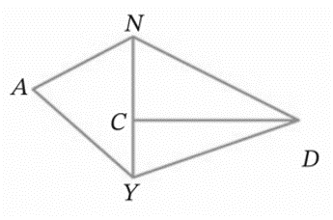
- Name three angles that have C as their vertex.

$$∠NCD, ∠DCY, ∠NCY$$

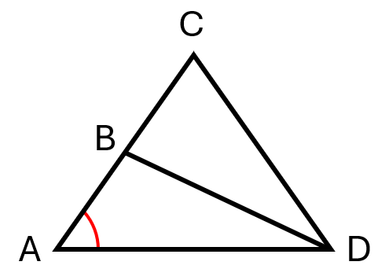
- Write four different names for the marked angle.

$$∠CAD, ∠BAD, ∠DAB, ∠DAC$$
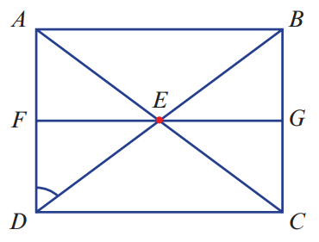
- Write six different names for the marked angle.

$$∠ADB, ∠FDE, ∠ADE, ∠FDB,∠BDA, ∠EDF, ∠EDA, ∠BDF$$
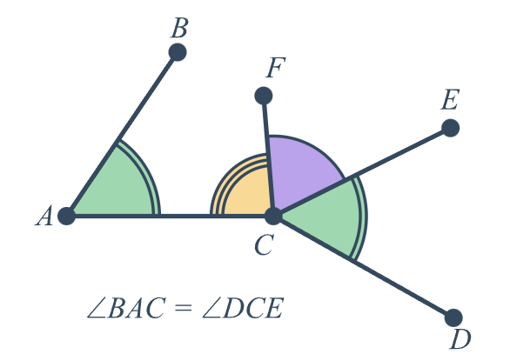
- Equal angles are shown using the same number of arcs or using the same symbol.
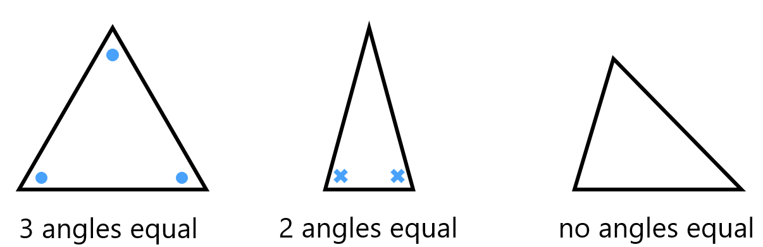

Name the pairs of equal angles.
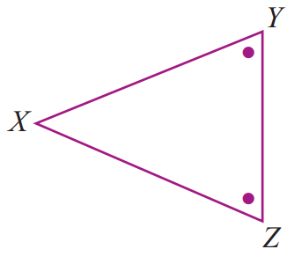  $$∠XYZ=∠XZY$$ | 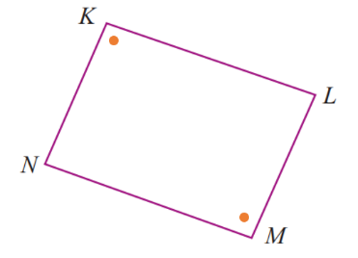  $$∠NKL=∠LMN$$ | 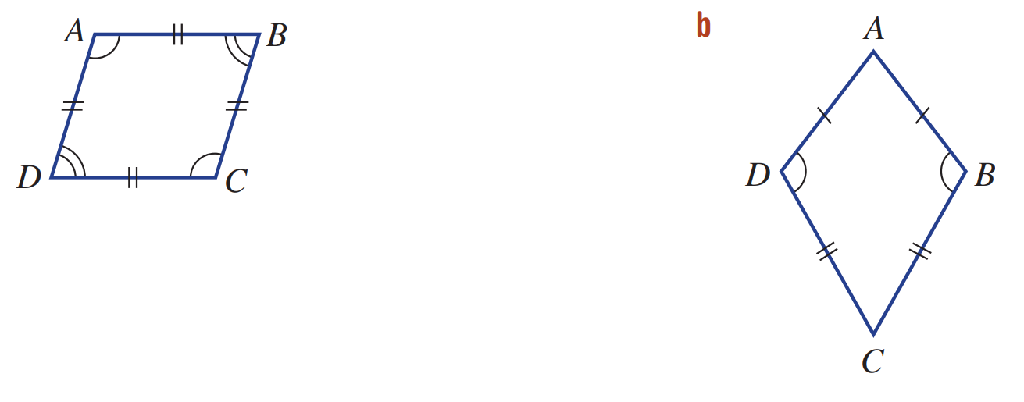  $$∠ADC=∠ABC$$
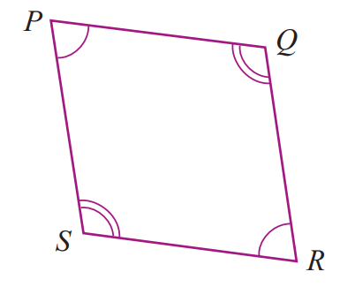  $$∠SPQ=∠QRS$$  $$∠PSR=∠PQR$$ | $$∠DAB=∠BCD$$  $$∠ADC=∠ABC$$

Classifying Angles based on Turn

- Angles Classified Based on Turn
Acute angle | 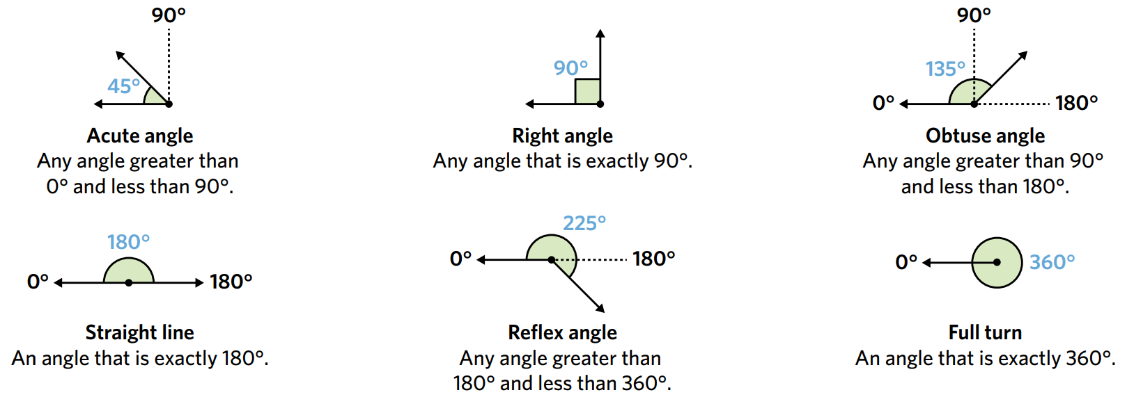  Right angle | Obtuse angle
$$0°<θ<90°$$ | $$θ=90°$$ | $$90°<θ<180°$$
Straight line | Reflex angle | Full turn, or revolution
$$θ=180°$$ | $$180°<θ<360°$$ | $$θ=360°$$

- Classify Angles
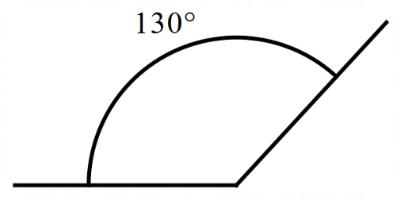
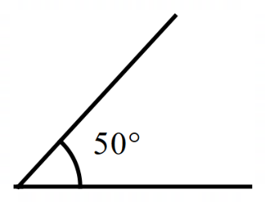
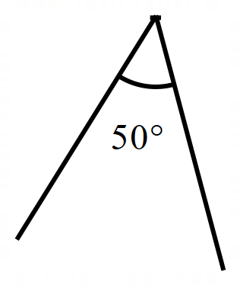
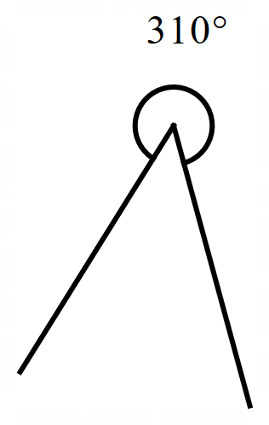
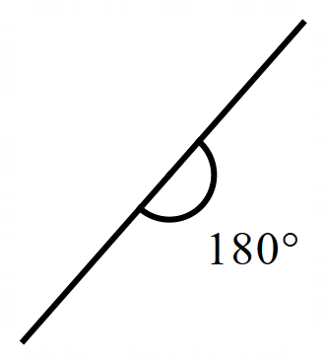
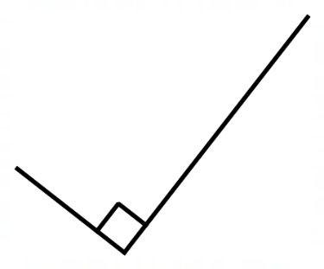
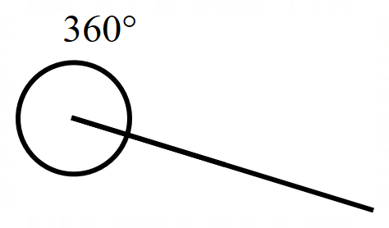
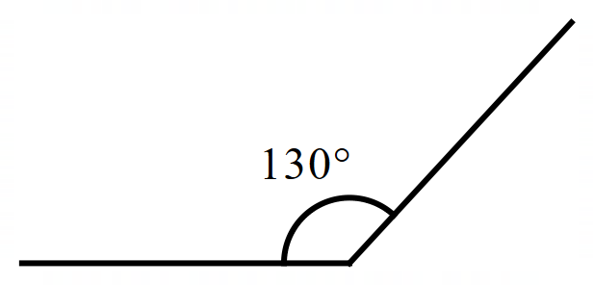

Foundation
- Decide whether each of these angles is acute, obtuse, or reflex.
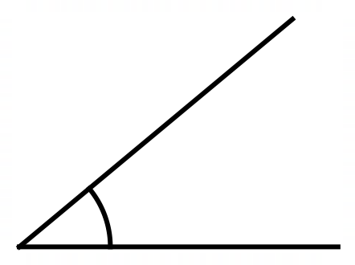  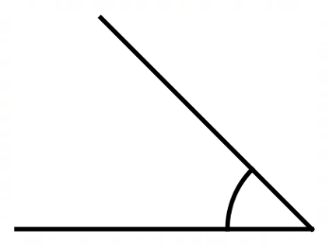  Acute Obtuse Reflex  acute | Acute Obtuse Reflex  acute | Acute Obtuse Reflex  acute
Acute Obtuse Reflex  obtuse | 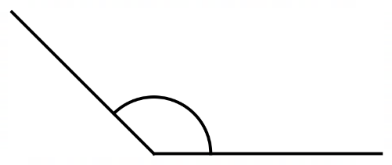  Acute Obtuse Reflex  obtuse | 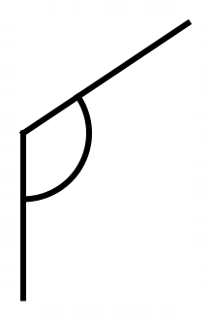  Acute Obtuse Reflex  obtuse
Acute Obtuse Reflex  obtuse | Acute Obtuse Reflex  reflex | 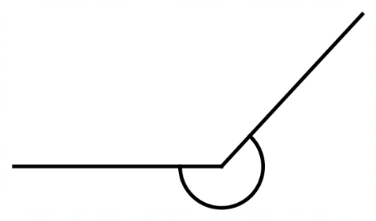  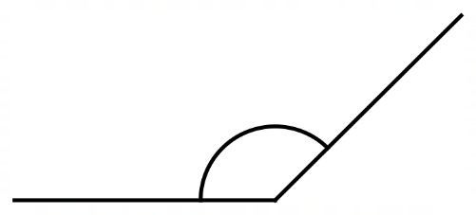  Acute Obtuse Reflex  reflex
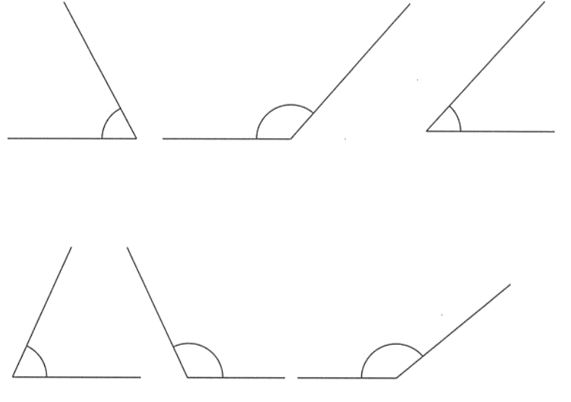  Acute Obtuse Reflex  acute | Acute Obtuse Reflex  obtuse | Acute Obtuse Reflex  acute
Acute Obtuse Reflex  acute | Acute Obtuse Reflex  obtuse | Acute Obtuse Reflex  obtuse
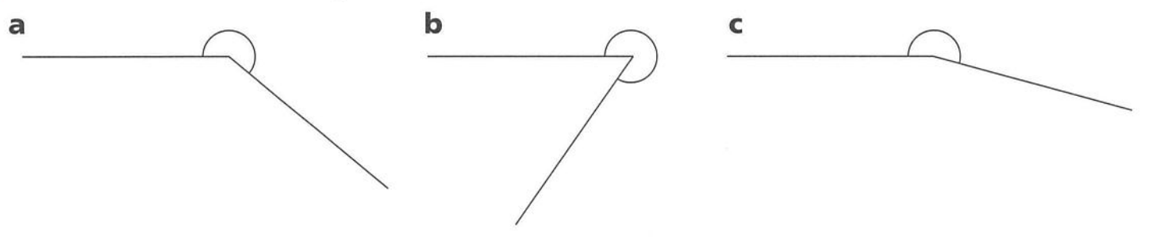  Acute Obtuse Reflex  reflex | Acute Obtuse Reflex  reflex | Acute Obtuse Reflex  reflex

Development
- Classify these angles.
- $58°$  acute | - $175°$  obtuse | - $90°$  right angle | - $195°$  reflex
- $360°$  revolution | - $149°$  obtuse | - $242°$  reflex | - $180°$  straight line
- $15°$  acute | - $136°$  obtuse | - $305°$  reflex | - $224°$  reflex

- Classify these angles.
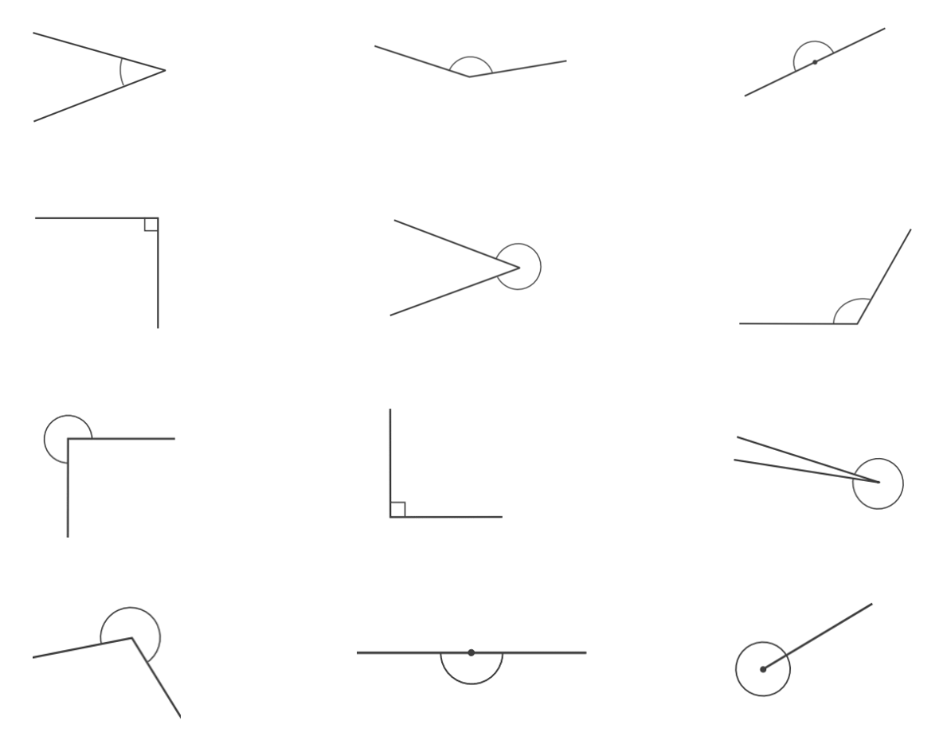  acute | obtuse | straight line
right angle | reflex | obtuse
reflex | right angle | reflex
reflex | straight line | revolution

- Classify the angles shown in these diagrams as either acute, obtuse, or right angle.
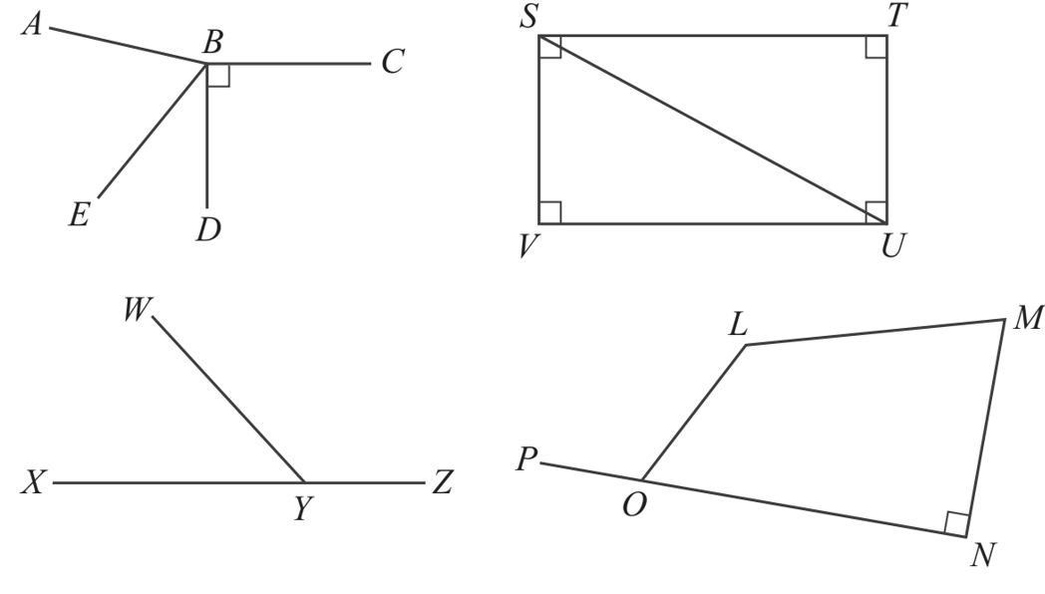  ∠ABC …………………  obtuse  ∠CBD …………………  right angle  ∠EBD …………………  acute  ∠ABE …………………  acute | ∠SVU …………………  right angle  ∠STU …………………  right angle  ∠VSU …………………  acute  ∠TUS …………………  acute | ∠OLM …………………  obtuse  ∠PON …………………  straight line  ∠LOP …………………  obtuse  ∠ONM …………………  right angle

Mastery
- Look at the letters below. Which one has both parallel and perpendicular lines?
A C E L Z

E

- Which of these angles:
$$105°,95°,25°,85°,175°$$
  - Is the smallest obtuse angle?
95°
  - Is the largest acute angle?
85°

- Which of these angles are:
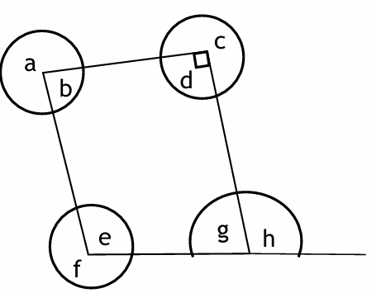
  - Acute

$$b, g$$
  - Obtuse

$$e, h$$
  - Reflex

$$a, c, f$$

Complementary and Supplementary Angles

- Complementary and Supplementary Angles
Complementary angles | Supplementary angles
If two angles sum to $90°$,  they are complementary  $$∠ABC+∠DEF=90°$$ | 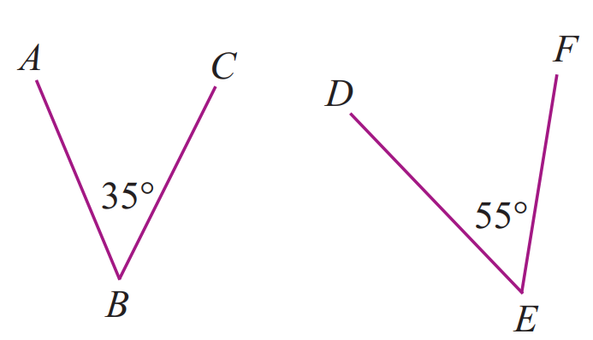  If two angles sum to $180°$,  they are supplementary  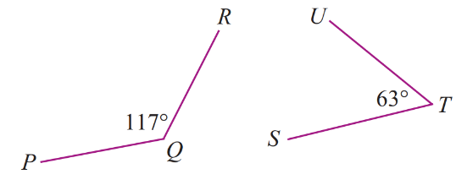  $$∠PQR+∠SUT=180°$$

- Identify whether two angles are complementary, supplementary, or neither
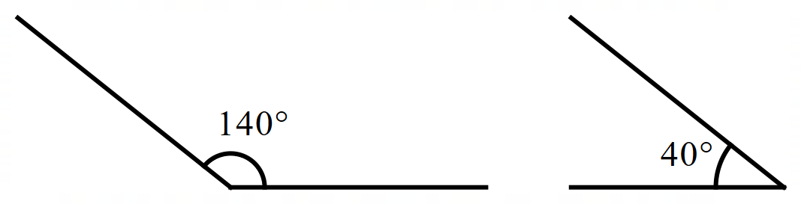  140 $+$ 40 $=$ ………  - Complementary  - Supplementary  - Neither | 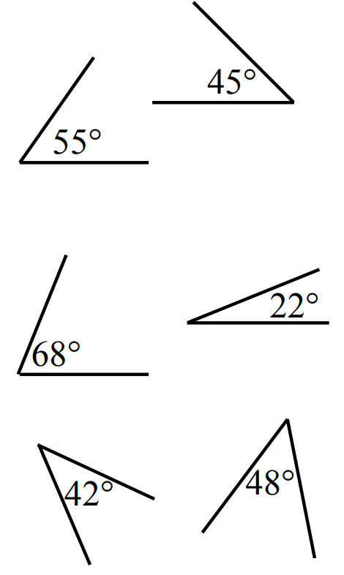  ……… $+$ ……… $=$ ………  - Complementary  - Supplementary  - Neither
……… $+$ ……… $=$ ………  - Complementary  - Supplementary  - Neither | 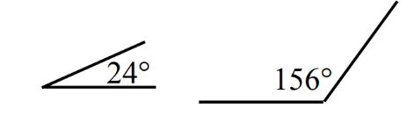  ……… $+$ ……… $=$ ………  - Complementary  - Supplementary  - Neither

- Key Ideas
- Two angles that sum to ……………… are supplementary.
- Two angles that sum to ……………… are complementary.

Foundation
- Decide whether these angles are complementary, supplementary, or neither.
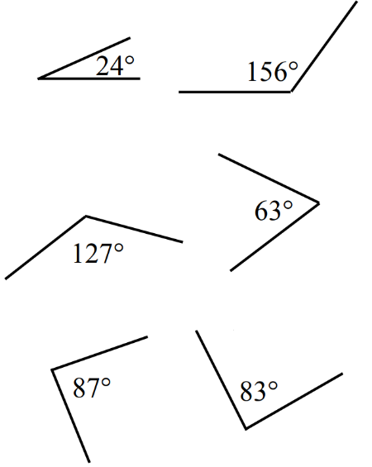  ……… $+$ ……… $=$ ………  - Complementary  - Supplementary  - Neither  neither | ……… $+$ ……… $=$ ………  - Complementary  - Supplementary  - Neither  complementary | ……… $+$ ……… $=$ ………  - Complementary  - Supplementary  - Neither  neither
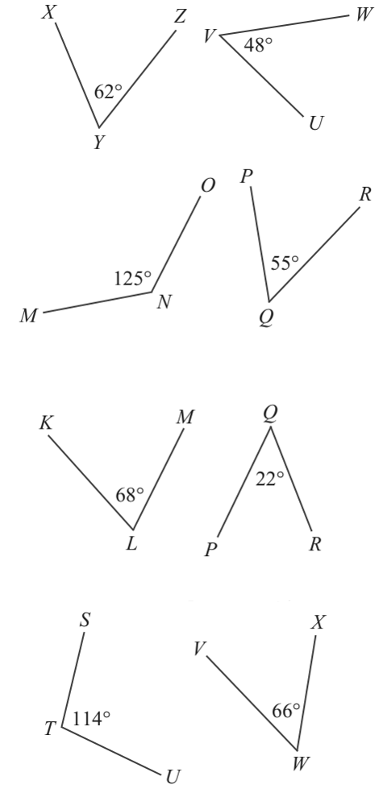  ……… $+$ ……… $=$ ………  - Complementary  - Supplementary  - Neither  neither | 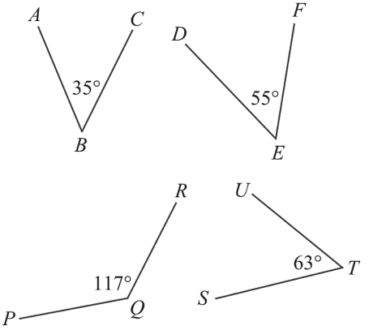  ……… $+$ ……… $=$ ………  - Complementary  - Supplementary  - Neither  complementary | ……… $+$ ……… $=$ ………  - Complementary  - Supplementary  - Neither  complementary
……… $+$ ……… $=$ ………  - Complementary  - Supplementary  - Neither  supplementary | ……… $+$ ……… $=$ ………  - Complementary  - Supplementary  - Neither  supplementary | ……… $+$ ……… $=$ ………  - Complementary  - Supplementary  - Neither  supplementary

- When two angles add up to $90°$, we call each angle the “complement” of the other.
Find the complement of these angles by subtracting it from $90°$.
- $30°$  60° | - $45°$  45° | - $73°$  17°
- $21°$  69° | - $9°$  81° | - $57°$  33°

- When two angles add up to $180°$, we call each angle the “supplement” of the other.
Find the supplement of these angles by subtracting it from $180°$.
- $110°$  70° | - $45°$  135° | - $162°$  18°
- $16°$  164° | - $123°$  57° | - $27°$  153°

Development
- Complete the table.
Angle | Complement | Supplement
25$°$ | 65° | 155°
65$°$ | 25° | 115°
13$°$ | 77° | 167°
79$°$ | 11° | 101°
57$°$ | 33° | 123°
3$°$ | 87° | 177°
41$°$ | 49° | 139°

- Work out the:
- complement of 40°  50° | - supplement of 60°  120° | - complement of 41°  49°
- supplement of 100°  80° | - supplement of 15°  165° | - supplement of 48°  132°
- complement of 72°  18° | - complement of 5°  85° | - supplement of 90°  90°

- If a pair of complementary angles are placed adjacent to each other,
what type of angle is formed?

Right-angle
- If a pair of supplementary angles are placed adjacent to each other,
what type of angle is formed?

Straight line
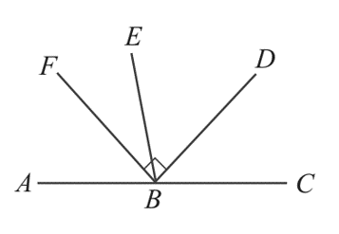
- State whether these pairs of angles are complementary, supplementary, or neither.
- ∠FBE and ∠DBE  complementary | - ∠ABE and ∠CBE  supplementary
- ∠FBE and ∠DBC  neither | - ∠FBC and ∠FBA  supplementary
- ∠FBA and ∠DBC  neither | - ∠FBA and ∠EBD  neither

Adjacent Angles

- Adjacent Angles
Adjacent means “next to”.
If two angles share a common vertex, a common arm, and do not overlap,
then they are adjacent angles.

- Identify whether two angles are adjacent
✖ | 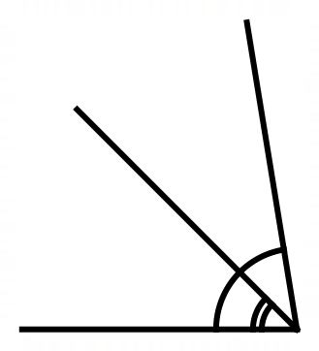  ✔  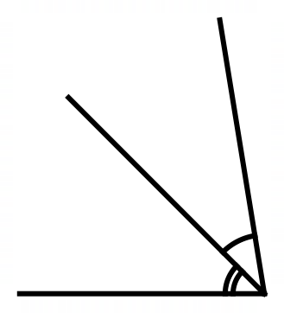 |  | 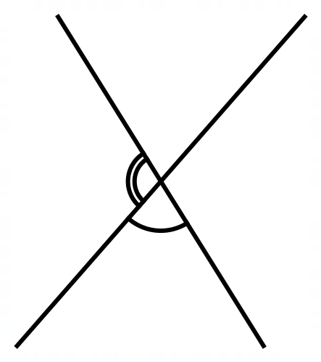  ✔ |  | 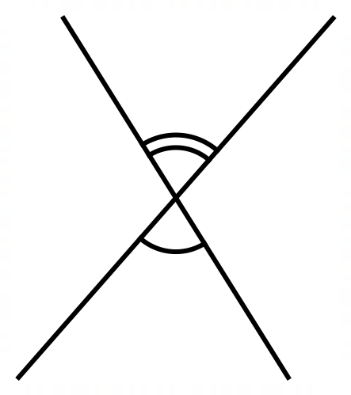  ✖
Decide whether these marked angles are adjacent.
 |  |  |  | 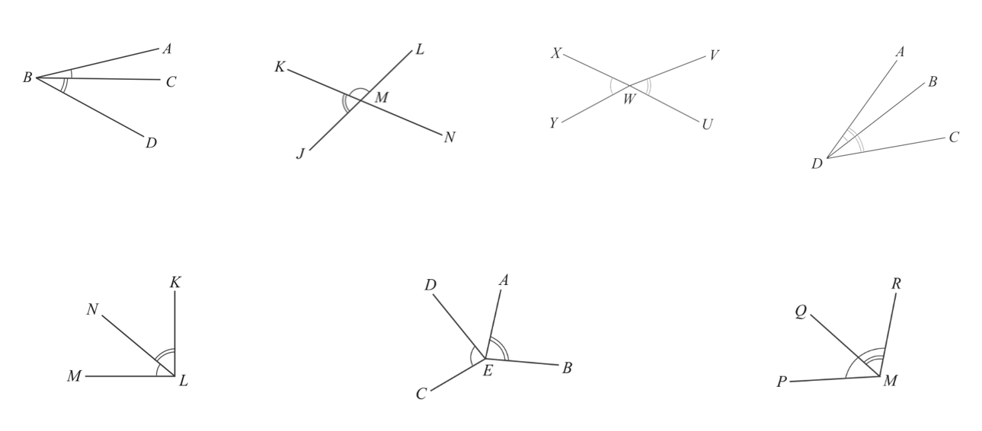
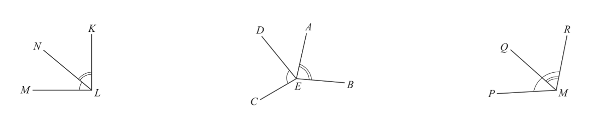

- Key Ideas
- Angles that are ‘next to’ each other are called ……………………, they have a common ……………… and ………………

Foundation
- On the diagram, identify an angle adjacent to:
- $∠RQS$  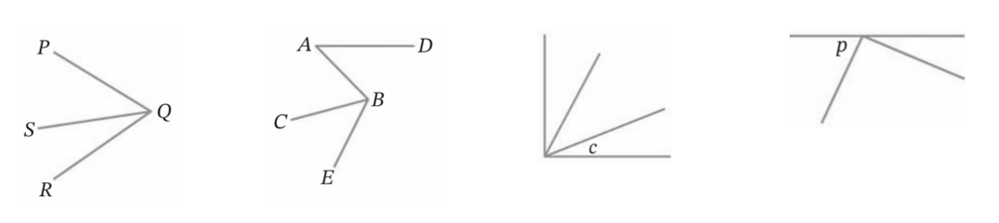  ⌒ | - $∠ABC$  ⌒ | - Angle marked $c$  ⌒ | - Angle marked $p$  ⌒

- Decide whether the marked angles in each diagram are adjacent.
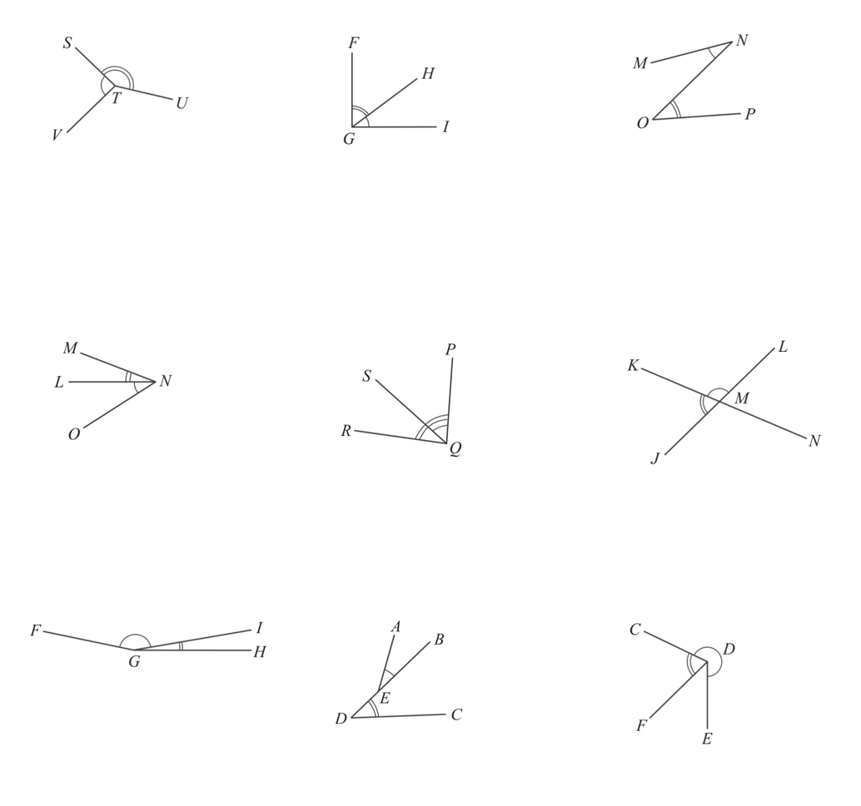  adjacent | adjacent | not adjacent
adjacent | Not adjacent | adjacent
adjacent | Not adjacent | adjacent

- Find the value of the pronumeral in each diagram.
84° | 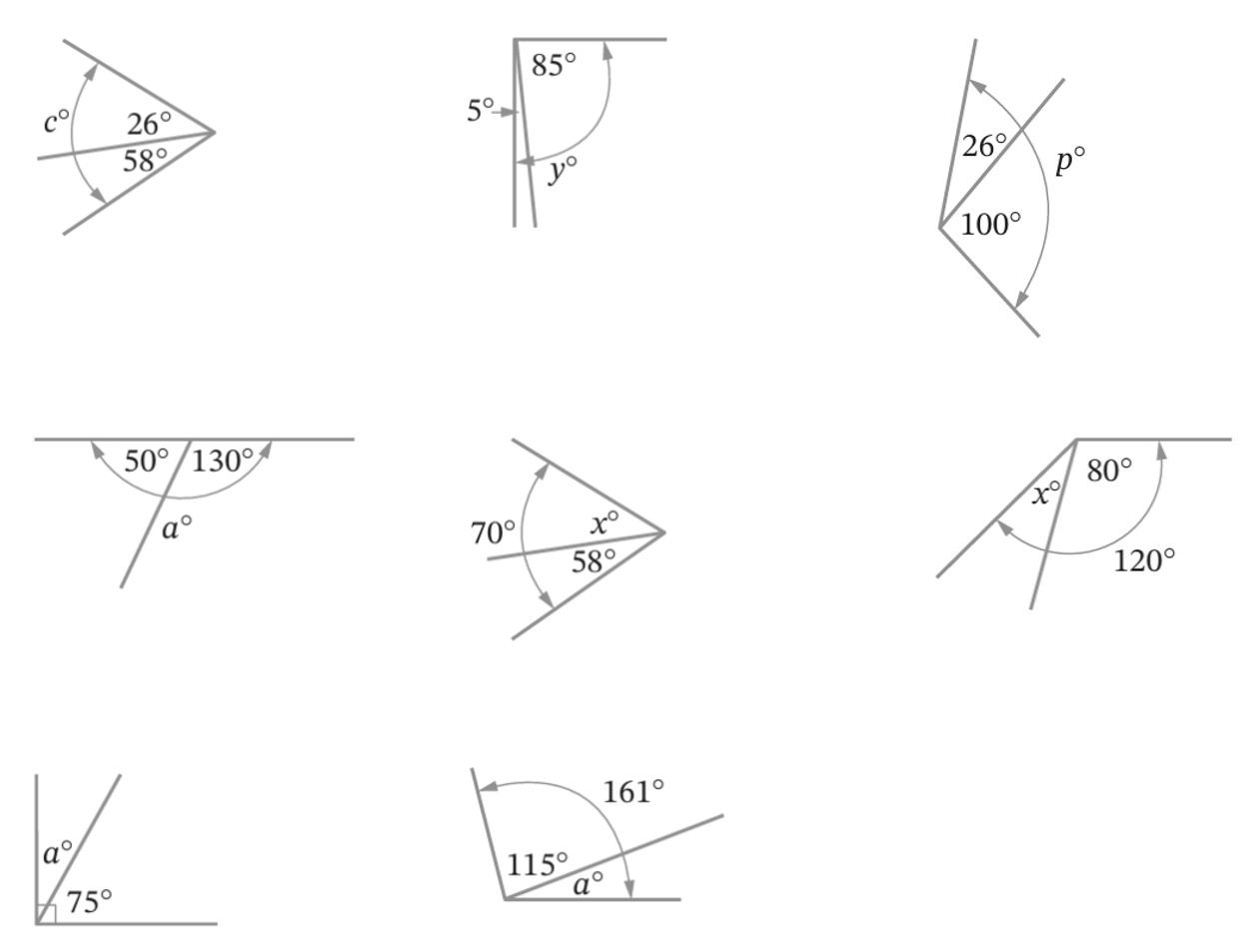  90° | 126°
180° | 12° | 40°
15° | 46°

Angles in a Right Angle and Straight Line

- Angles in a Right-Angle and Straight Line
Angles in a right-angle | Angles on a straight line
If angles are within a right angle,  then they add up to 90 degrees.  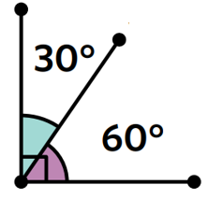  - https://www.geogebra.org/m/htq7jgyq | If angles are on a straight-line,  then they add up to 180 degrees.  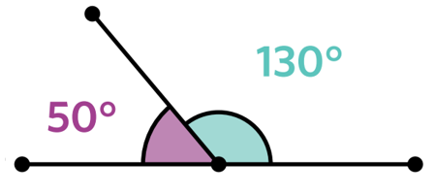  - https://www.geogebra.org/m/bfdfrbqg
To find unknown angles involving angles in a right-angle and straight line:

- Write an equation using angle relationships.
- Simplify the equation, if needed.
- Solve for the unknown.

- Example Solve problems involving angles in a right-angle and straight line
Find the value of the pronumerals.
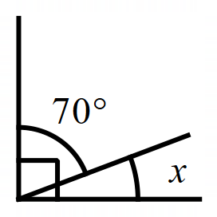  1. $x+70=90$ (angles in a right-angle)  3. $x=20$ | 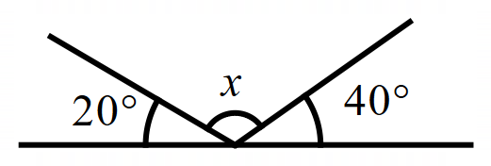  1. $x+20+40=180$ (angles on a straight-line)  2. $x+60=180$  3. $x=120$

- Guided Practice
Calculate the value of the pronumerals.
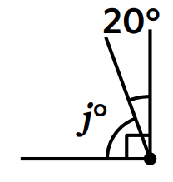 | 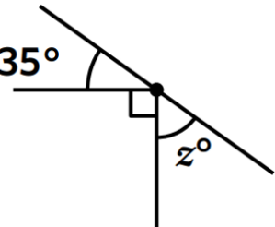
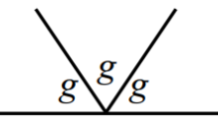 | 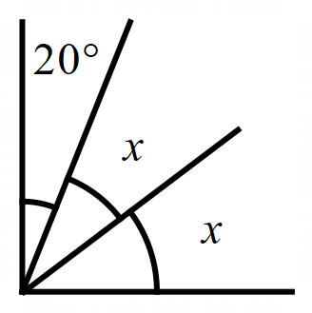

Foundation
- Find the value of each pronumeral.
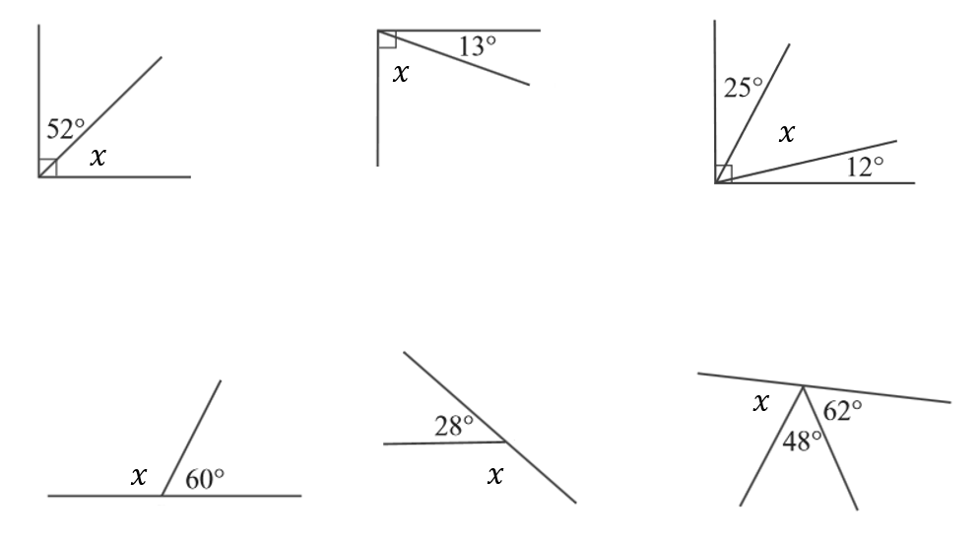  $x+52=90$  $x=$ ……  38° | $x+$ …… $=$ ……  $x=$ ……  77° | $x+$ …… $+$ …… $=$ ……  $x+$ ……… $=$ ……  $x=$ ……  53°
$x+60=180$  $x=$ ……  120° | $x+$ …… $=$ ……  $x=$ ……  152° | $x+$ …… $+$ …… $=$ ……  $x+$ ……… $=$ ……  $x=$ ……  70°

- Calculate the value of the unknown angle.
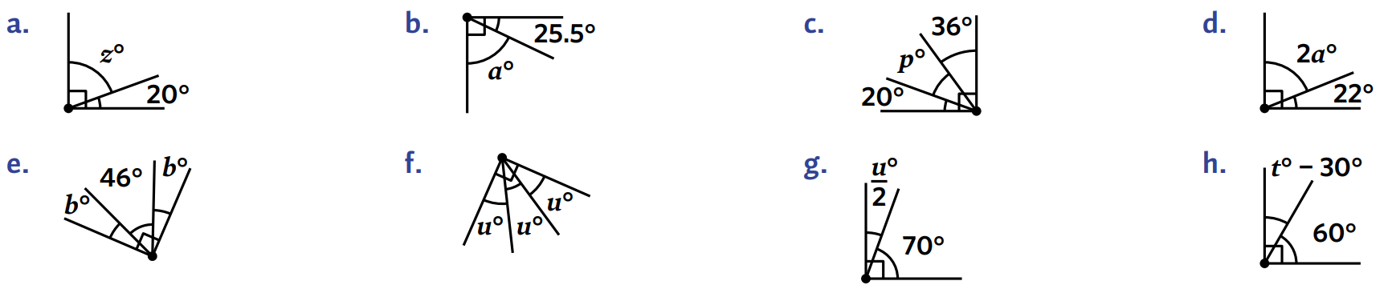  $$z+20=90$$  $z=$ ………  70° | 34° | 22°
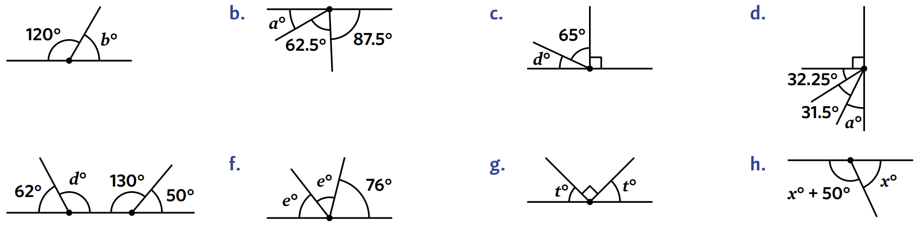  $$b+120=180$$  $b=$ ………  60° | 25° | 52°

Development
- Calculate the value of the letter $a$ in each diagram, giving reasons.
- $a+30=90$(angles in a right angle)  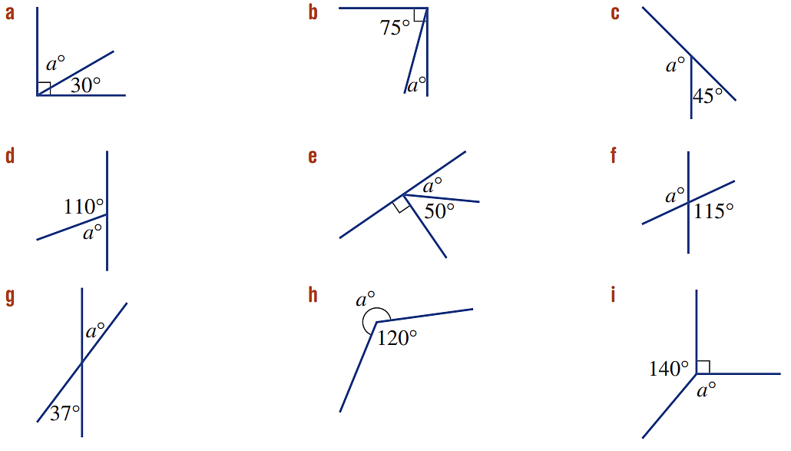  $a=$ ……  60° | $a+45=180$ (angles on a straight line)  $a=135$
$a+75=90$ (angles in a right angle)  $a=15$ | 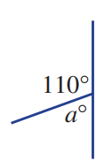  $a+110=180$ (angles in a straight line)  $$a=70$$
$a+50+90=180$ (angles in a straight line)  $$a+140=180$$  $$a=40$$ | 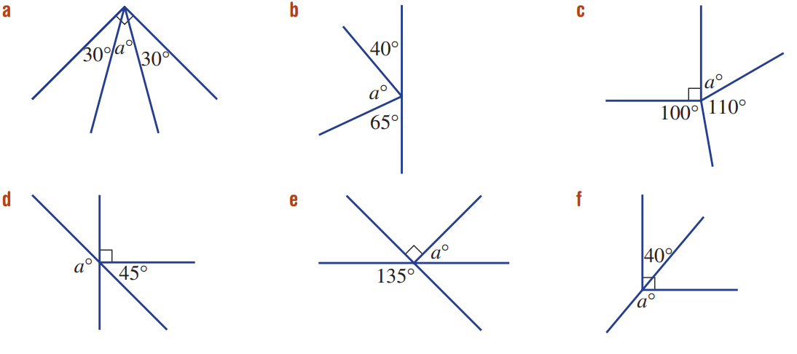  $a+40+65=180$ (angles in a straight line)  $$a+105=180$$  $$a=75$$
$a+30+30=90$ (angles in a right angle)  $$a+60=90$$  $$a=30$$ | 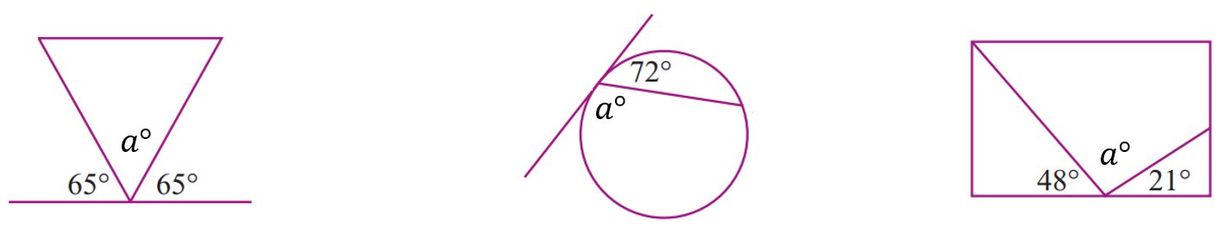  $a+65+65=180$ (angles in a straight line)  $$a+130=180$$  $$a=50$$
$a+72=180$ (angles in a straight line)  $$a=108$$ | $a+48+21=180$ (angles in a straight line)  $$a+69=180$$  $$a=111$$

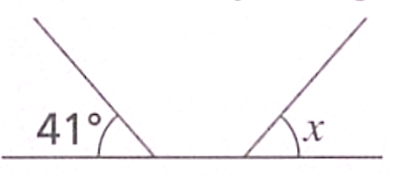
- Marta thinks that $x=180°-41°=139°$ because angles on a straight line add up to 180°.
Explain why she is incorrect.

41° and $x$ do not share a common vertex; they are not adjacent.

- Decide whether each statement is true or false.
- $a+b=180$  True False  false | - $a+b+c=180$  True False  true | - $a+b=180$  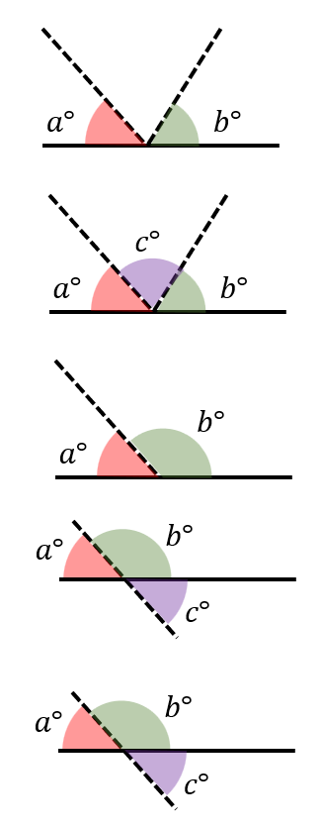  True False  true
- $a+b+c=180$  True False  false | - $b+c=180$  True False  true | - $a+b=180$  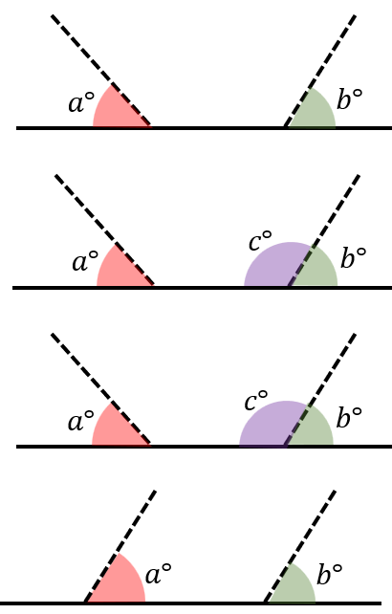  True False  false
- $a+b+c=180$  True False  false | - $b+c=180$  True False  true | - $a+b=180$  True False  false

- Felix has a gaming chair that has a backrest that can lean all the way back until it is flat. If the angle between the chair and the backrest is $119°$, how much more will it have to turn to lay flat?

$$61°$$
- Explain why PQR is not a straight line.
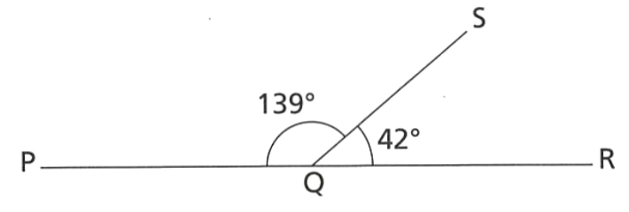

$139+42=181°$, a straight line must sum to 180

Mastery
- Determine the size of the missing angles using complementary angles.
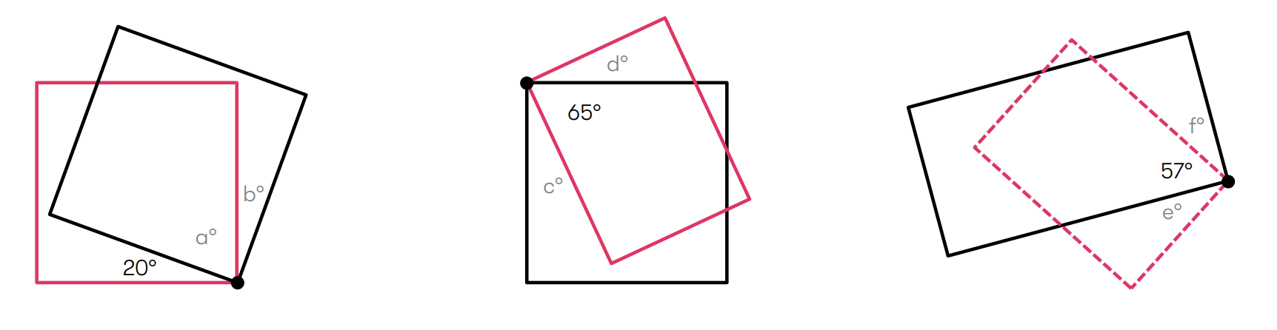  $$a=70, b=20$$ | $$c=25, d=25$$ | $$e=33, f=33$$
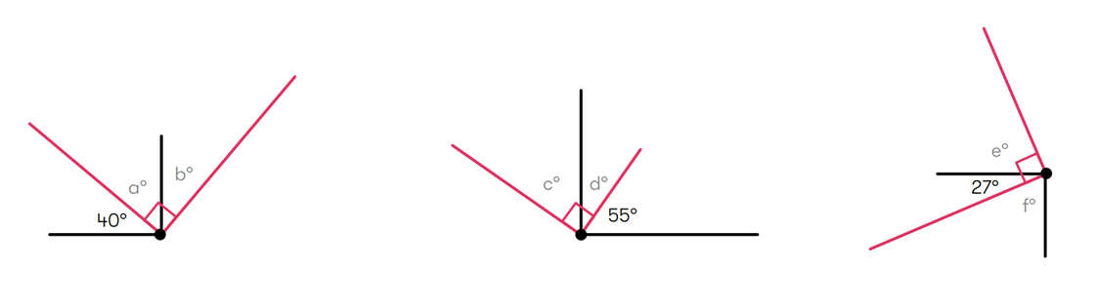  $$a=50, b=40$$ | $$c=55, d=35$$ | $$e=63, f=63$$
$$a=50$$ | $$b=70$$ | 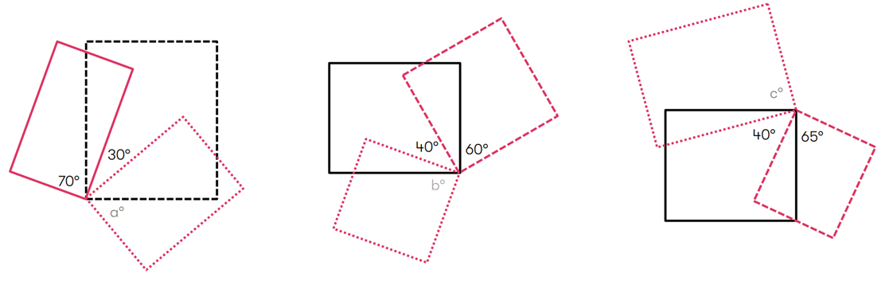  $$c=65$$
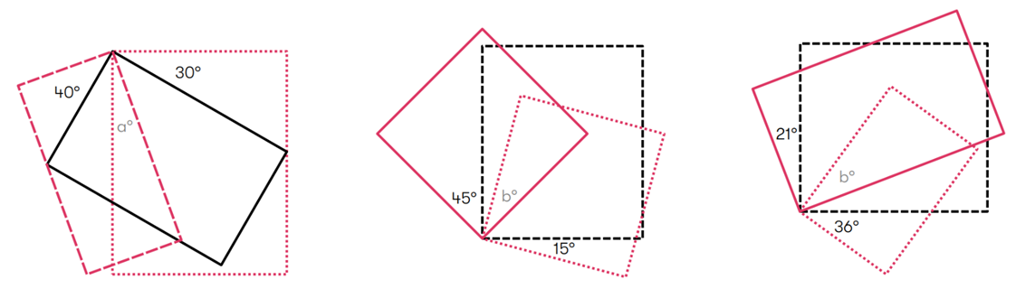  $$a=20$$ | $$a=30$$ | $$b=33$$

- Determine the size of the missing angles using supplementary angles.
$$a=30, b=60, c=30$$ | $$d=35, e=35, f=55$$ | 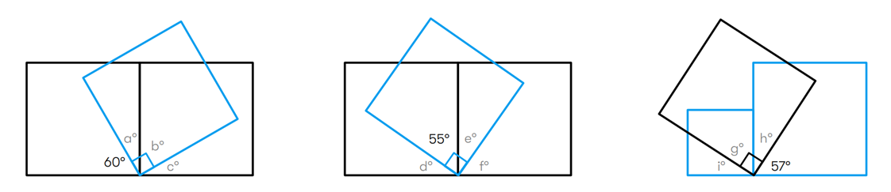  $$g=57, h=33, i=33$$
$$a=50, b=40, c=40$$ | $$d=65, e=25, f=65$$ | 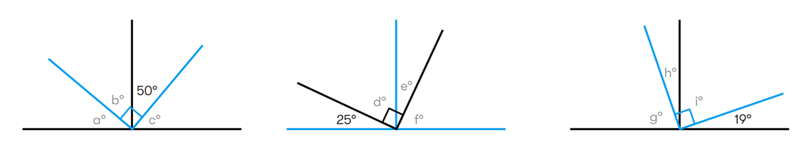  $$g=71, h=19, i=71$$
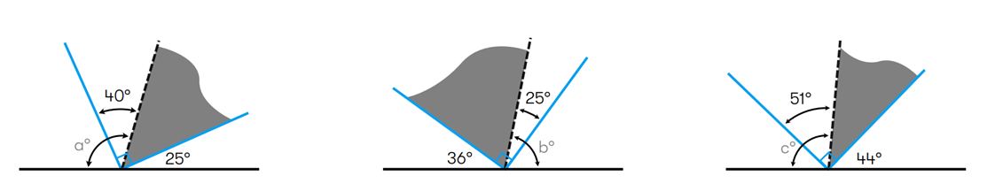  $$a=105$$ | $$b=79$$ | $$c=97$$
$$a=150$$ | $$b=135$$ | 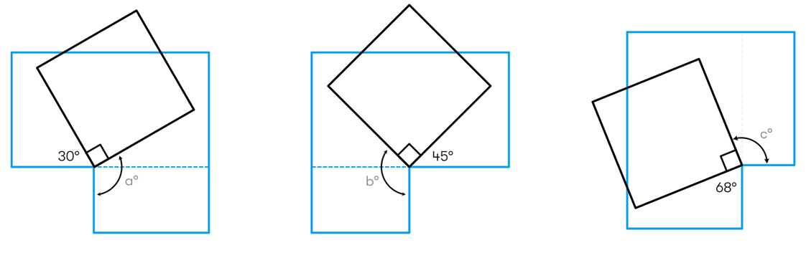  $$c=112$$

Angles at a Point

- Angles at a Point
Angles that share a common vertex sum to 360°

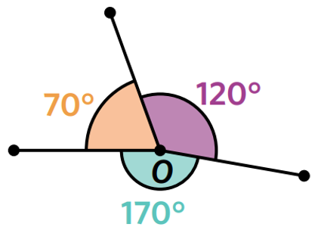
To find unknown angles involving angles at a point:

- Write an equation using angle relationships.
- Simplify the equation, if needed.
- Solve for the unknown.

- Example Solve problems involving angles at a point
Find the value of the pronumerals.
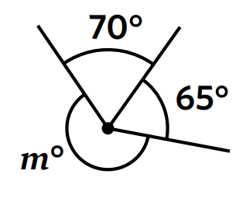  1. $m+70+65=360$ (angles at a point$)$  2. $m+135=360$  3. $m=225$ | 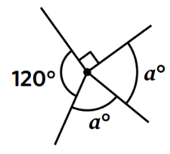  1. $a+a+120+90=360$ (angles at a point)  2. $2a+210=360$  3. $2a=150$  $a=75$

- Guided Practice
Find the value of the pronumerals.
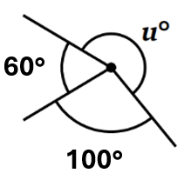 | 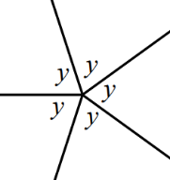
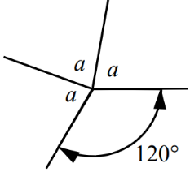 | 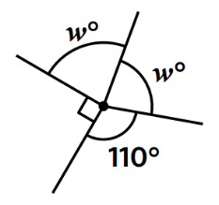

Foundation
- Calculate the value of the unknown angle.
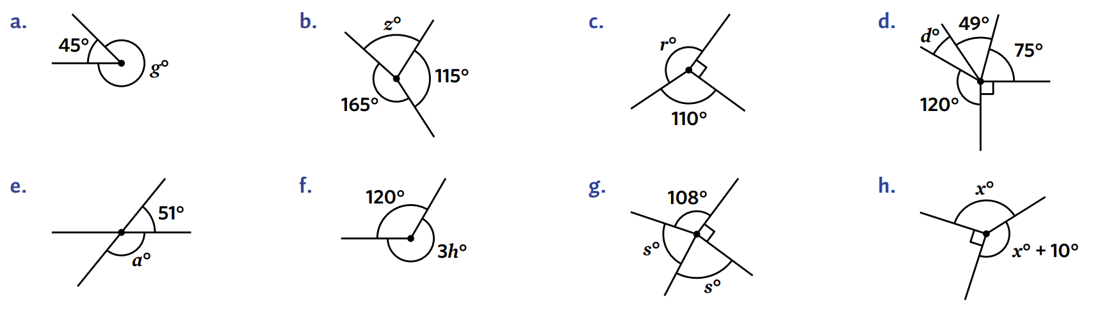  $$45+g=360$$ $g=$ ………  315° | 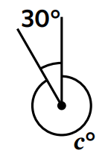  330° | 160°
26° | 80° | 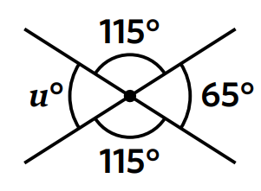  65°

- Seb measures these angles and writes $a = 82°$ and $b = 284°$.
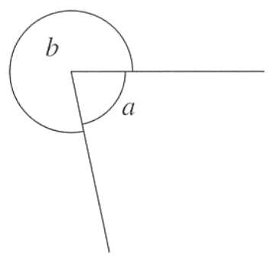
Explain how you know that Seb must have measured incorrectly.

$a+b$ must sum to 360. $284+82=366$.

- Calculate the value of the pronumeral.
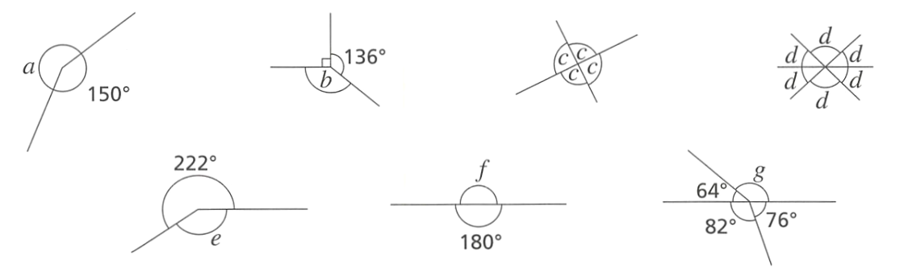  134° | 90° | 60°
49° | 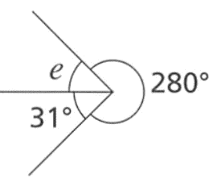  180° | 138°

Development
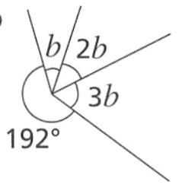
- Determine the value of $b$.

28°
- Calculate the value of the pronumeral.
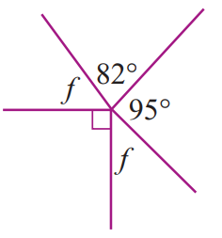  46.5° | 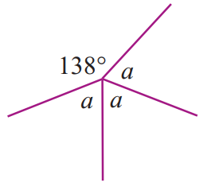  74° | 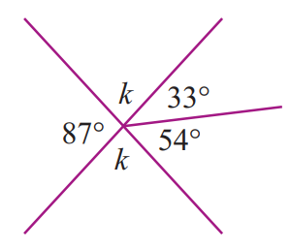  93°
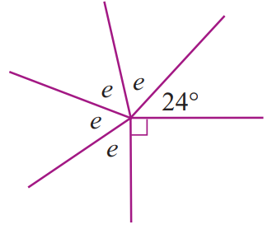  61.5° | 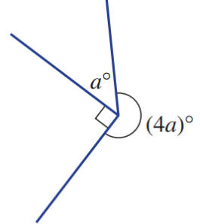  54° | 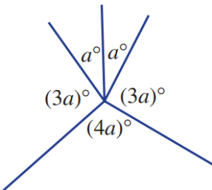  30°

- Calculate the unknown angles.
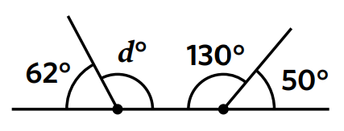  118° | 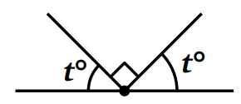  45° | 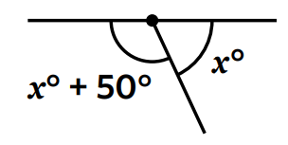  65°
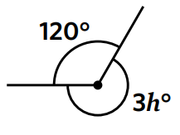  80° | 129° | 81°

Vertically Opposite Angles

- Vertically Opposite Angles
Vertically opposite angles are opposite each other at the vertex when two lines intersect.
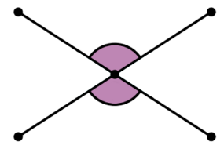
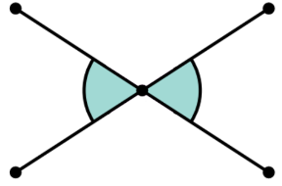

- Identify the vertically opposite angle
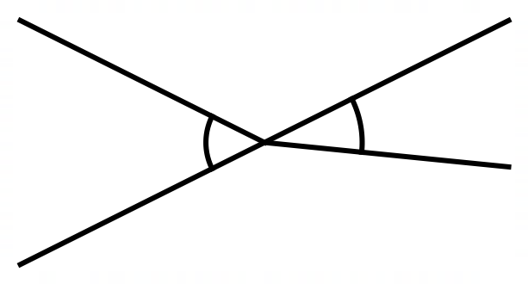  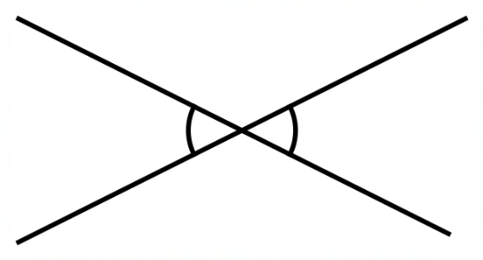  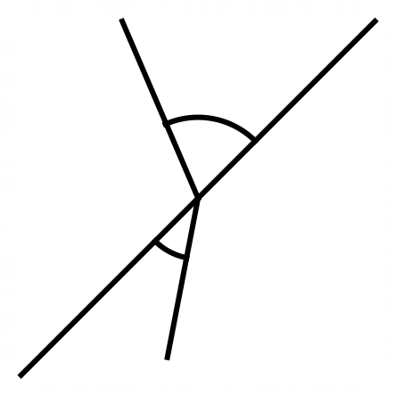  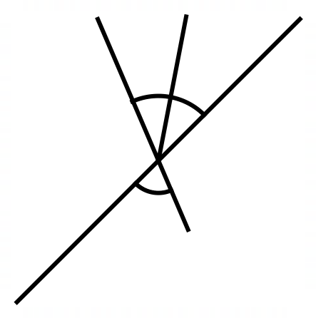  ✖ | ✔ |  | ✔ |  | ✖
Identify the angle that is vertically opposite angle to the identified angle.
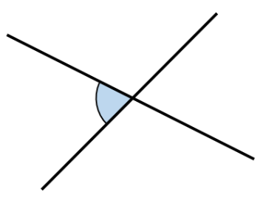 |  |  |  | 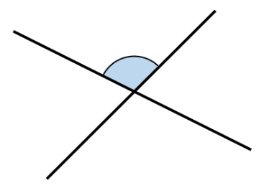  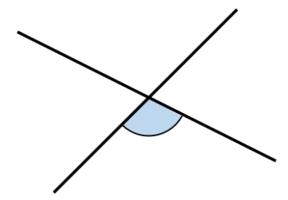
 |  | 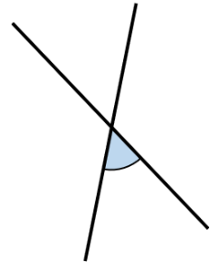  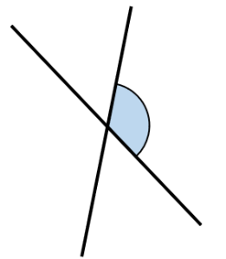 |  | 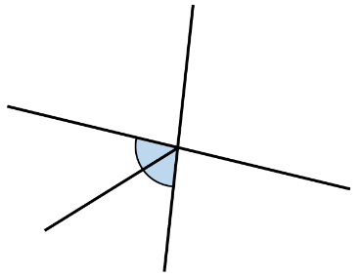
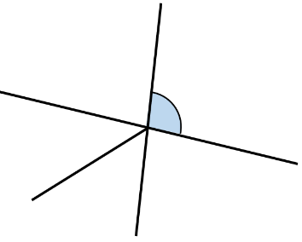 |  | 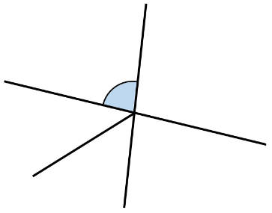 |  | 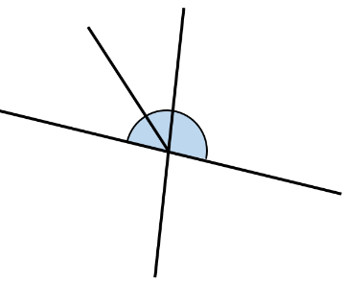
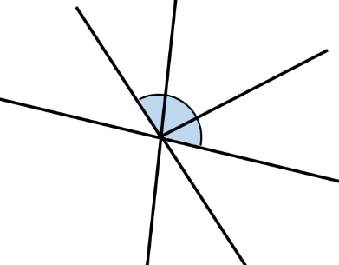
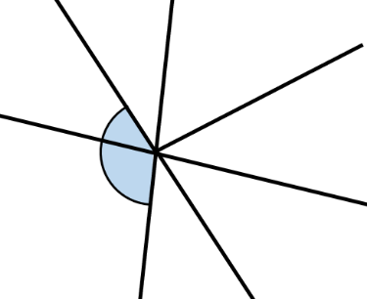
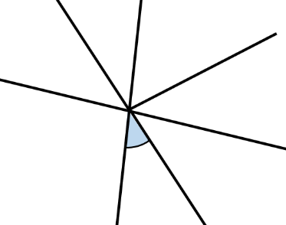

- Vertically Opposite Angles are Equal
Vertically opposite angles are equal.
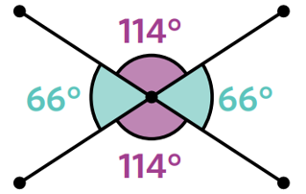

- Example Solve problems involving vertically opposite angles
Calculate the value of $a$  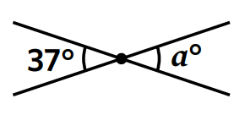  $a=37$ (vertically opposite) | Calculate the value of $x$  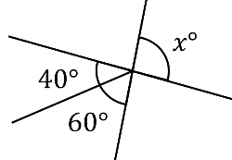  $40+60=x$ (vertically opposite) $100=x$

- Guided Practice
Calculate the value of the pronumerals.
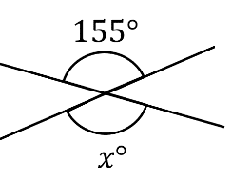  $x=155°$ | 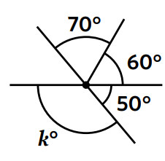  $k=130°$
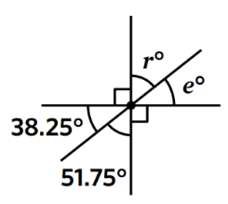  $r=51.75°$, $e=38.25°$ | 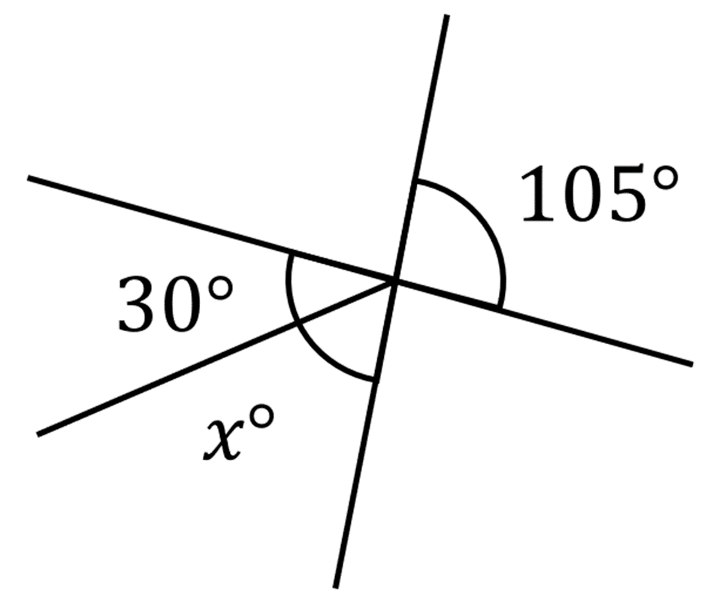  $x=75°$

- Key Ideas
- Vertically opposite angles are …………………

Foundation
- Identify the vertically opposite angle to $∠FGH$ in these diagrams.
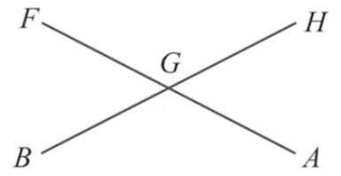  $$∠BGA$$ | 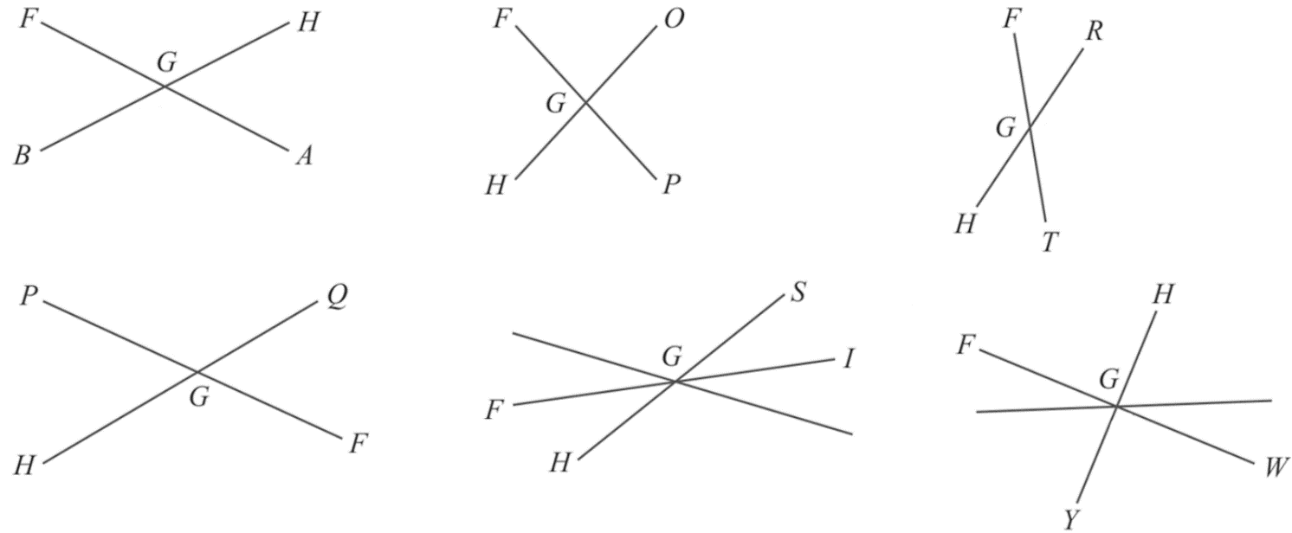  $$∠OGP$$ | $$∠RGT$$
$$∠PGQ$$ | 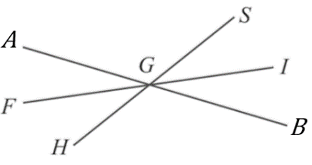  $$∠SGI$$ | $$∠YGW$$

- Label the angle and the angle vertically opposite to it.
- $∠FGS$  $$∠HGI$$ | - $∠SGB$  $$∠AGH$$ | - $∠AGI$  $$∠FGB$$
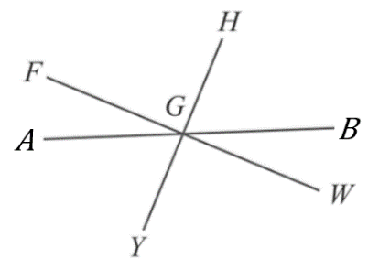  - $∠FGB$  $$∠AGW$$ | - $∠YGF$  $$∠BGA$$ | - $∠AGW$  $$∠FGB$$

- Calculate the value of the unknown angles.
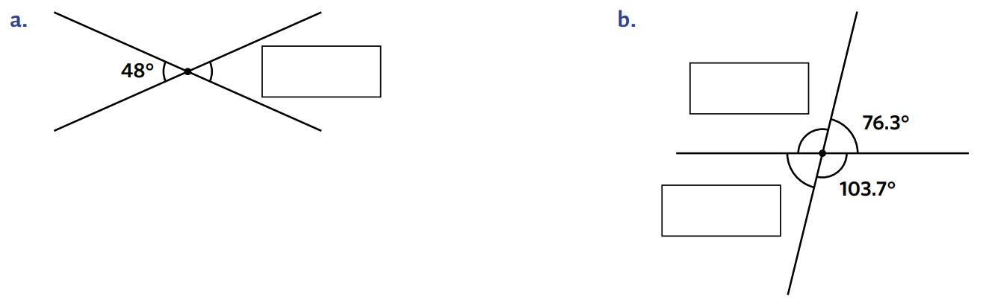  48° | 103.7°, 76.3°
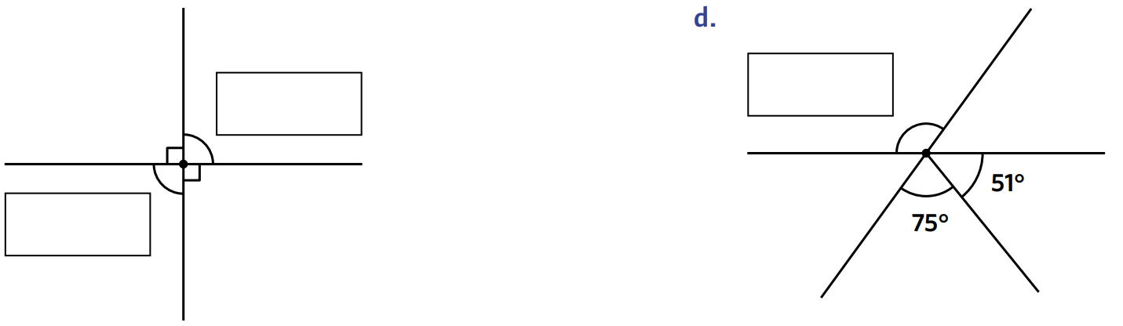  90°, 90° | 126°

- Determine the value of each unknown angle.
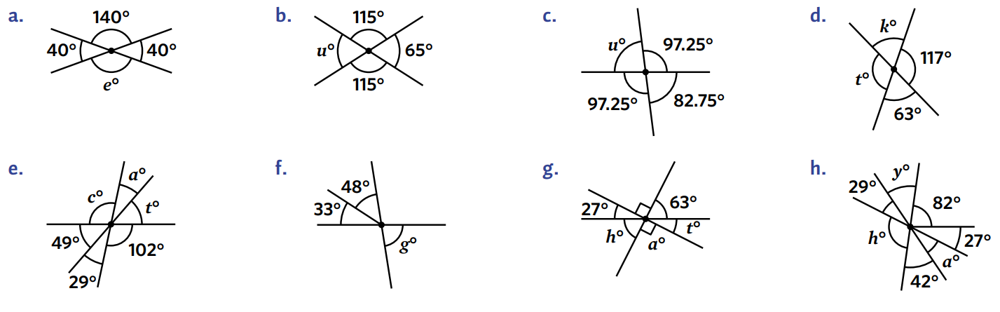  140° | 65° | 82.75°
$$t=117°$$  $$k=63°$$ | 81° | 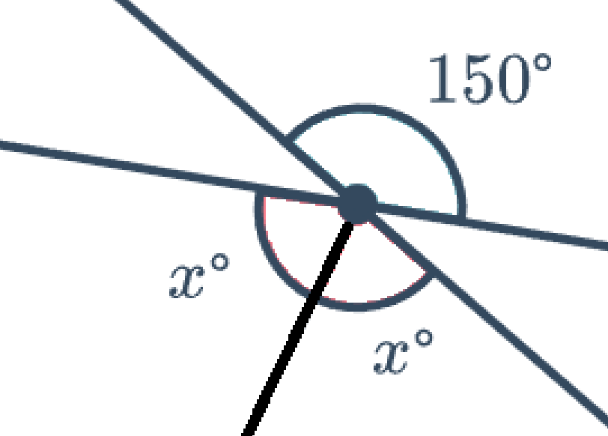  75°

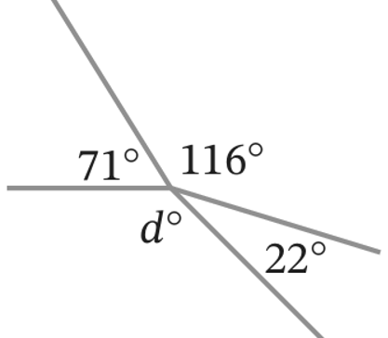
- Jimmy says $d=116°$ because it is vertically opposite to $116°$.
Explain why he is incorrect and find the correct value of $d$.

$d$ is not vertically opposite because it is not formed by the same straight lines that form 116$°$
We can find $d$ using angles at a point; $360-22-116-71=151$

Mixed Practice

- Angle Relationships
Angles at a Point  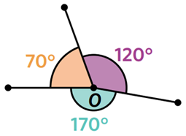  If angles share a common vertex,  then they sum to $360°$ | Vertically Opposite Angles  If angles are vertically opposite,  then they are equal
Angles in a Right-Angle  If angles are within a right angle,  then they add up to 90 degrees. | Angles on a Straight Line  If angles are on a straight-line,  then they add up to 180 degrees.

Foundation
- Calculate the value of the unknown angles. You do not need to show reasoning.
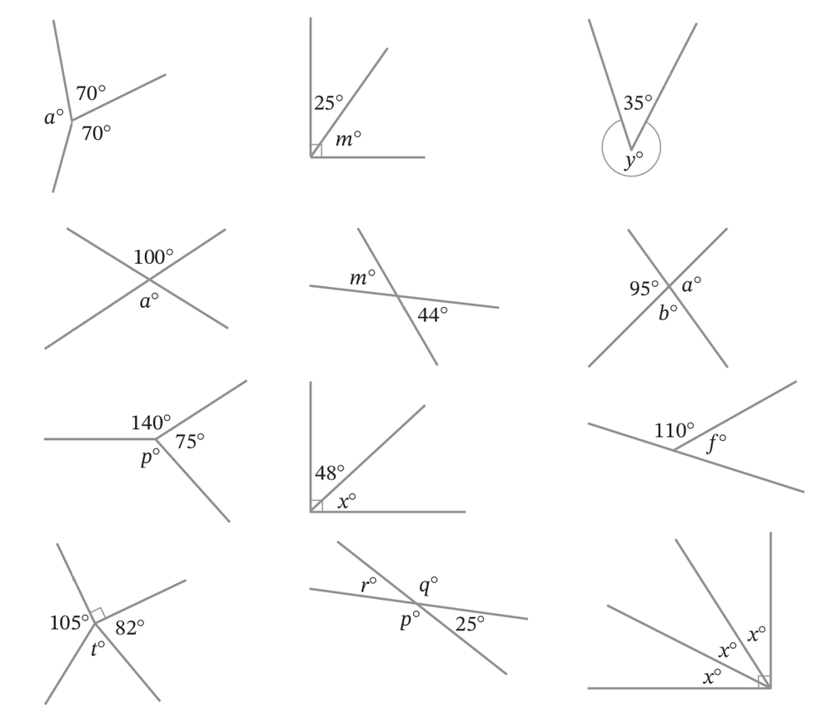  `220° | 65° | 325° | 100°
44° | $$a=95°, b=85°$$ | 145° | 42°
70° | 83° | $$r=25°, p=q=155°$$ | 30°

Development
- Combine your knowledge of angle relationships to calculate the value of each angle.
You do not need to give reasoning.
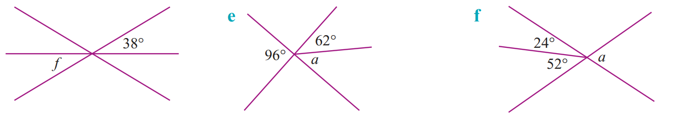  38° | 34° | 76°
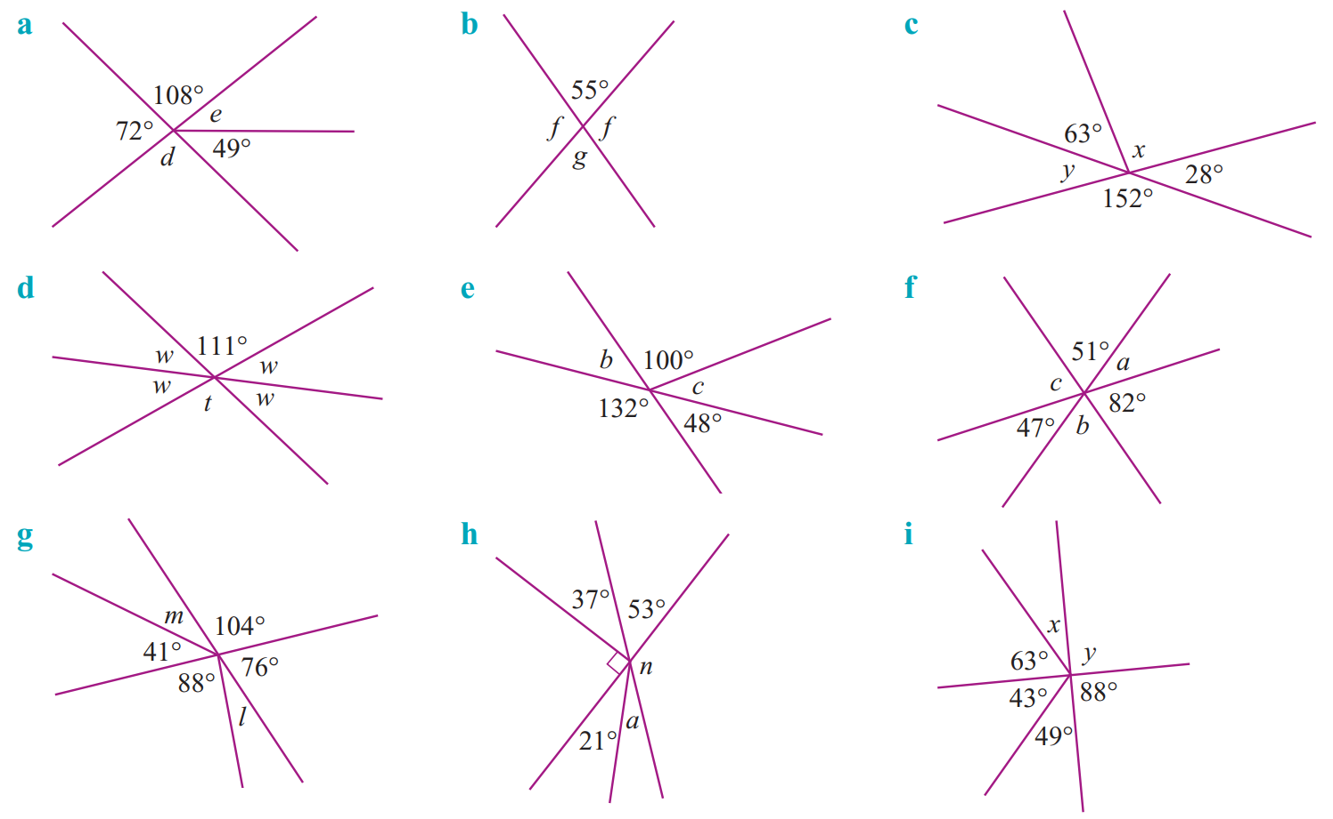  $$d=108°, e=23°$$ | 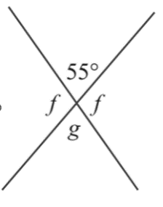  $$g=55°,f=125°$$ | $$x=89°, y=28°$$
$$t=111°.w=34.5°$$ | $$b=48°,c=32°$$ | $$a=47°,b=51°,c=82°$$
$$l=16°, m=35°$$ | $$a=32°, n=127°$$ | $$x=25°, y=92°$$

Mastery
- Decide whether these diagrams have the correct information or not. Justify your answer.
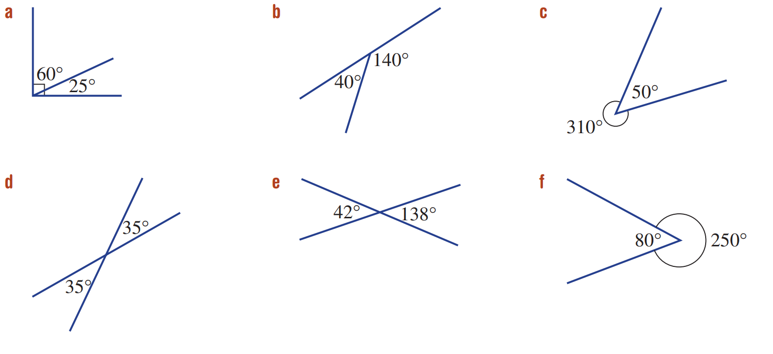  $60+25=85°$  No, as angles in a right angle must sum to $90°$. | 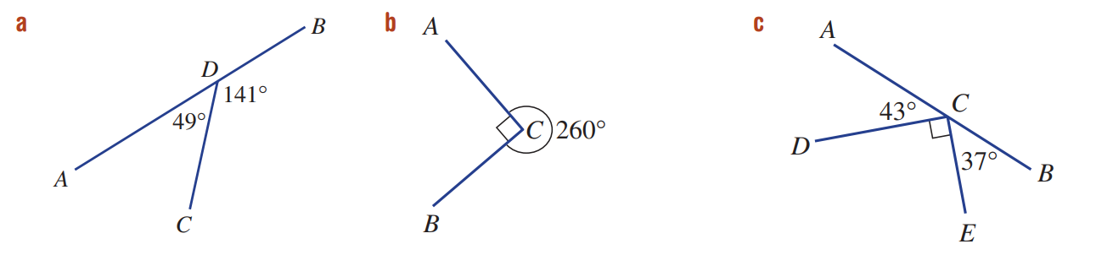  No, angles at a point sum to 360° | Yes, angles at a point sum to 360°
Yes, vertically opposite angles are equal. | No, vertically opposite angles are equal. | No, angles at a point sum to 360°
No, angles on a straight line sum to 180° | Yes, angles on a straight line sum to 180° | No, angles on a straight line sum to 180°

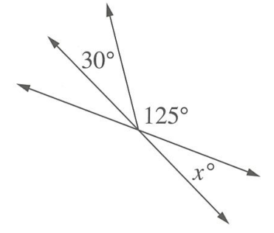
- Calculate the value of $x$.

$$x=25°$$
- Calculate the value of $r$ and $f$
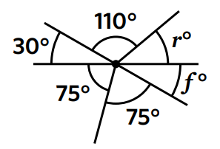

$$r=40°, f=30°$$
- Which has the larger value, $f$ or $g$? Explain your reasoning.
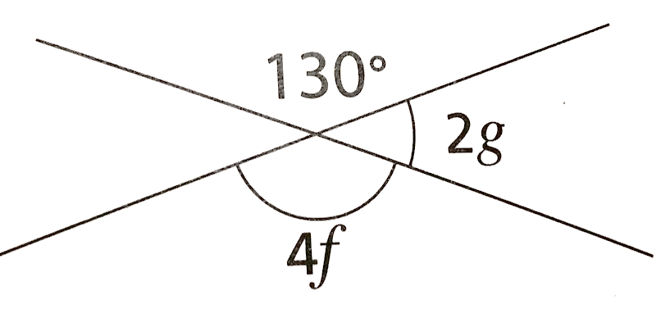

$$f=32,5, g=25, ∴ f>g$$
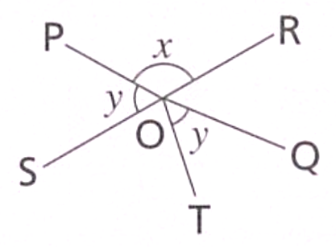
- Write expressions in terms of $x$ and/or $y$ for
- $∠ROQ$  $$∠ROQ=y$$ | - $∠SOT$  $$∠SOT=x-y$$

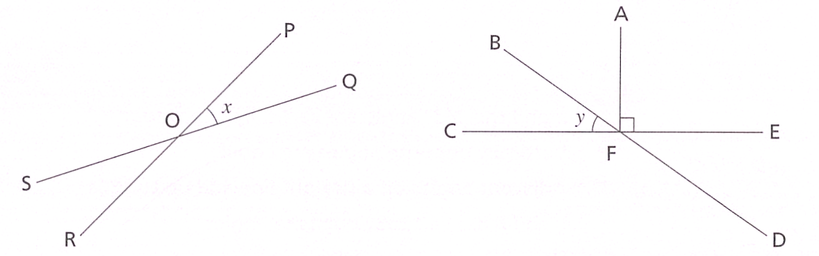
- Consider the two diagrams.

Write an expression for:
- $∠ROS$  $$x$$ | - $∠POS$  $$180-x$$ | - $∠ROQ$  $$180-x$$
- $∠DFC$  $$180-y$$ | - $∠EFD$  $$y$$ | - $∠AFB$  $$90-y$$

Perpendicular and Parallel Lines

- Parallel Lines
Parallel lines run in the same direction and never meet, even if extended forever.
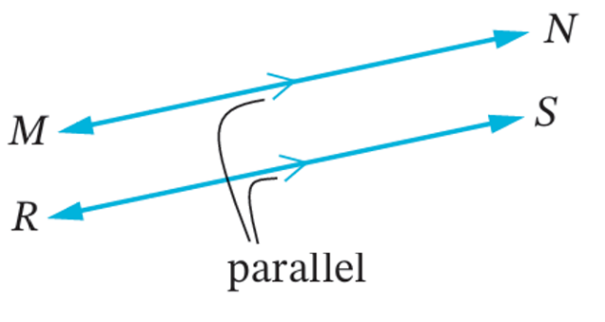
Diagrams show them with arrows >; statements use the $||$ symbol.

$MN || RS$

- Identify parallel lines
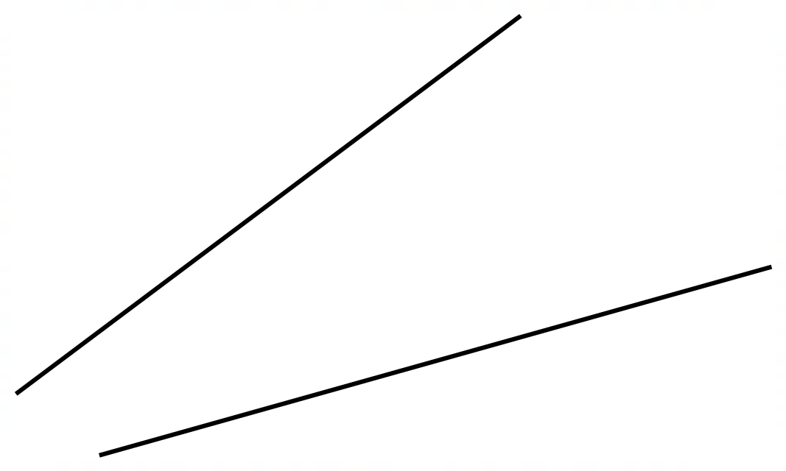  ✖ | ✔  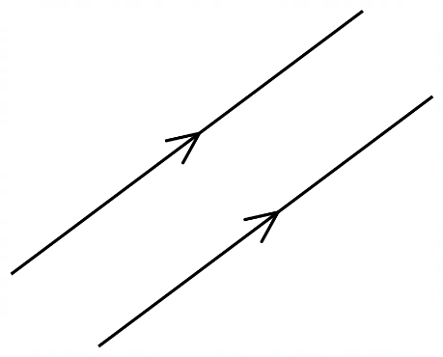 | 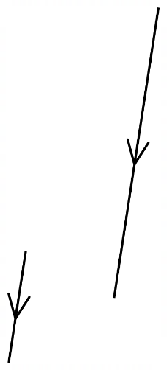  ✔ | ✖  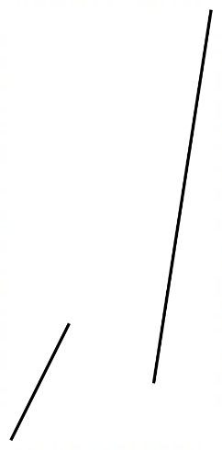
Draw a parallel line that passes through the given point.
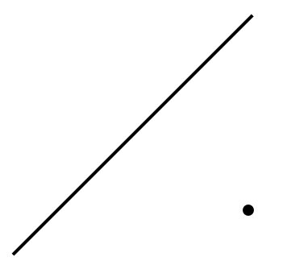 |  | 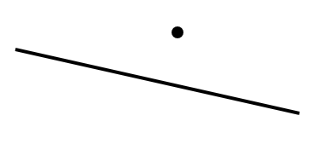
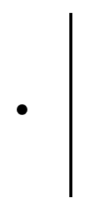 |  | 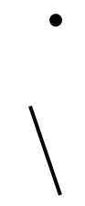

- Perpendicular Lines
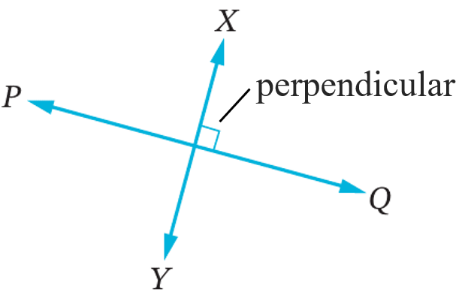
Perpendicular lines intersect at a right angle.
Diagrams show this with a square; statements use the $⊥$ symbol.

$PQ⊥XY$

- Identify perpendicular lines
✖  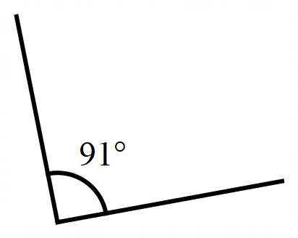 | ✔  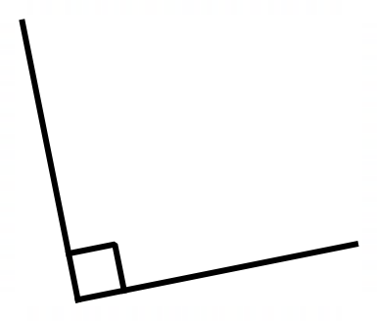 | 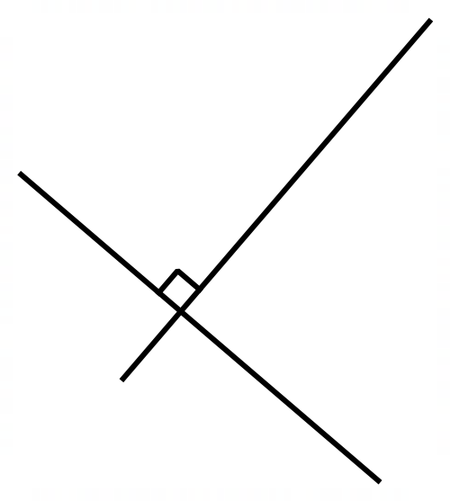  ✔ | 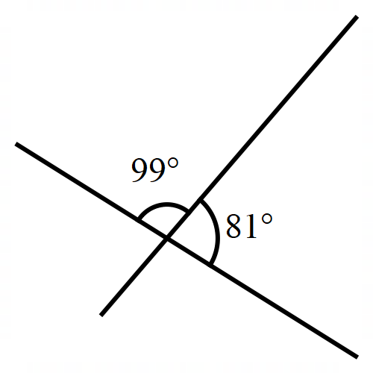  ✖
Draw a perpendicular line that passes through the given point.
 |  | 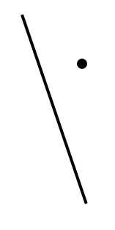

- Example Identify perpendicular and parallel lines
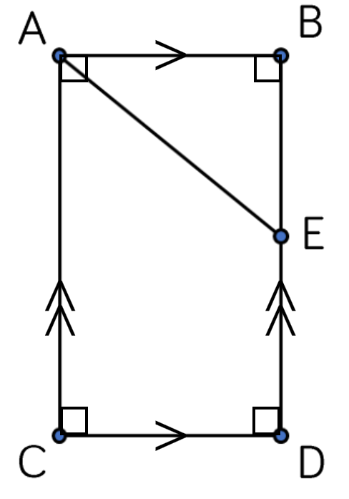 | Name two pairs of parallel lines in the diagram  $AB || CD$ and $AC || BD$  Name two pairs of perpendicular lines in the diagram.  $AC⊥CD$ and $BD⊥AB$

- Guided Practice
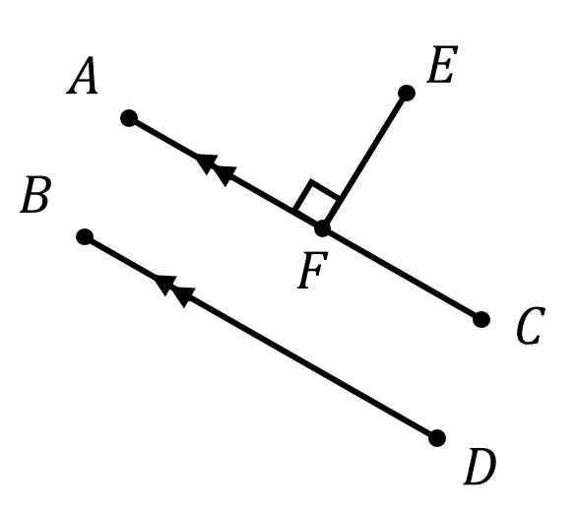
Name a pair of parallel lines.

Name a pair of perpendicular lines.

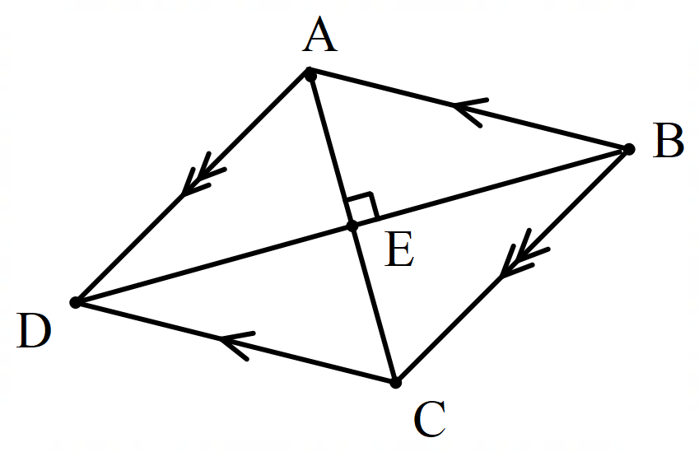
Name two pairs of parallel lines.

Name a pair of perpendicular lines.

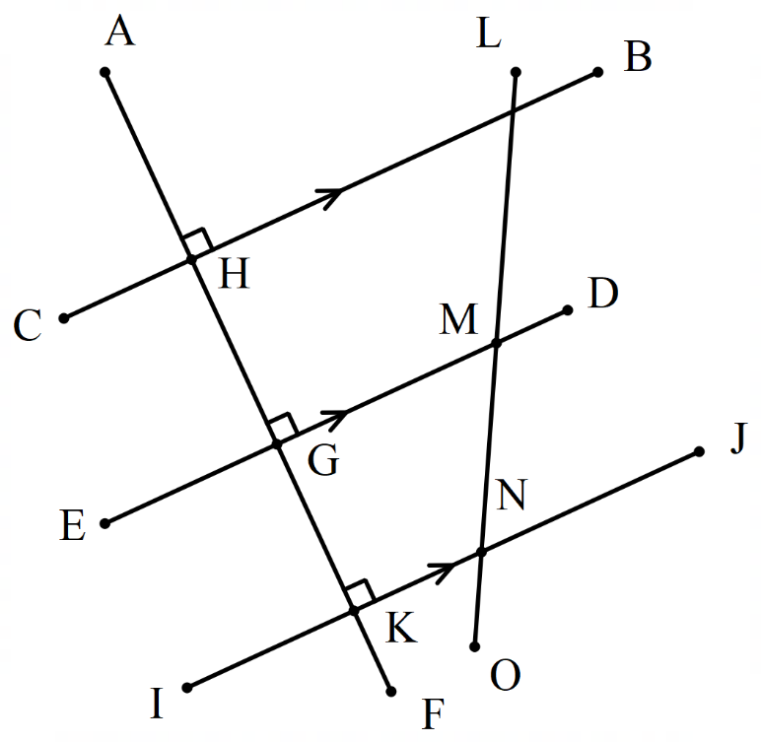
Name a set of three parallel lines.

Which line is perpendicular to all three parallel lines?

- Key Ideas
- Two lines that are in the same direction are called ……………………………
- Two lines that meet at 90° are called …………………………

Foundation
- Complete the statements:
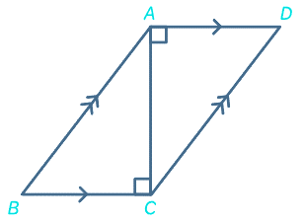
  - DA is parallel to …………
CB
  - AB is …………… to CD
parallel
  - AC is perpendicular to ……… and ………
BC and AD

- Consider the diagram of a swing set on the right.
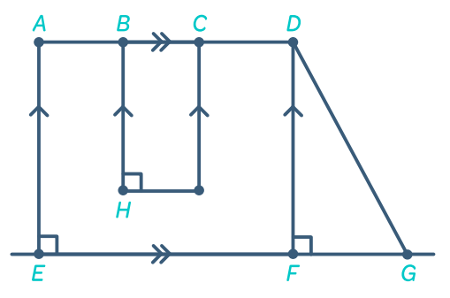
  - How many line segments are parallel to AE?
I
3: BH, CI, DF
  - Identify 2 line segments perpendicular to EG.
AE or DF

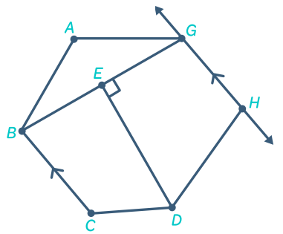
- Consider the diagram to the right.
  - Name a line segment parallel to GH
BC
  - Identify a line segment perpendicular to GE

DE
- Name all the pairs of perpendicular lines in the following diagrams.
Write a statement like $WX⊥YZ$
CD ⊥ EF | KL ⊥ LM | 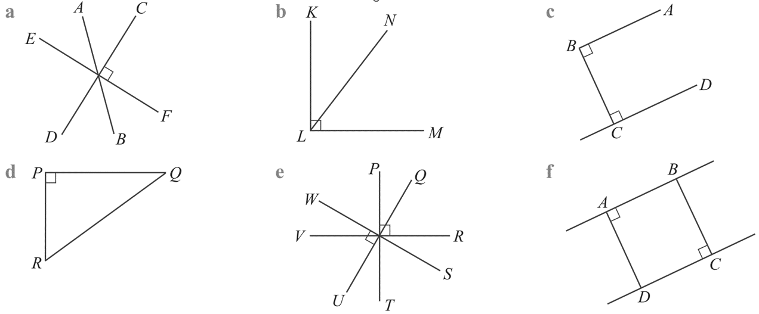  AB ⊥ BC, BC ⊥ CD
RP ⊥ PQ | PT ⊥ PR, WS ⊥ UQ | AB ⊥ AD, BC ⊥ DC

- Name the pairs of parallel lines in these diagrams.
Write a statement like $WX || YZ$
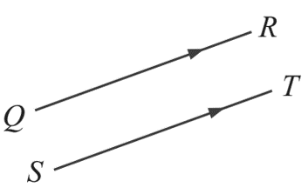  QR || ST | 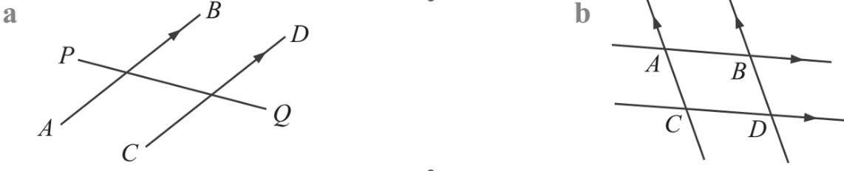  AB || CD | AB || CD, AC || BD

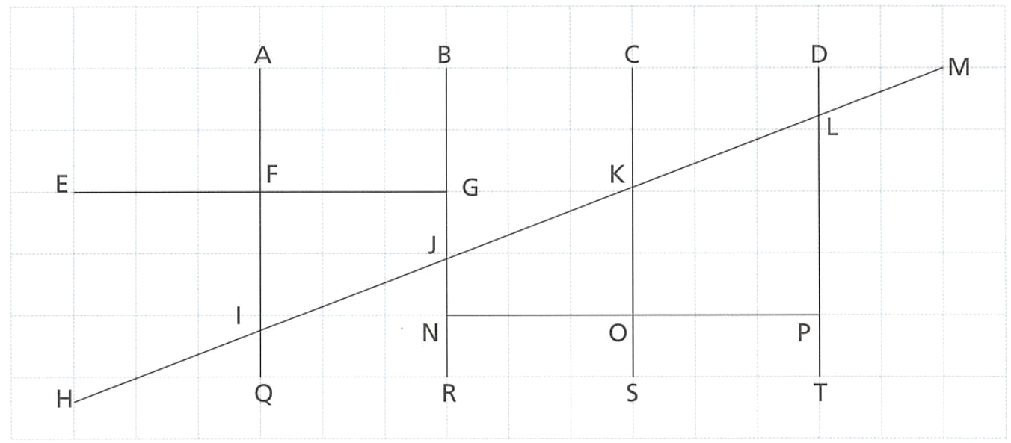
- A diagram is drawn on a square grid.

Decide whether these statements are true or false.
  - AQ is parallel to BR.
true
  - NP is perpendicular to CS.
true
  - BR is perpendicular to HM.
false
  - BR is parallel to DT.
true
  - Add arrows and right-angle symbols to show parallel and perpendicular lines.

Angles on Transversals

- Transversals
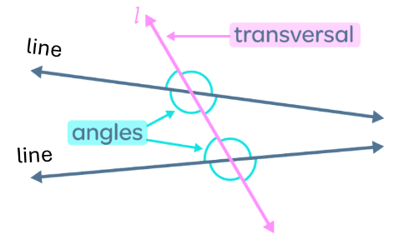
A transversal is a line that intersects two or more lines.

A transversal forms three types of angle pairs:
- Corresponding angles
- Alternate angles
- Co-interior angles

- Corresponding Pairs
Corresponding angle pairs have matching positions on the same side of the transversal.
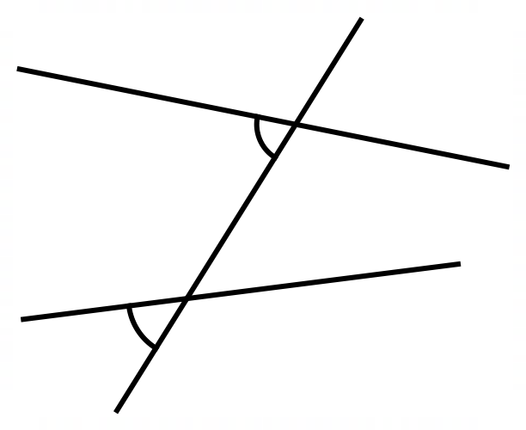
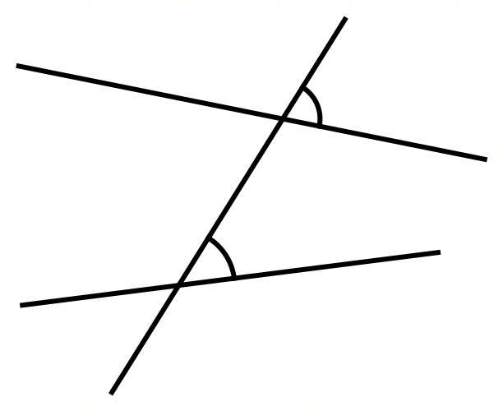
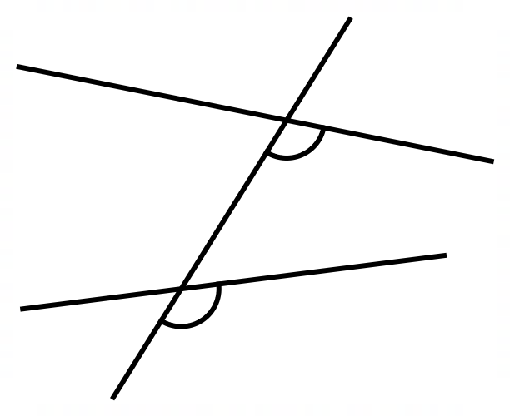
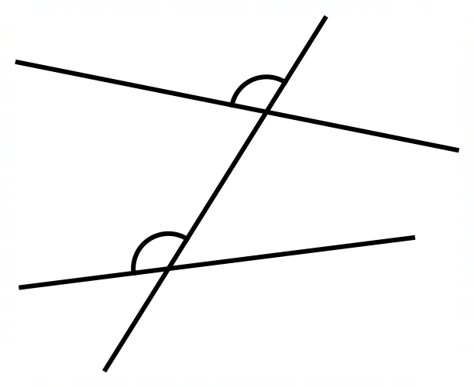

- Identify the corresponding angle
Draw the angle that is corresponding to the one shown on the diagram.
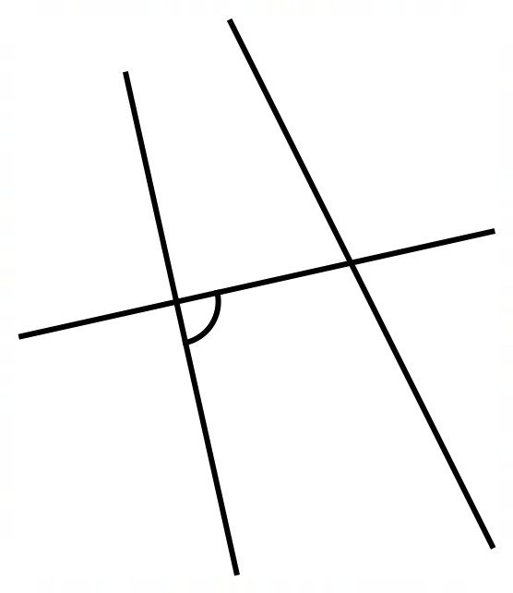
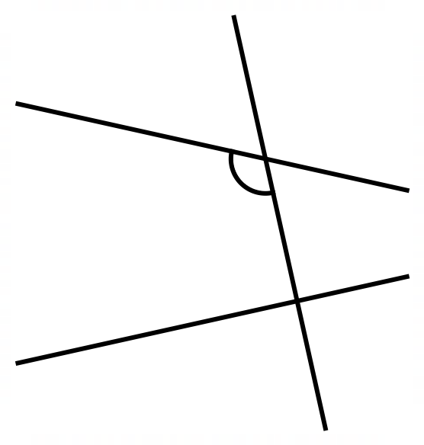
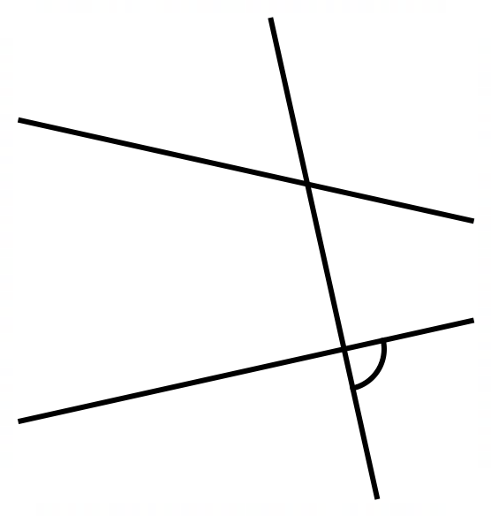

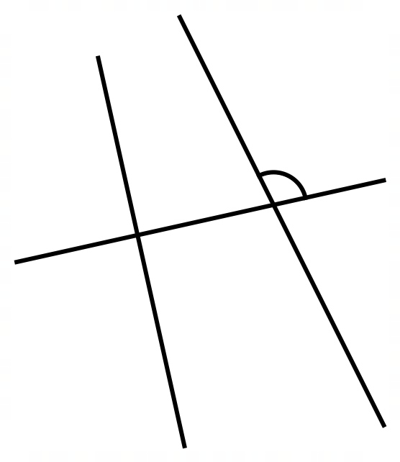 |  | 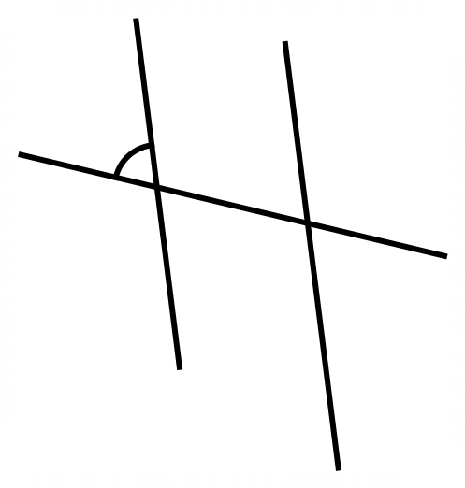  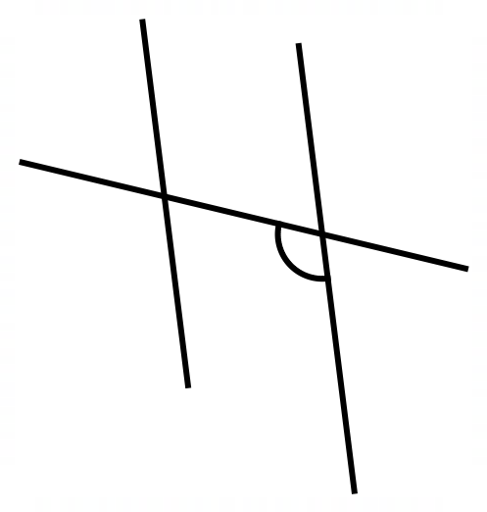
- Alternate Pairs
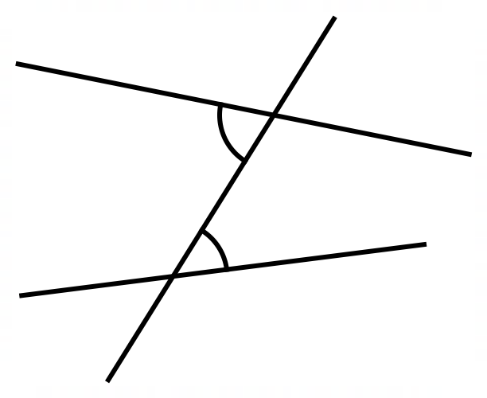
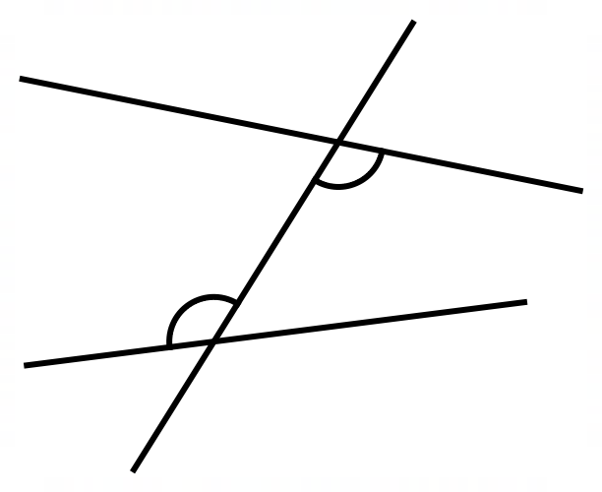
Alternate angle pairs are on opposite sides of the transversal, inside the lines.

- Identify the alternate angle
Draw the angle that is alternate to the one shown on the diagram.
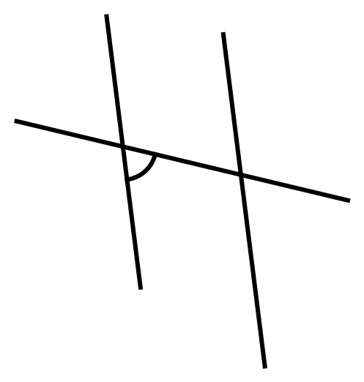
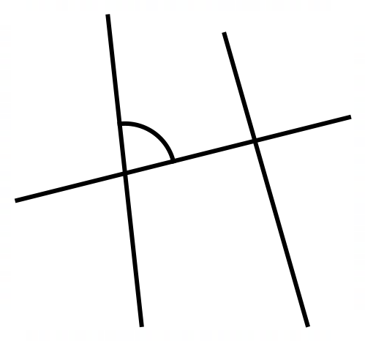
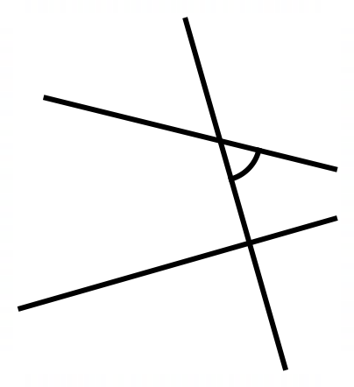

- Co-interior Pairs
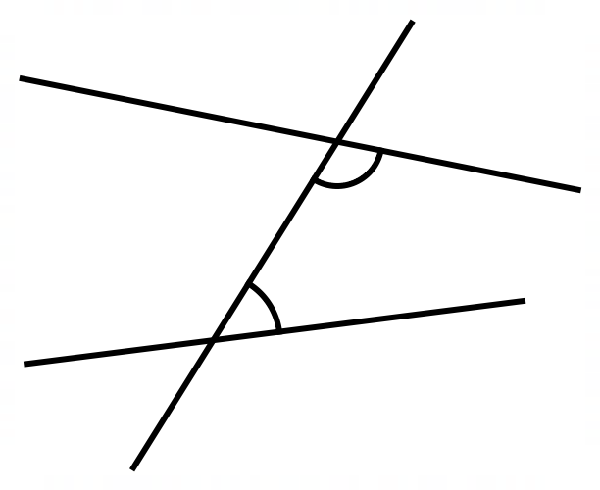
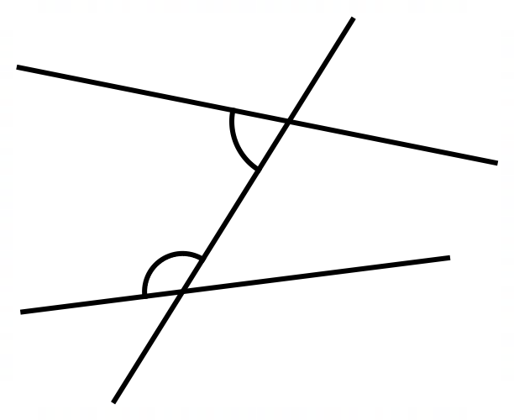
Co-interior angle pairs are on the same side of the transversal, inside the lines.

- Identify the co-interior angle
Draw the angle that is co-interior to the one shown on the diagram.

- Angles on Transversals
Corresponding Pairs  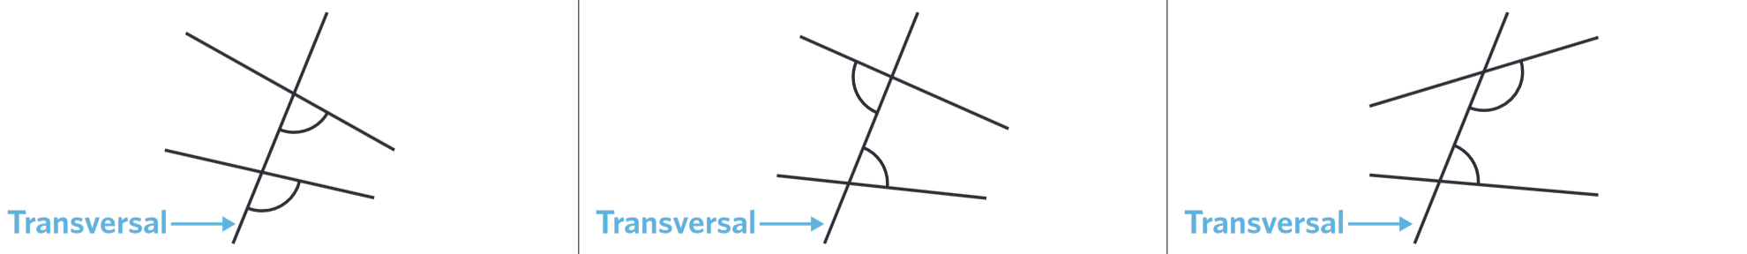  Matching positions on same side of transversal. | Alternate Pairs  Opposite sides of transversal, inside the lines. | Co-interior Pairs  Same side of transversal, inside the lines.

- Identify transversal angle relationships
 | 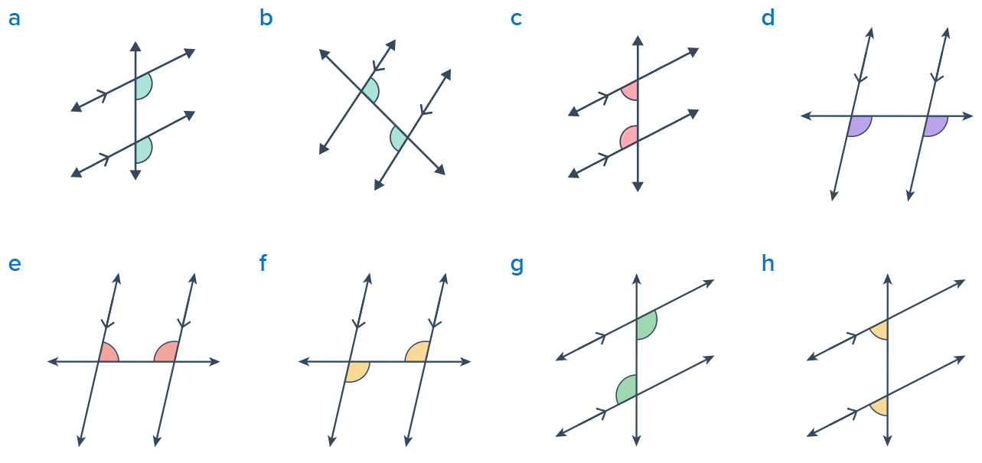
 |  | 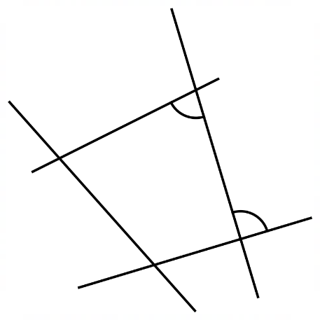 | 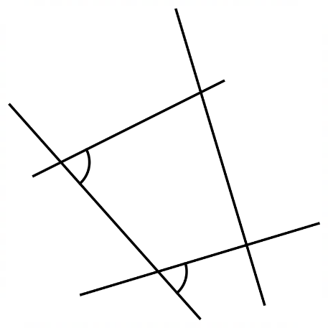  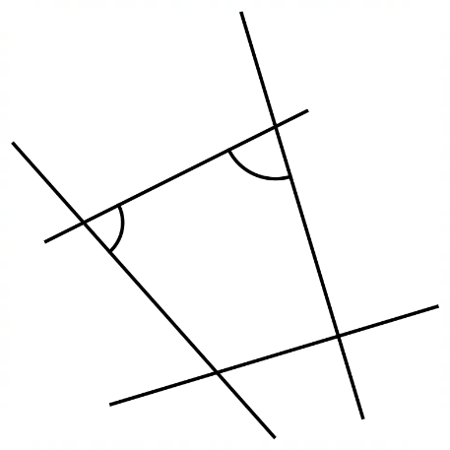  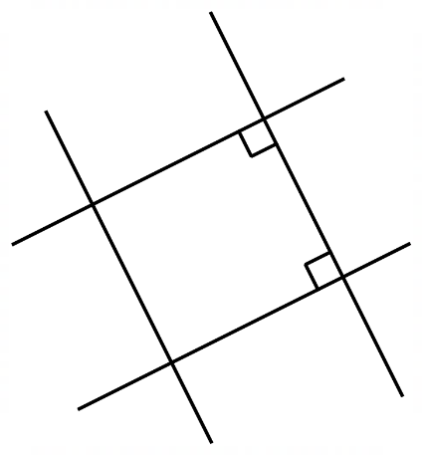

Foundation
- Identify the angle relationship shown.
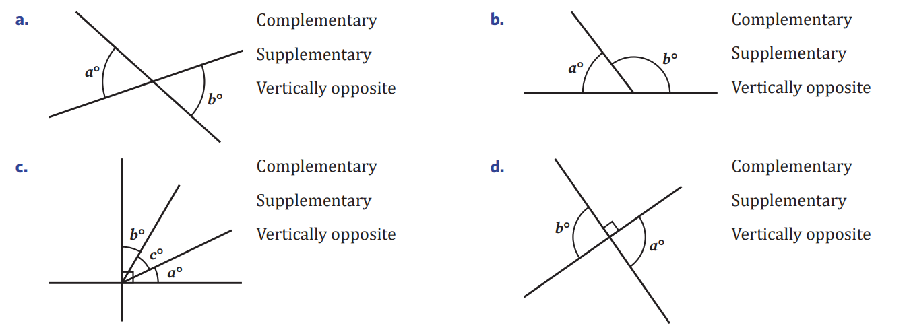  vertically opposite | Supplementary
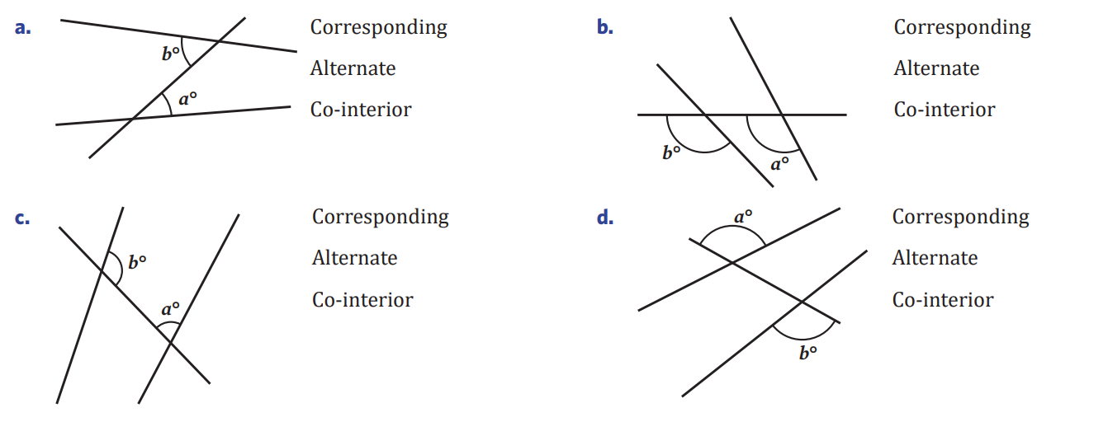  alternate | vertically opposite
co-interior | corresponding

- Draw an arc showing the angle corresponding to $x$.
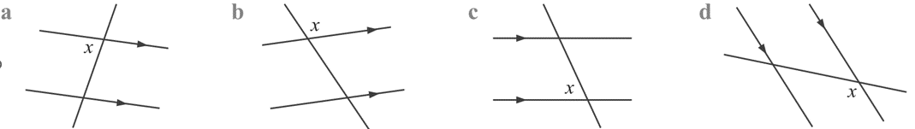  ⌒ | ⌒ | ⌒ | ⌒

- Draw an arc showing the angle alternate to $d$.
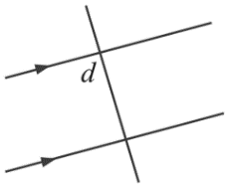  ⌒ | 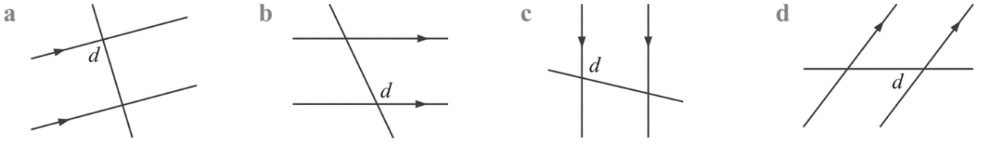  ⌒ | ⌒ | ⌒

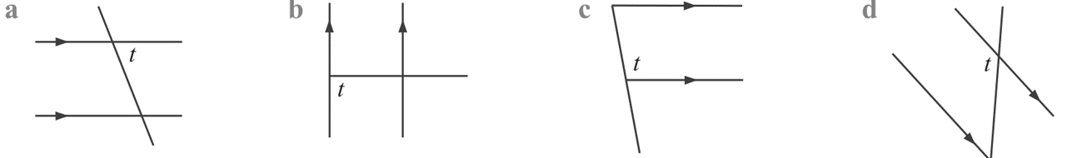
- Draw an arc showing the angle co-interior to $t$.
⌒
⌒ | ⌒ |  | ⌒

- Label the missing angle arc for the corresponding, alternate, or co-interior angle.
There can be more than one answer, or no answer.
- Corresponding  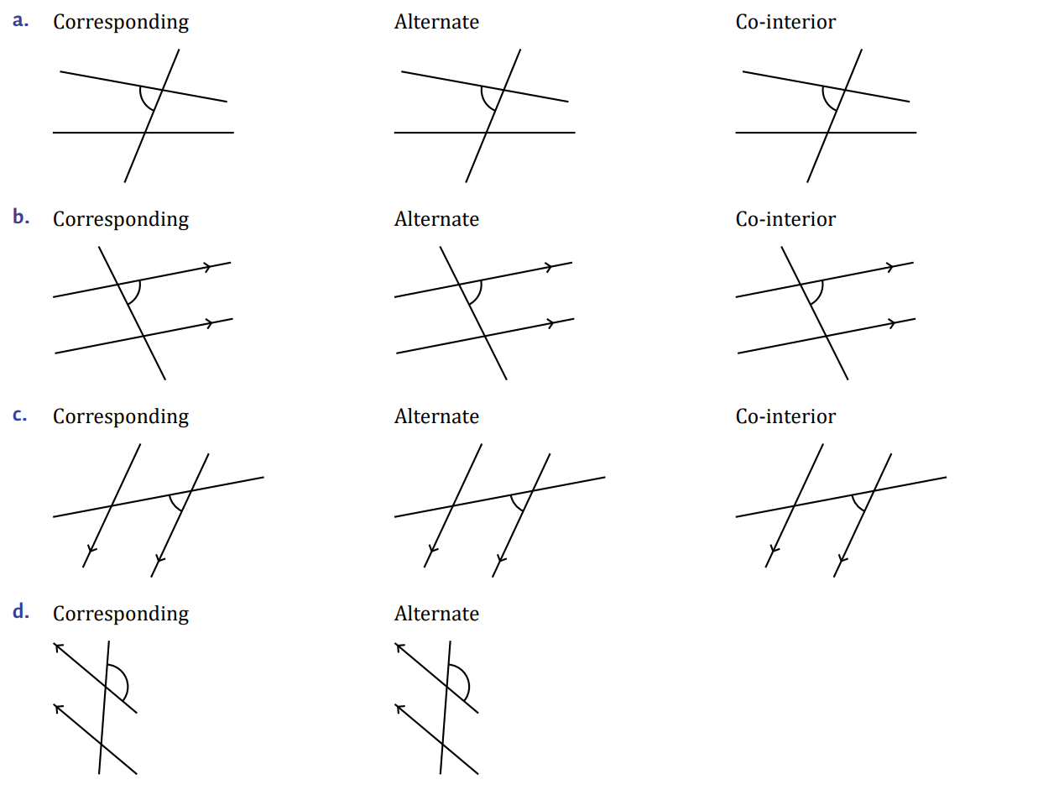  ⌒ | - Alternate  ⌒ | - Co-interior  ⌒
- Corresponding  ⌒ | - Alternate  ⌒ | - Co-interior  ⌒
- Corresponding  ⌒ | - Alternate  ⌒ | - Co-interior  ⌒
- Corresponding  ⌒ | - Alternate  No alternate angle | - Co-interior  No co-interior angle
- Corresponding  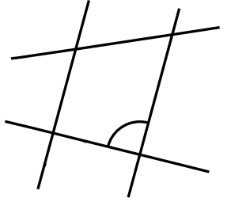  ⌒  ⌒ | - Alternate  ⌒  ⌒ | - Co-interior  ⌒  ⌒
- Corresponding  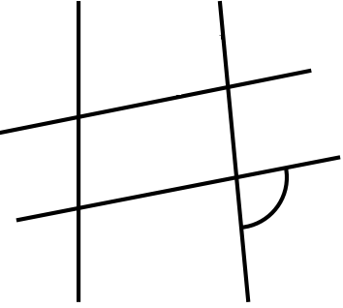  ⌒  ⌒ | - Alternate  No alternate angle | - Co-interior  No co-interior angle

- Identify whether these angles are corresponding, alternate, or co-interior.
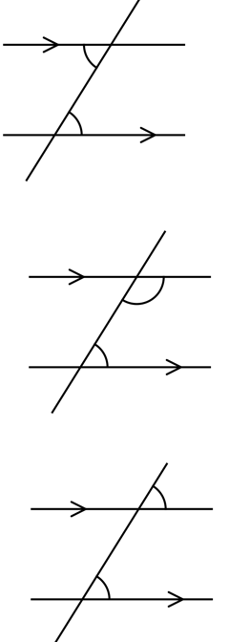  corresponding | 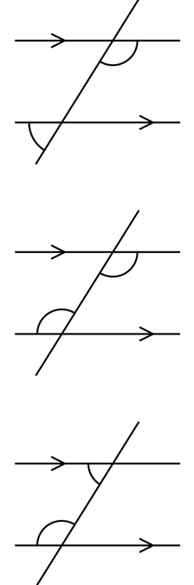  alternate | co-interior
alternate | 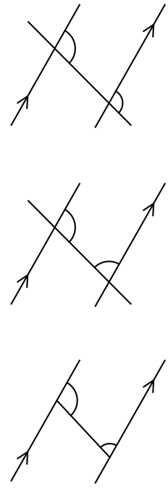  co-interior | corresponding
corresponding | co-interior | co-interior
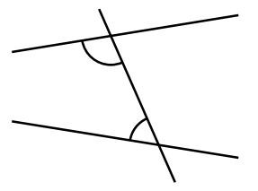  co-interior | 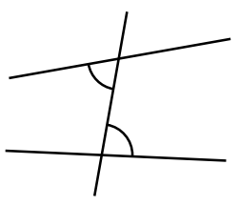  alternate | 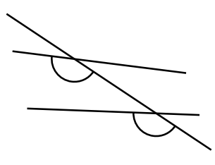  corresponding
co-interior | alternate | 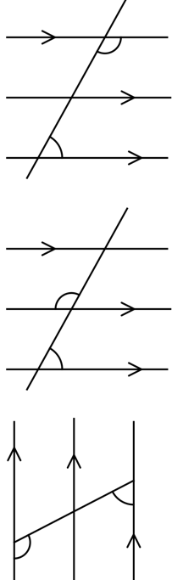  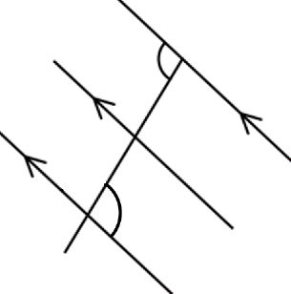  co-interior

Development
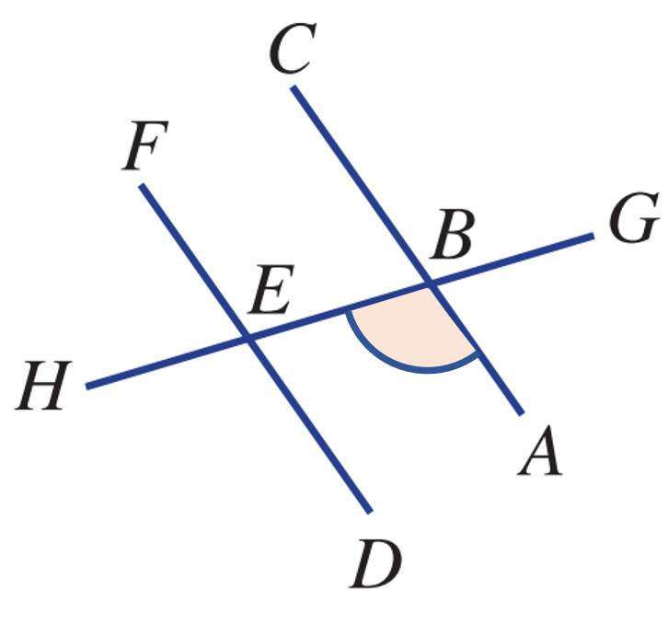
- Referring to the angle indicated, name the angle that is:
  - Vertically opposite $∠CBG$

  - Corresponding …………
$$∠HED$$
  - Alternate …………
$$∠FEB$$
  - Co-interior …………
$$∠BED$$
- Referring to the angle indicated, name the angle that is:
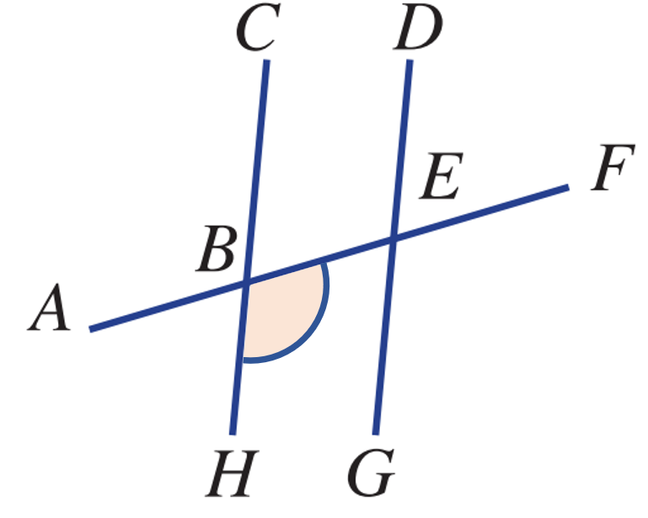
  - Vertically opposite …………
$$∠ABC$$
  - Corresponding …………
$$∠GEF$$
  - Alternate …………
$$∠DEA$$
  - Co-interior …………
$$∠GEB$$
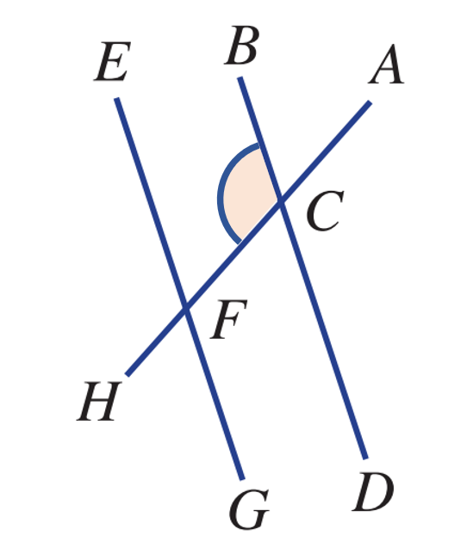
- Referring to the angle indicated, name the angle that is:
  - Vertically opposite …………
$$∠ACD$$
  - Corresponding …………
$$∠EFH$$
  - Alternate …………
$$∠GFA$$
  - Co-interior …………
$$∠EFA$$
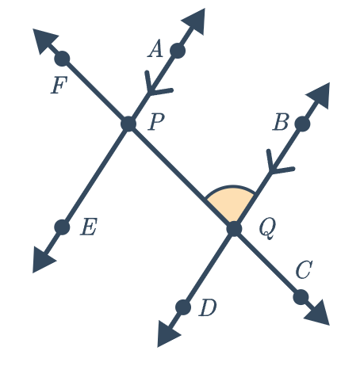
- Referring to the angle indicated, name the angle that is:
  - Vertically opposite …………
$$∠DQC$$
  - Corresponding …………
$$∠FPA$$
  - Alternate …………
$$∠EPC$$
  - Co-interior …………
$$∠APC$$
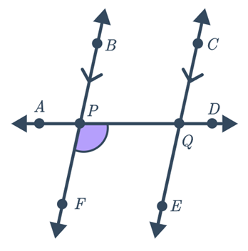
- Referring to the angle indicated, name the angle that is:
  - Vertically opposite …………
$$∠APB$$
  - Corresponding …………
$$∠EQD$$
  - Alternate …………
$$∠CQA$$
  - Co-interior …………
$$∠EQA$$

Angles on Parallel Lines

- Transversal Relationships on Parallel Lines
Corresponding angles on parallel lines are equal. | Alternate angles on parallel lines are equal. | Co-interior angles between parallel lines sum to 180°  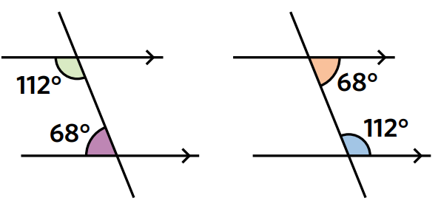  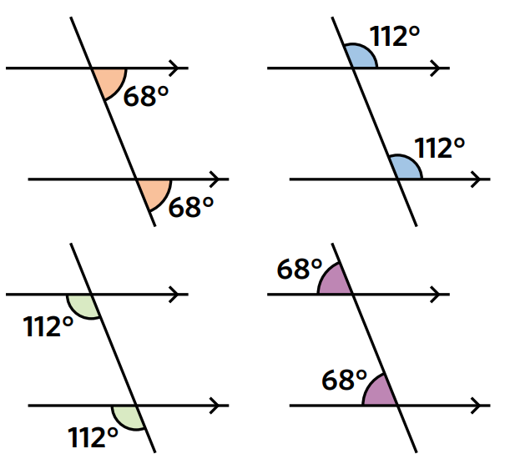  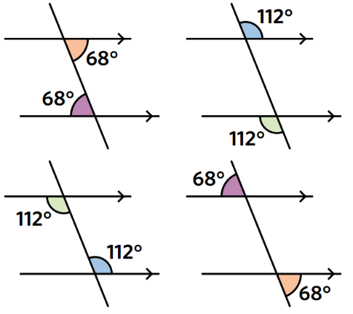

- Example Calculate angles using parallel line properties
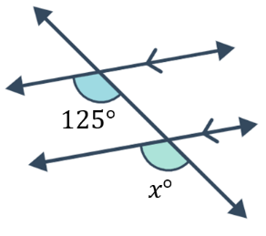  $x=125$ (corresponding angles on || lines) | 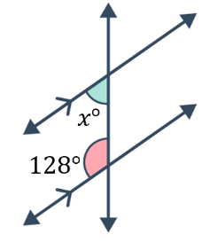  $128+x=180$ (co-interior angles in || lines)  $x=52$

- Guided Practice
Find the value of the unknown angle. Give a brief reason.
$a=80°$ (corresponding angles on || lines) | 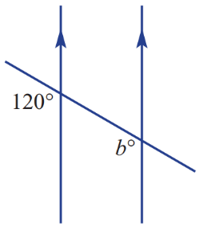  $b=120°$ (corresponding angles on || lines) | 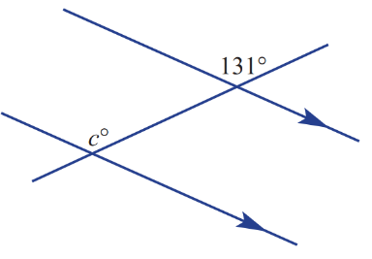  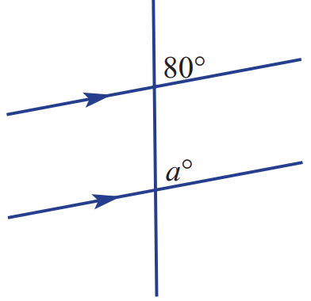  $c=131°$ (corresponding angles on || lines)
$g=100°$ (co-interior angles in || lines) | 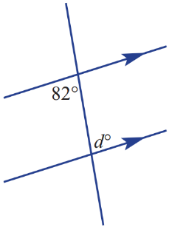  $d=82°$ (alternate angles on || lines) | 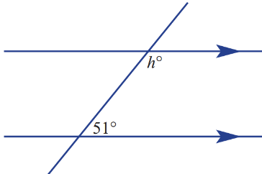  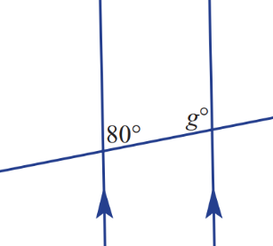  $h=129°$ (co-interior angles on || lines)
- Deciding whether Two Lines are Parallel
If corresponding angles  are not equal,  then the lines are not parallel.  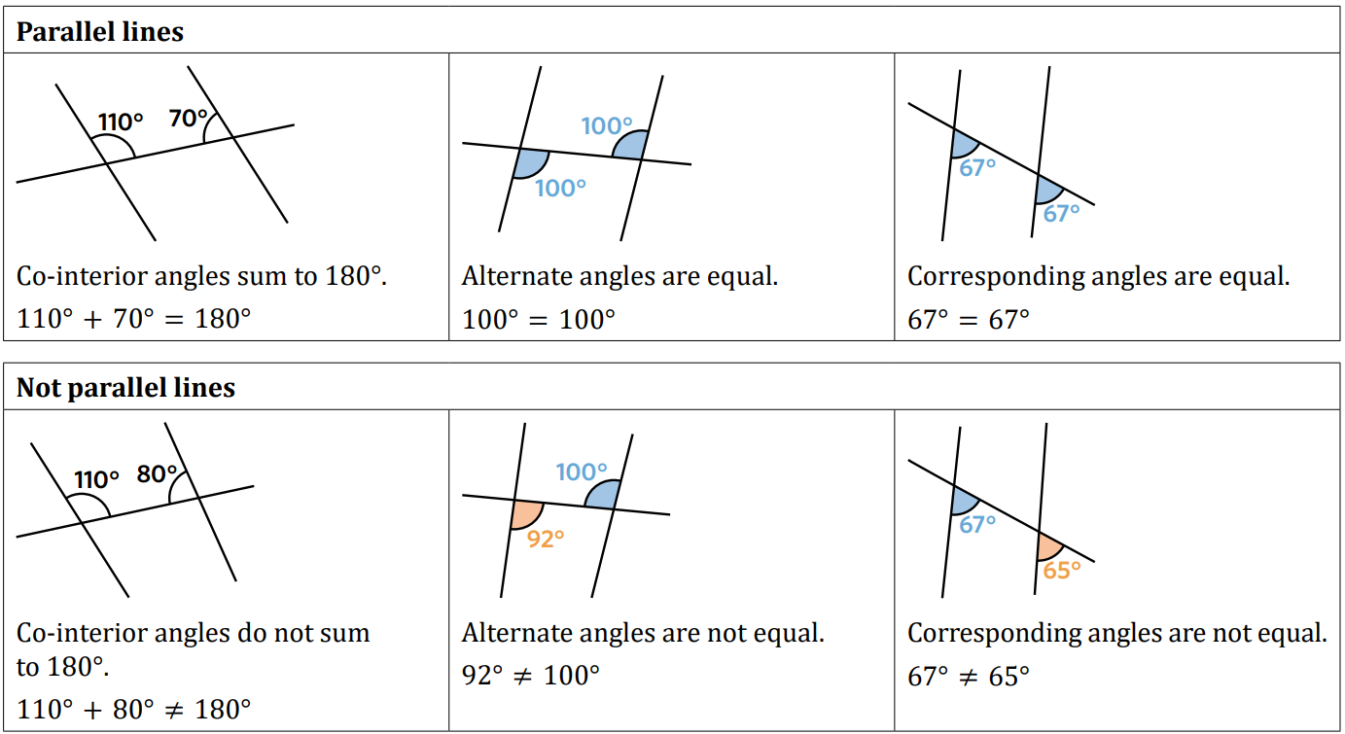 | If alternate angles  are not equal,  then the lines are not parallel. | If co-interior angles  do not sum to $180°$,  then the lines are not parallel.

- Example Determine whether two lines are parallel
Decide whether these lines are parallel.
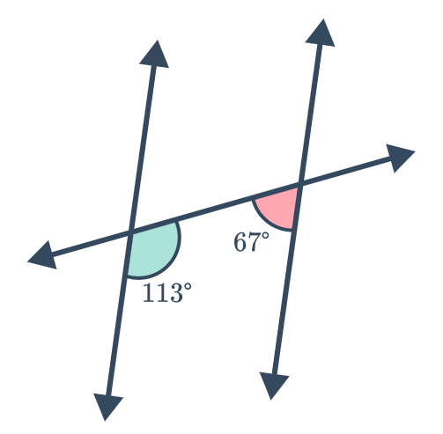  The co-interior angles sum to $180°$  Parallel. | 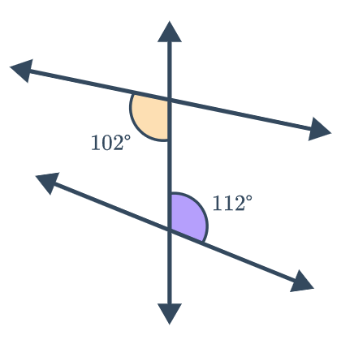  Alternate angles are  not equal.  Not parallel.

- Guided Practice
Decide whether these lines are parallel. Give a reason for your answer.
No, corresponding angles not equal. | 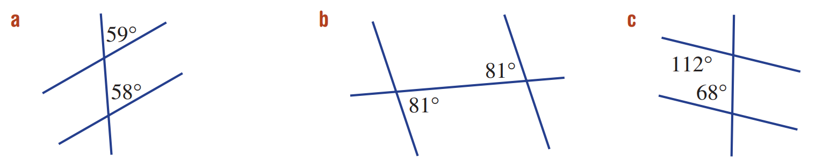  Yes, corresponding angles are equal. | Yes, co-interior angles sum to $180°$.

- Key Ideas
- Corresponding angles on parallel lines are always ……………………………
- Alternate angles on parallel lines are always ………………………
- Co-interior angles between parallel lines always ………………………………

Foundation
- Match the diagram to the reason why the lines are parallel.
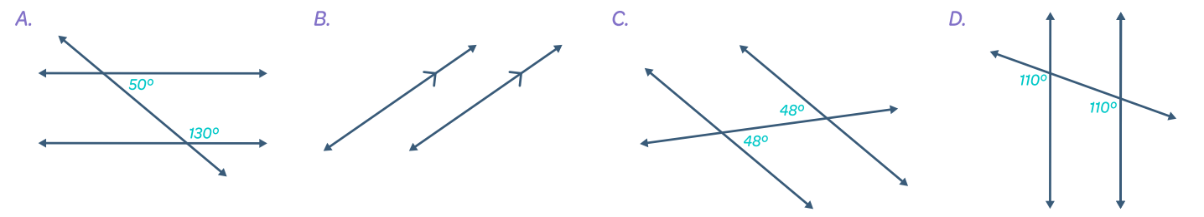

Alternate angles are equal. …………
C
Corresponding angles are equal. …………
D
Co-interior angles add to 180$°$. …………
A
The diagram shows parallel line markings. …………
B
- Complete these statements.
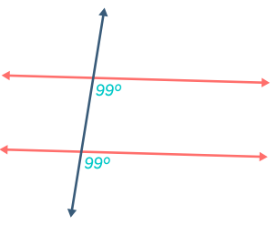
  - The alternate | corresponding | co-interior angles
are | aren’t equal, so the lines are | aren’t parallel.

The corresponding angles are equal, so the lines are parallel.
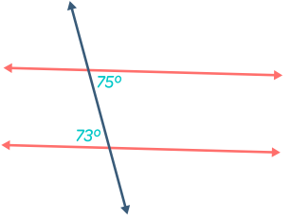
  - The ……………………………………… angles
………… equal, so the lines ………… parallel.

The alternate angles aren’t equal, so the lines aren’t parallel
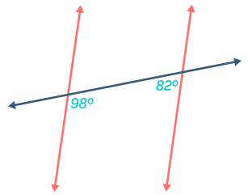
  - The ……………………………………… angles
………… add to 180, so the lines ………… parallel.

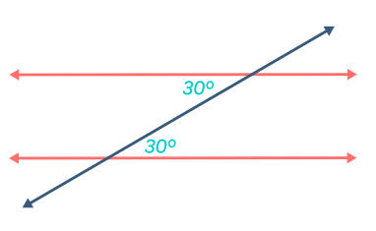
The co-interior angles don’t add to 180, so the lines aren’t parallel
  - The ……………………………………… angles
………… equal, so the lines ………… parallel.

The alternate angles aren’t equal, so the lines aren’t parallel.
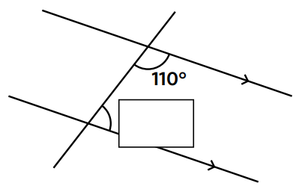
- Calculate the value of the missing angle and give a reason.
  - …………………… angles
between parallel lines sum to $180°$

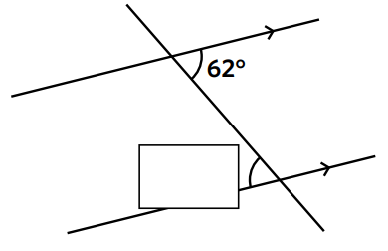
70$°$, cointerior
  - …………………… angles
between parallel lines are equal.

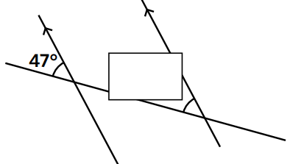
$62°$, alternate
  - …………………… angles
in parallel lines are equal.

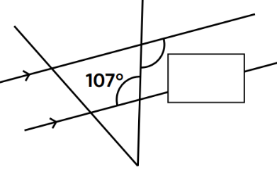
$47°$, corresponding
  - …………………… angles
between parallel lines are equal.

$107°$, alternate
- Calculate the value of the missing angle and give a reason.
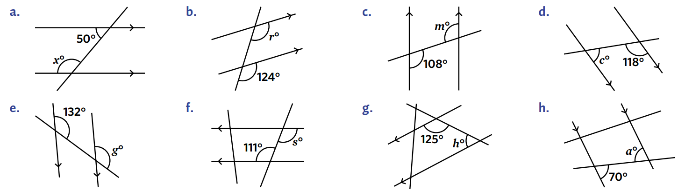  130° (co-interior angles in parallel lines) | 124° (corresponding angles on parallel lines) | 108° (corresponding angles on parallel lines)
62° (co-interior angles in parallel lines) | 132° (corresponding angles on parallel lines) | 111° (alternate angles on parallel lines)

Development
- For each diagram, calculate the value of the missing angles. Give a brief reason.
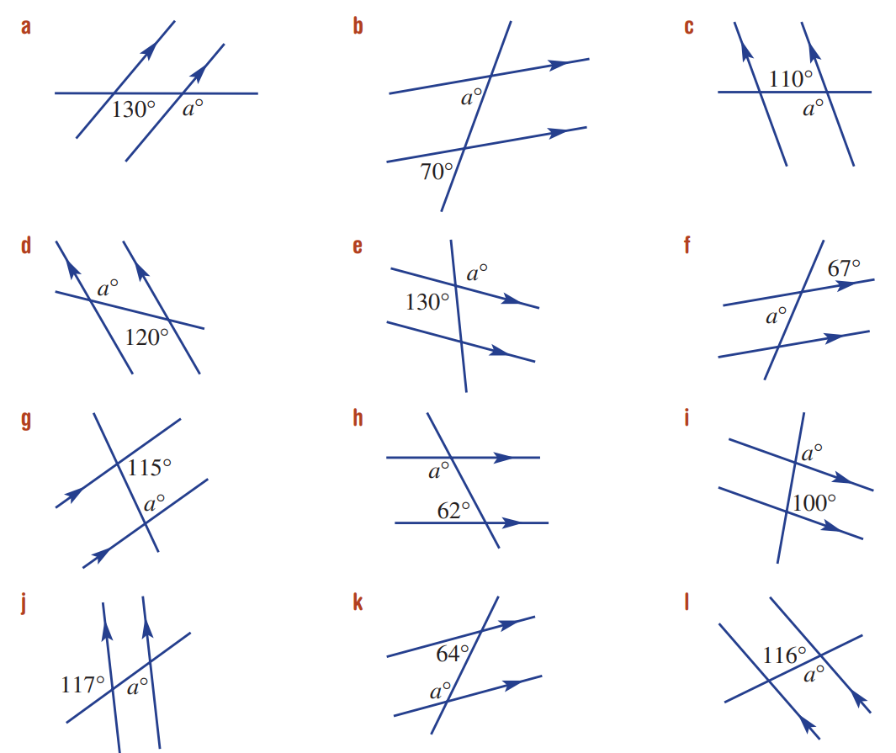  130 (corresponding angles on parallel lines) | 70 (corresponding angles on parallel lines) | 110 (alternate angles on parallel lines)
120 (alternate angles on parallel lines) | 130 (vertically opposite angles) | 67 (vertically opposite)
65 (co-interior angles between parallel lines) | 118 (co-interior angles between parallel lines) | 100 (corresponding angles on parallel lines)
117 (vertically opposite angles) | 116 (co-interior angles between parallel lines) | 116 (alternate angles on parallel lines)
- For each diagram, state whether the diagram has parallel lines.
Justify your answer using angle relationships.
Yes. Co-interior angles sum to 180° | No. Co-interior angles don’t sum to 180° | 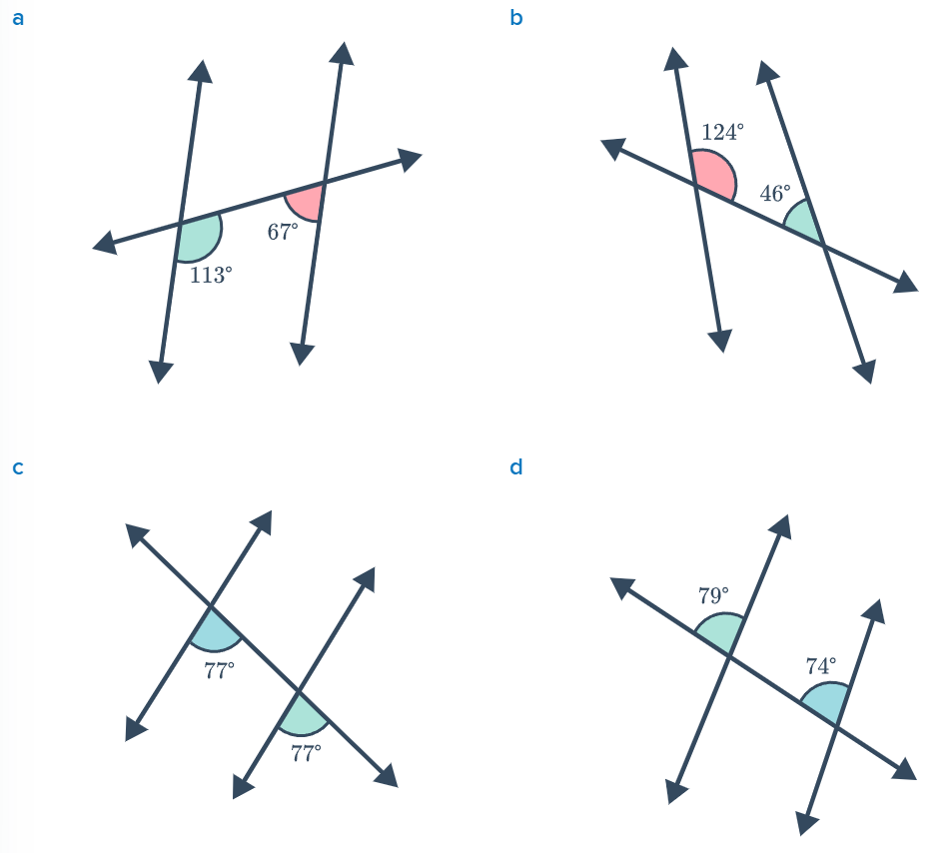  Yes. Corresponding angles are equal
No. Corresponding angles aren’t equal | 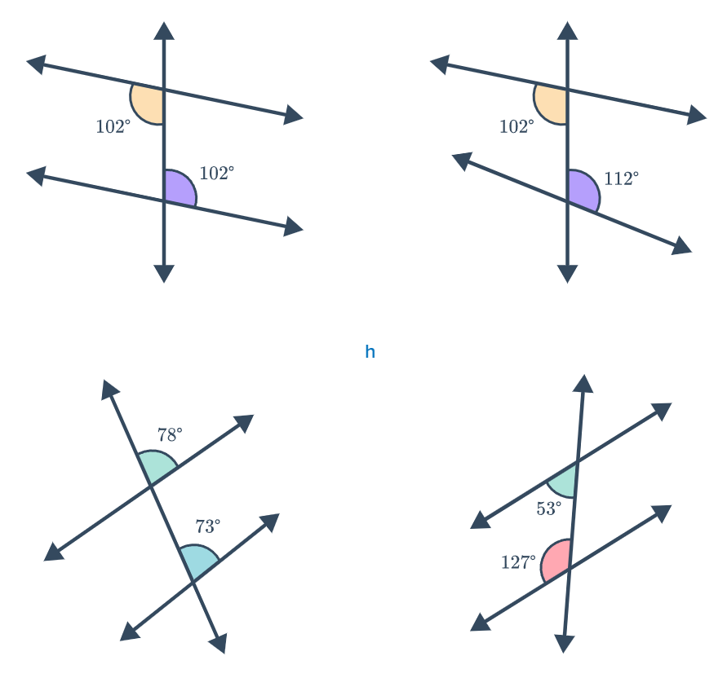  Yes. Alternate angles are equal | No. Alternate angles aren’t equal
No. Corresponding angles aren’t equal | Yes. Co-interior angles sum to 180° | 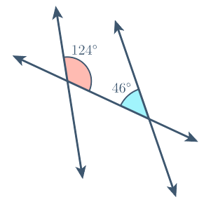  No. Co-interior angles don’t sum to 180°

Mastery
- Calculate the value of each unknown angle in the diagram. You do not need to show reasoning.
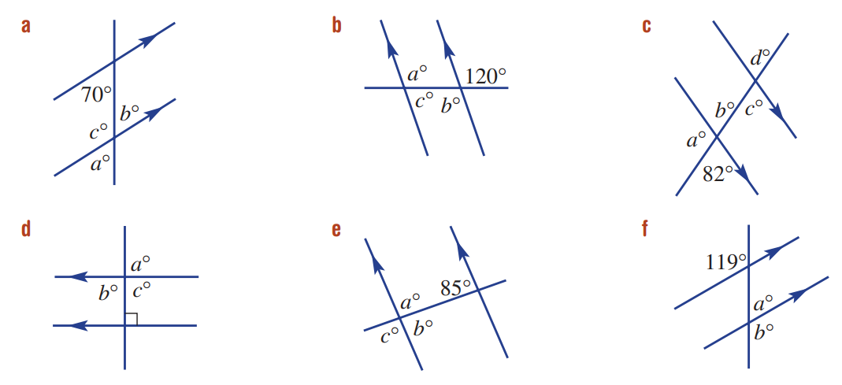  $$a=70$$  $$c=110$$  $$b=70$$ | $$a=120$$  $$b=120$$  $$c=60$$ | $$a=98$$  $$b=82$$  $$c=82$$  $$d=82$$
$$a=90$$  $$b=90$$  $$c=90$$ | $$a=95$$  $$b=85$$  $$c=95$$ | $$b=119$$  $$a=61$$
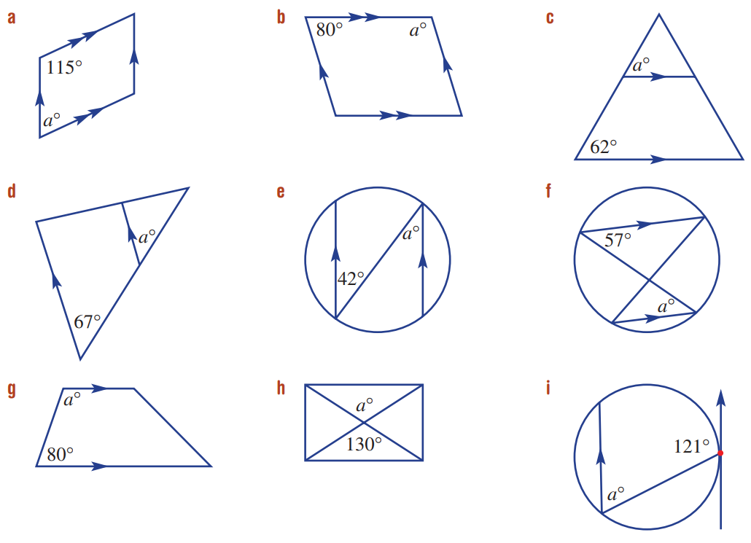  $$a=65$$ | $$a=100$$ | $$a=62$$
$$a=42$$ | $$a=130$$ | $$a=57$$

Problem-Solving involving Angles

Foundation
- Calculate the values of the unknown angles in alphabetical order. Give a brief reason.
$a=65$ (corresponding $∠$ on || lines)  $b=115$ (angles on a straight line) | $a=106$ (angles on a straight line)  $b=106$ (corresponding) | 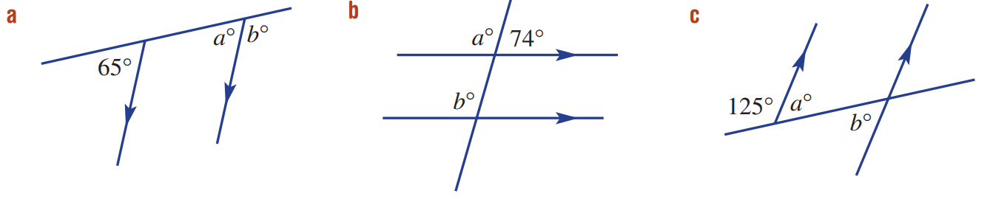  $a=55$ (angles on a straight line)  $b=55$ (alternate $∠$ on || lines)
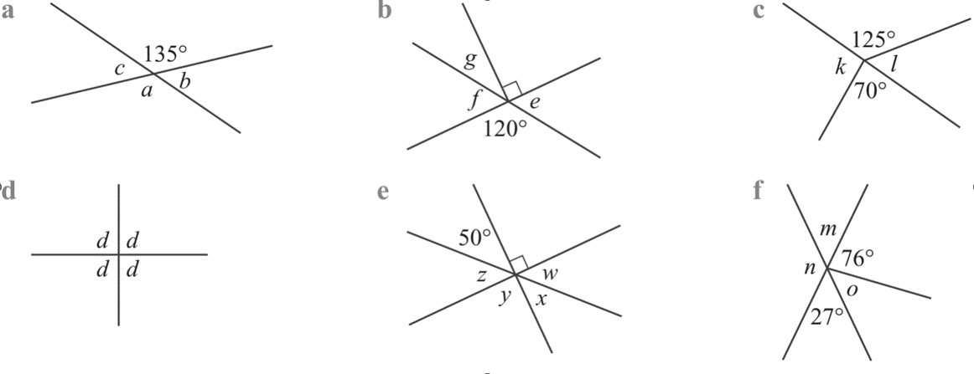  $e=60$ (angles on a straight line)  $f=60$ (vertically opposite)  $g=30$ (angles in a right-angle) | $m=27$ (vertically opposite)  $n=153$ (angles on a straight line)  $o=77$ (angles on a straight line) | $x=50$ (vertically opposite)  $z=40$ (angles on a straight line)  $w=40$ (vertically opposite)  $y=90$ (vertically opposite)
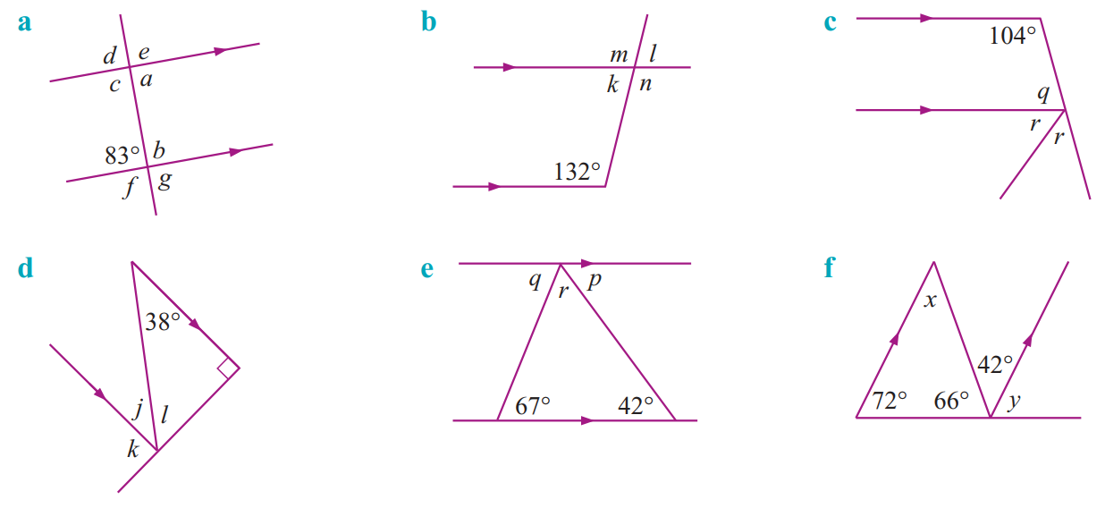  $a=83$ (alternate $∠$on || lines)  $b=97$ (angles on a straight line)  $c=97$ (alternate to $b$)  $d=83$ (corresponding $∠$ on || lines)  $e=97$ (vertically opposite to $c$)  $f=97$ (vertically opposite to $b$)  $g=83$ (vertically opposite) | $k=48$ (co-interior $∠$ between || lines)  $l=48$ (vertically opposite to $k$)  $m=132$ (corresponding $∠$ on || lines)  $n=132$ (vertically opposite to $m$) | $j=38$ (alternate $∠$on || lines)  $l=52$ (angles on a straight line)  $k=90$ (corresponding $∠$ on || lines)
$q=76$ (co-interior $∠$ between || lines)  $2r=104$ (corresponding $∠$ on || lines)  $$r=52$$ | $q=67$ (alternate $∠$on || lines)  $p=42$ (alternate $∠$on || lines)  $r=71$ (angles on a straight line) | $x=42$ (alternate $∠$on || lines)  $y=72$ (angles on a straight line)

Development
- Find the value of the pronumerals. You do not need to give reasoning.
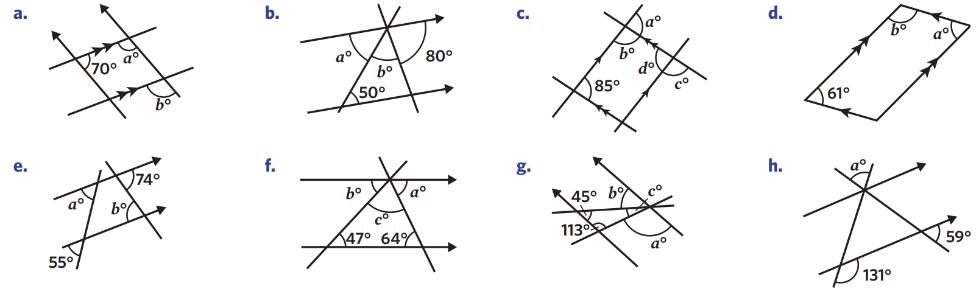  $$a=110$$  $$b=110$$ | $$a=50$$  $$b=50$$ | $$b=95$$  $$a=85$$  $$d=85$$  $$c=95$$
$$a=55$$  $$b=74$$ | $$b=47$$  $$a=64$$  $$c=69$$ | $$a=113$$  $$b=45$$  $$c=22$$
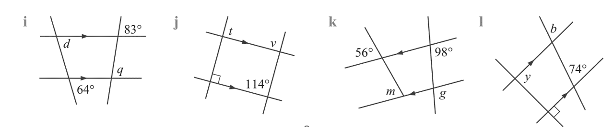  $$q=83$$  $$d=64$$ | $$v=114$$  $$t=90$$ | $$b=74$$  $$y=90$$
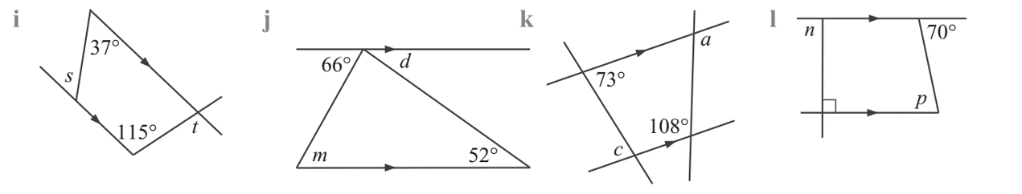  $$s=37$$  $$t=115$$ | $$m=66$$  $$d=52$$ | $$p=70$$  $$n=90$$
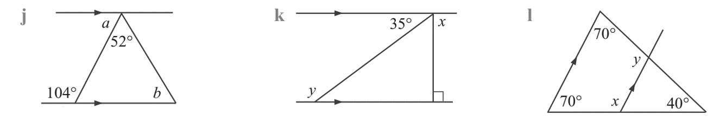  $$a=76$$  $$b=52$$ | $$x=90$$  $$y=145$$ | $$y=110$$  $$x=110$$
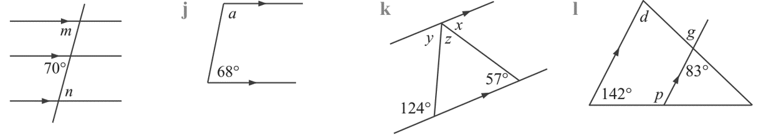  $$m=70$$  $$n=70$$ | $$a=112$$ | $$x=57$$  $$y=56$$  $$z=67$$
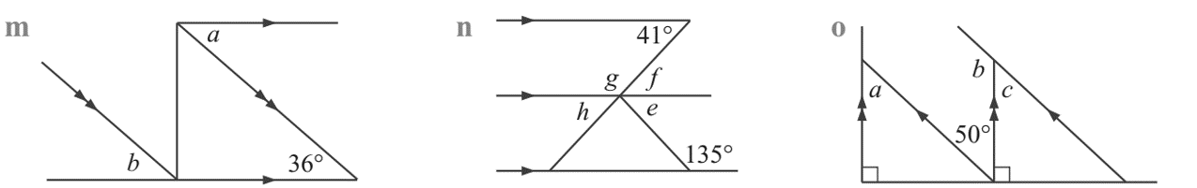  $$a=36$$  $$b=36$$ | $$f=41$$  $$g=139$$  $$h=41$$  $$e=45$$ | $$a=50$$  $$b=130$$  $$c=50$$
$$x=50$$ | $$x=112$$ | 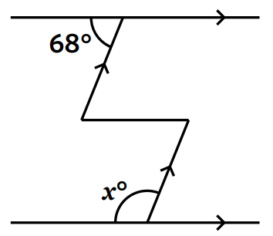  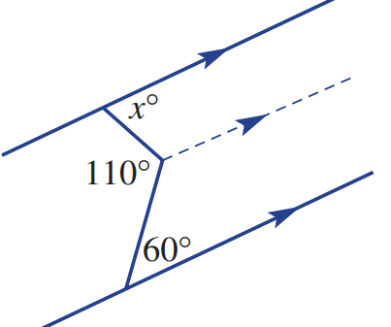  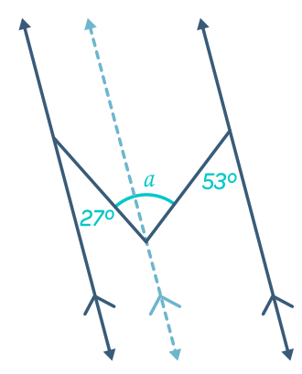  $$a=80$$

Mastery
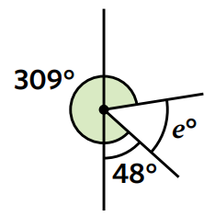
- Find the value of $e$. Notice that $309°$ and $48°$ are overlapping.

$$e=180-48-81=51$$
- Find these angles (hint: construct a parallel line)
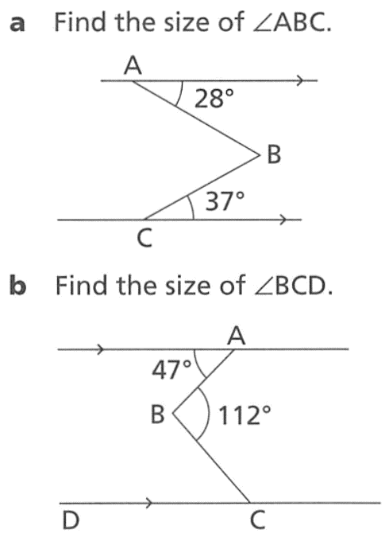  65° | 65° | 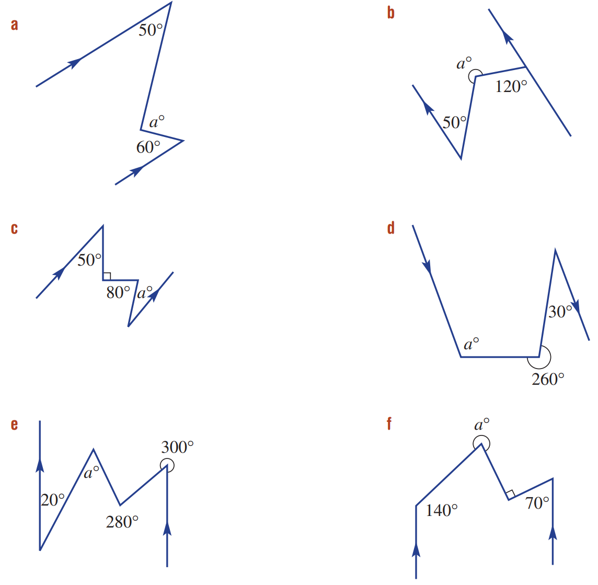  110°
250° | 40° | 110°
40° | 300°

Writing Formal Reasoning

- Example Solve geometry problems and write formal reasoning
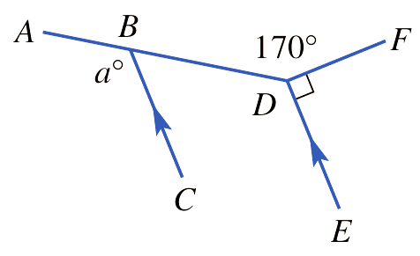
$∠BDE+170+90=360$ (angles at a point)
$∠BDE+260=360$
$∠BDE=100$

$a=100$ (corresponding angles on || lines)

- Guided Practice
Find the value of angle $a°$
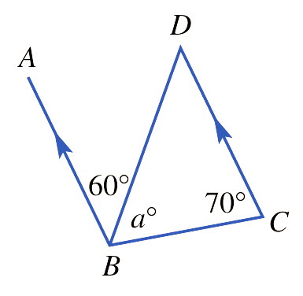

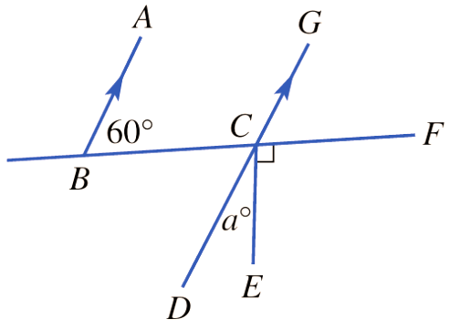

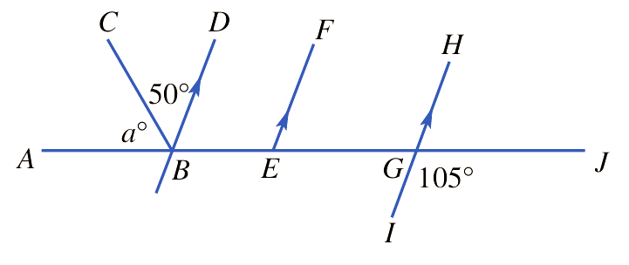

Foundation
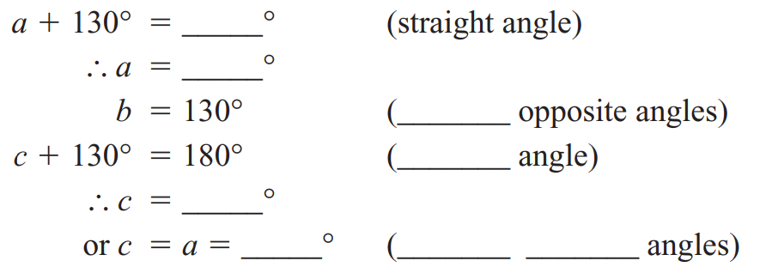
- Complete the following to calculate $a$, $b$, $c$.
If you have a choice of reasons, use them to check your answers.
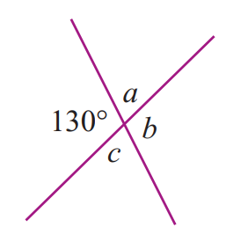

180 | 50 | vertically | straight | 50 | 50 | vertically opposite
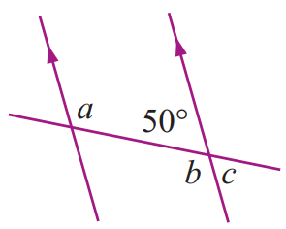
- Complete the following to calculate $a$, $b$, $c$.
If you have a choice of reasons, use them to check your answers.
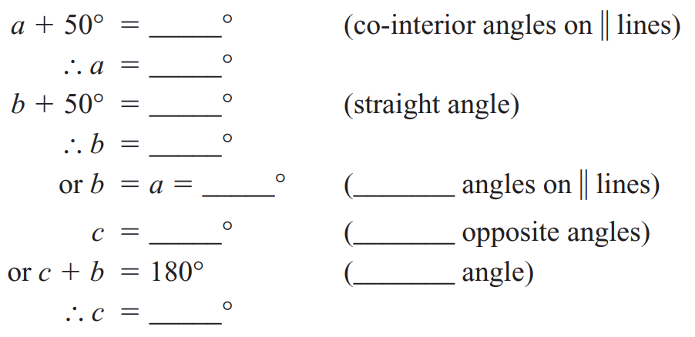

180 | 130 | 180 | 130 | 130 | alternate | 50 | vertically | straight | 50
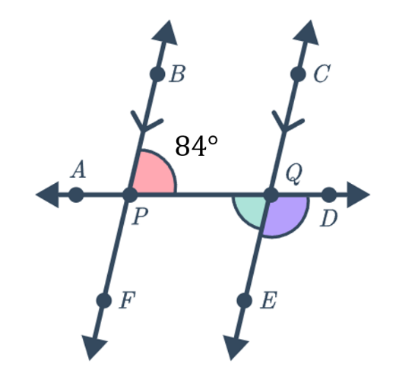
- Calculate $∠AQE$ and $∠DQE$giving full reasoning.
$∠AQE=$ ………$°$ (……………… angles on || lines)
$∠DQE+$ ………$°=180°$ (angles on a ……………… line)
$∴∠DQE=$ ………$°$

$∠AQE=84°$ (alternate angles on || lines)
$∠DQE+AQE=180°$ (angles on a straight line)
$$∴∠DQE=180-84=96°$$
- Calculate $∠CPE$ and $∠PQD$ giving full reasoning.
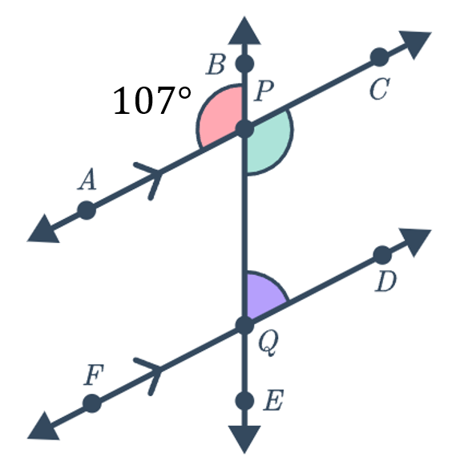

$∠CPE=107°$ (vertically opposite)
$∠PQD=73°$ (co-interior angles between parallel lines)

Development
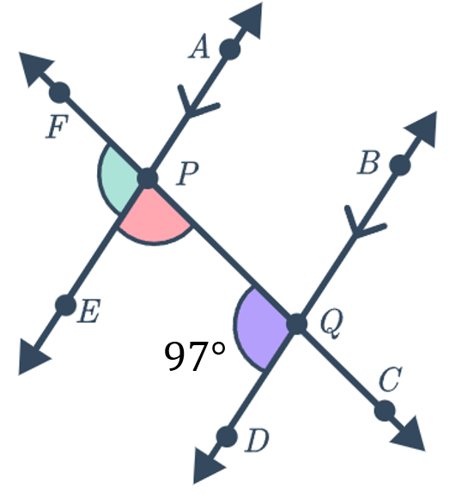
- Calculate $∠EPQ$ and $∠EPF$ giving full reasoning.

$∠EPQ=83°$ (co-interior angles between parallel lines)
$∠FPE=97°$ (corresponding angles on parallel lines)
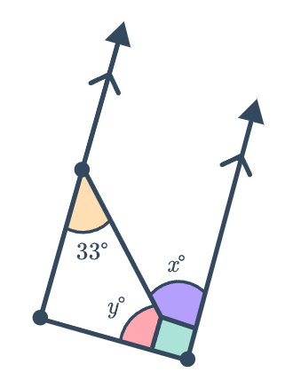
- Calculate $x$ and $y$ giving full reasoning.

$x=33°$ (alternate angles on parallel lines)
$y=57°$ (angles in a right-angle)
- Calculate $∠FPE$ giving full reasoning.
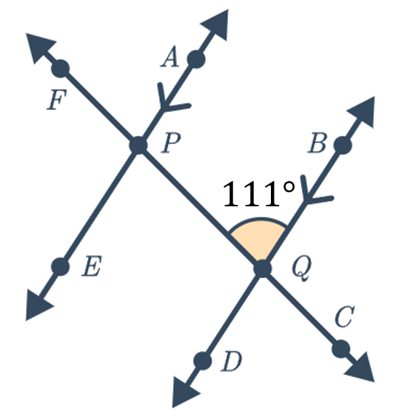

$∠EPQ=111°$ (alternate angles on parallel lines)
$∠FPE=69°$ (angles on a straight line)
- Calculate as many angles as you can in these diagrams. You do not need to show reasoning.
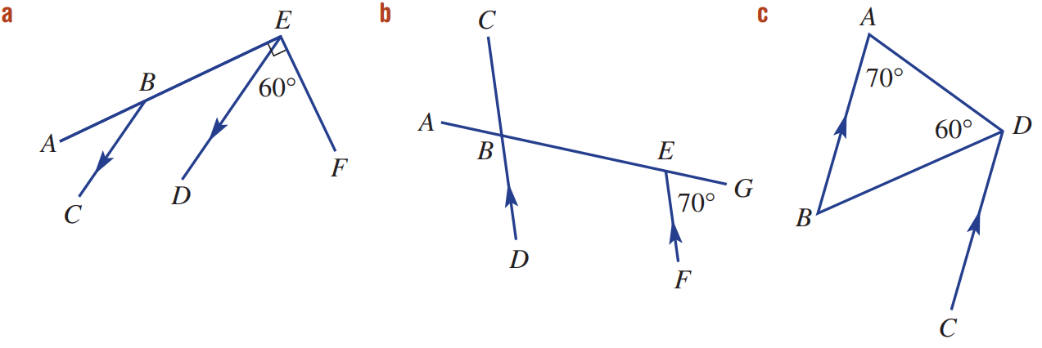

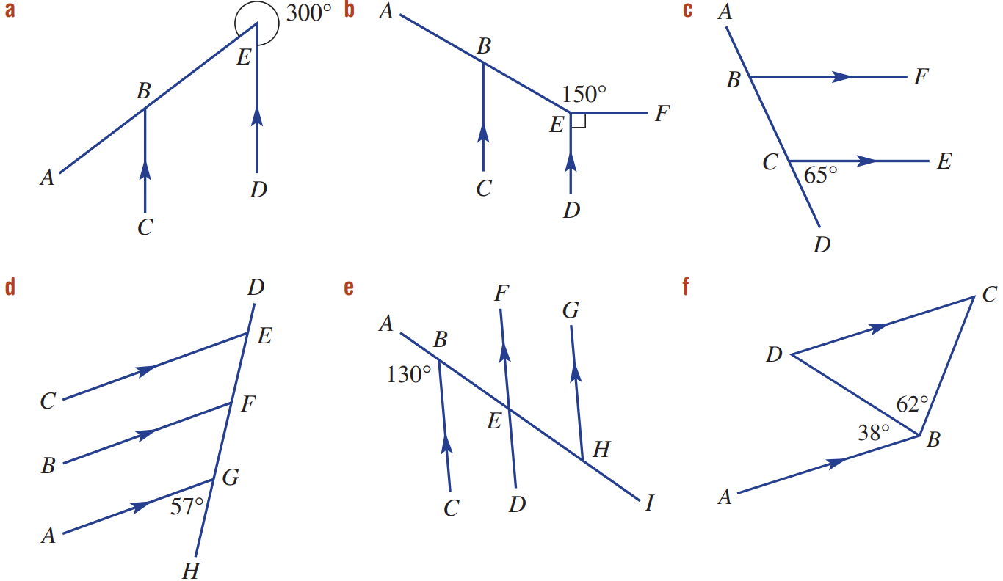

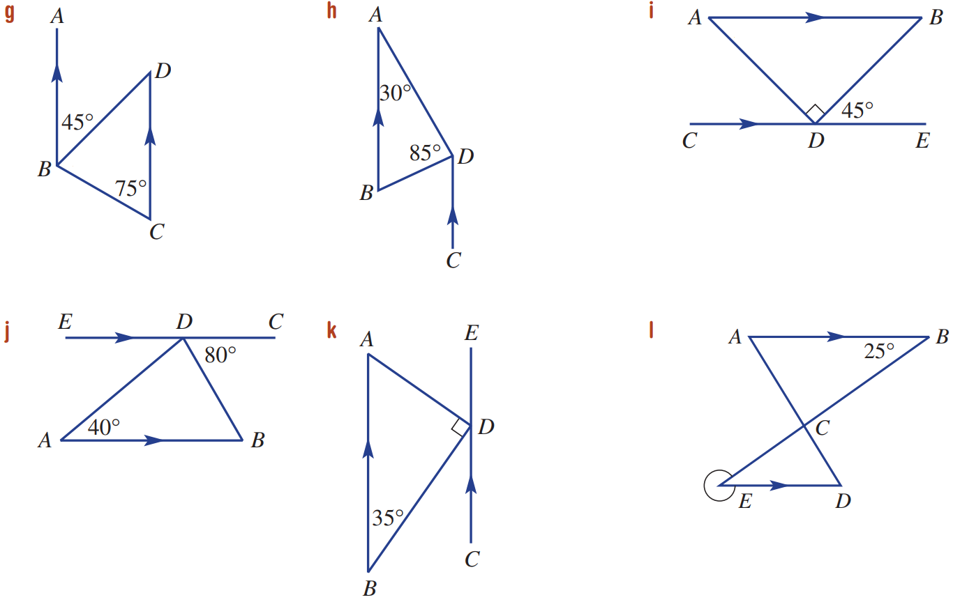

Mastery
- For these questions, you will need to construct a parallel line. Give full reasoning.
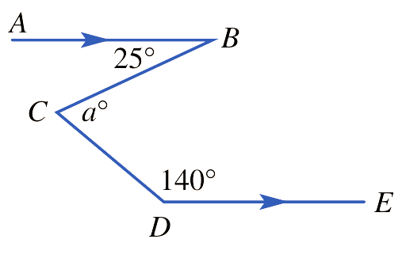
  - Construct $CF$ parallel to $AB$ and $DE$
$$F$$
$∠BCF=$ …… $°$ (alternate angles on || lines)
$∠FCD+140=180°$ (co-interior angles in || lines)
$∠FCD=$ ………
$∴a=$ …… $+$ ……
$=$ …………
$25°$ | $40°$ | $25°+40°$ | $a=65°$
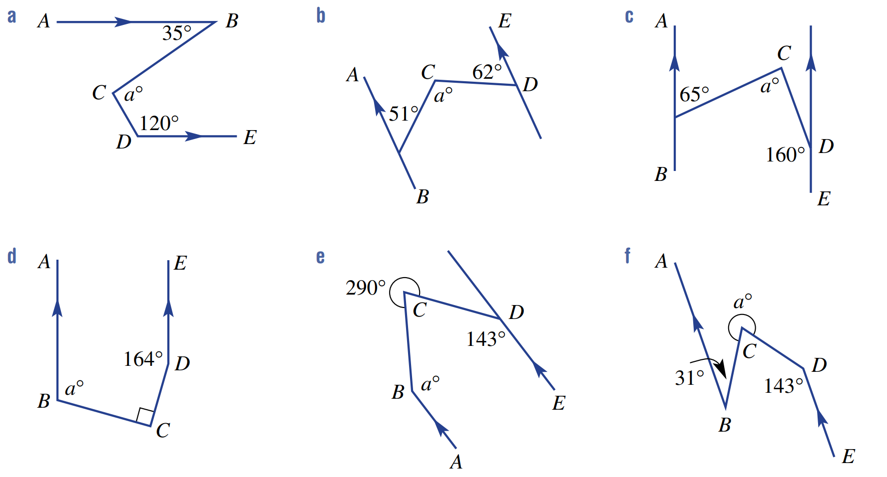

construct CF parallel to AB and DE
$∠BCF=35°$ (alternate angles on || lines)
$∠FCD=60°$ (co-interior angles in || lines)
$$a=35+60=95°$$
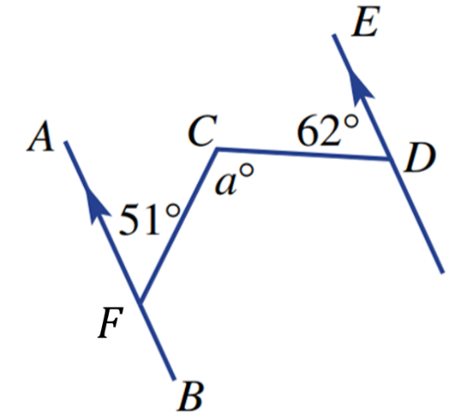

construct CG parallel to AB and DE
$∠GCF=51°$ (alternate angles on || lines)
$∠GCD=62°$ (alternate angles on || lines)
$$a=51+62=113°$$

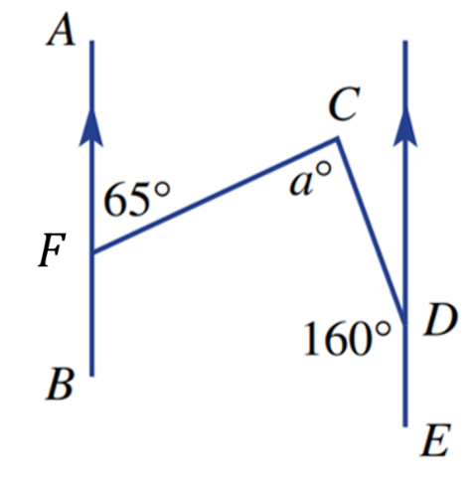

Construct CG parallel to AB and DE
$∠GCF=65°$ (alternate angles on || lines)
$∠GCD=20°$ (co-interior angles in || lines)
$$a=65+20=85°$$

Construct CF parallel to AB and ED
$∠DCF=16°$ (co-interior angles in || lines)
$∠BCF=74°$ (angles in a right angle)
$a=106°$ (co-interior angles in || lines)

Construct CF parallel to AB and DE
$∠DCF=37°$ (co-interior angles in || lines)
$∠BCF=33°$ (angles at a point)
$a=147°$ (co-interior angles in || lines)

Geometry Problems involving Equations

Foundation
- Use angle facts to form an equation for each diagram.
Then solve your equations to find the value of each letter.
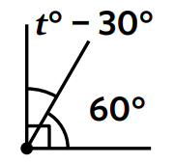  $t-30+60=90$  $t+$ …… $=90$  $t=$ ……  $$t=60°$$ |  | 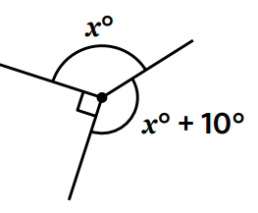  $x+x+10+90=$ ……  $$x=130°$$
$$a=12.5°$$ | $$b=28°$$ |  | 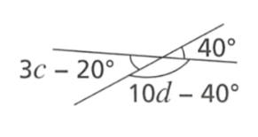  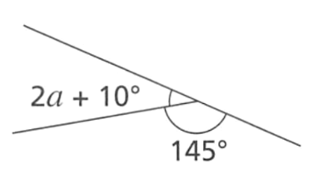  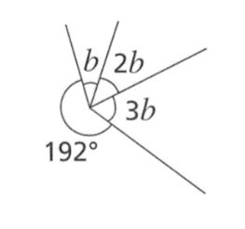  $$c=20°$$  $$d=18°$$
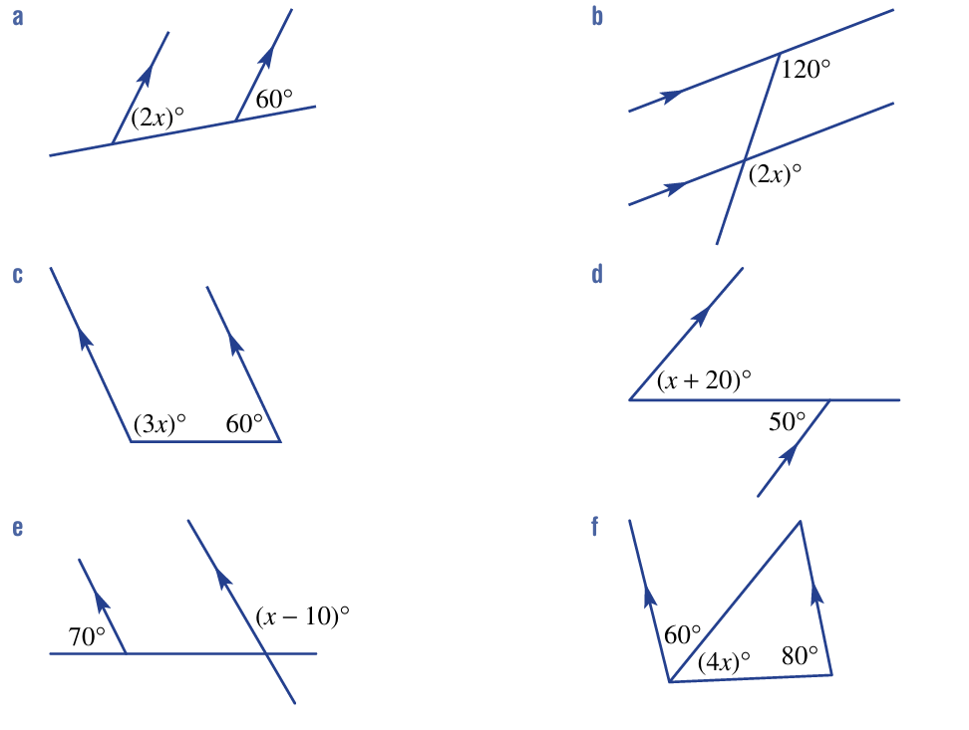  $$x=30$$ | $$x=60$$ |  | $$x=40$$
$$x=30$$ | $$x=120$$ |  | $$x=10$$

Development
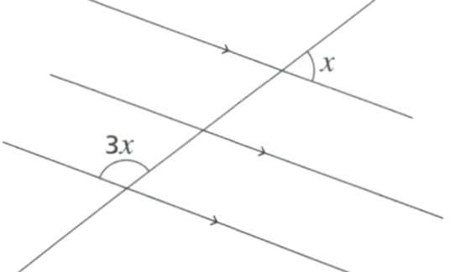
- Work out the value of $x$.

$$x=45°$$
- Work out value of $x$ in these diagrams.
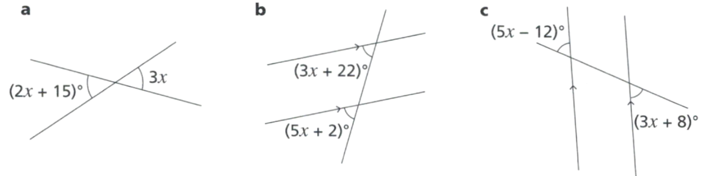  $$x=15°$$ | $$x=10°$$ | $$x=10°$$

- Determine the value of each pronumeral.
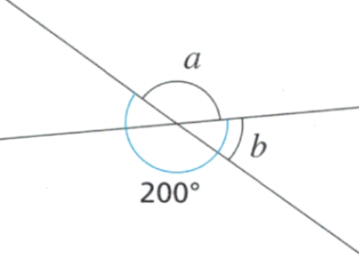  $$a=160°$$  $$b=20°$$ | 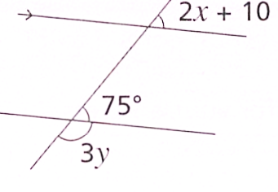  $$x=32.5°$$  $$y=35°$$
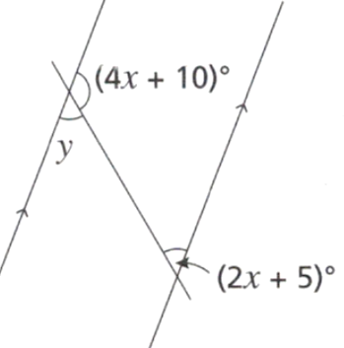  $$x=27.5°$$  $$y=60°$$ | 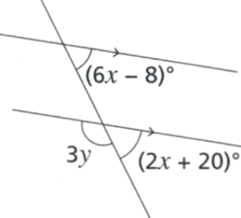  $$x=7°$$  $$y=48\frac{2}{3}°$$
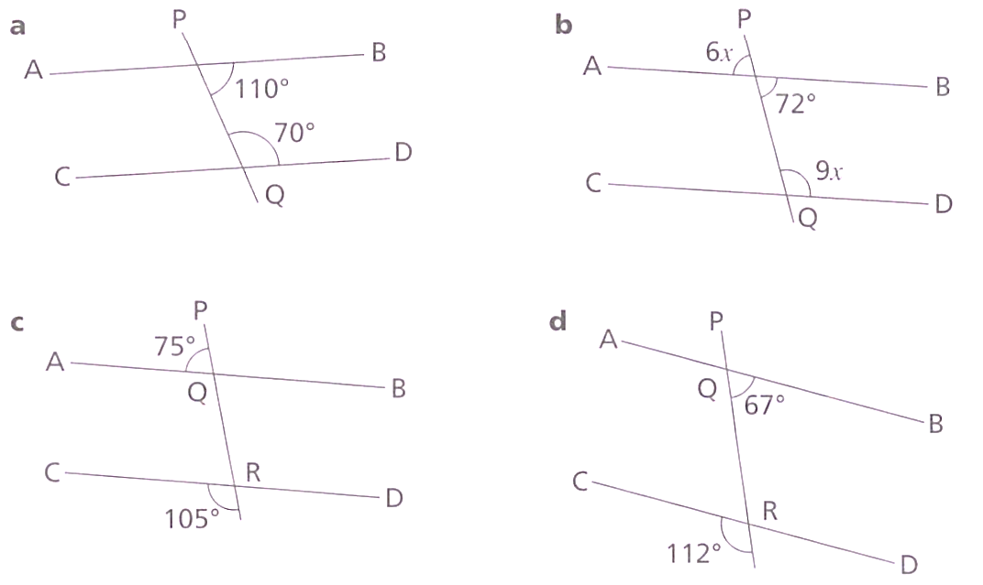
- In each case, decide if AB is parallel to CD. Give a reason why or why not.
Yes, co-interior angles sum to 180. | $∠PRD=112°$ (vertically opposite)  $∴$ no, as co-interior angles don’t sum to 180
$∠AQR=105°$ (angles on a straight line)  $∴$ yes as corresponding angles are equal. | $$6x=72$$  $$x=12$$  $$∠PQD=9x=108°$$  $∴$ yes as co-interior angles sum to 180

- Work out the value of the pronumerals in each of these diagrams.
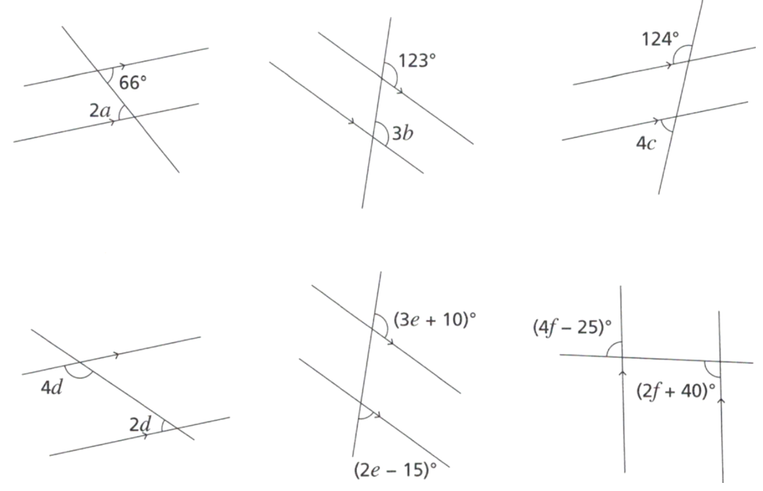  $$a=33°$$ | $$b=41°$$ | $$c=31°$$
$$d=30°$$ | $$e=37$$ | $$f=27.5°$$

Mastery
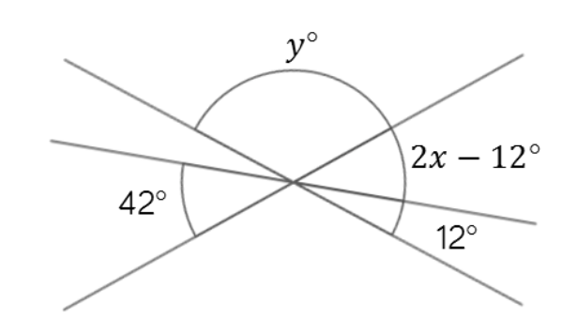
- Calculate the values of $x$ and $y$.

$$x=32$$
$$y=116°$$
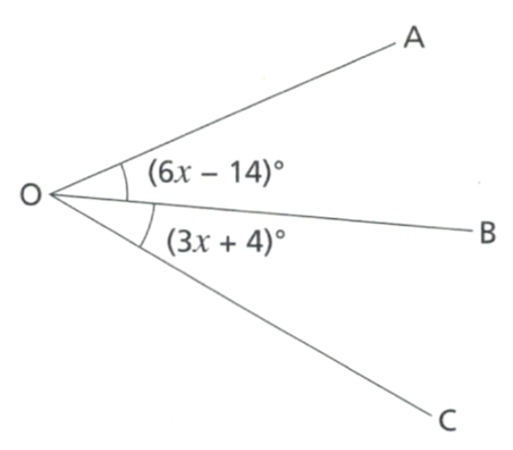
- OB is the bisector of $∠AOC$. (in other words, OB splits $∠AOC$ into equal halves).
Work out the size of $∠AOC$

$$∠AOC=44°$$

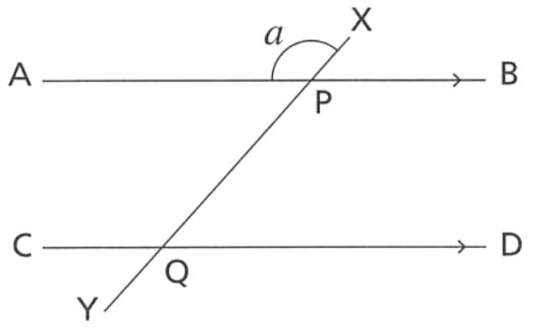
- Consider the diagram below.

  - Prove that $∠CQY=180°-a$

$∠CPX=a$ (corresponding angles on || lines)
$∠CQY=180°-a$ (angles on a straight line)
  - Prove that $∠DQY=a$

$$∠CQY+∠DQY=180°$$
$$180°-a+∠DQY=180°$$
$$∴∠DQY=a$$

Challenge Exercise
- Determine the angle between the minute hand and hour hand at:
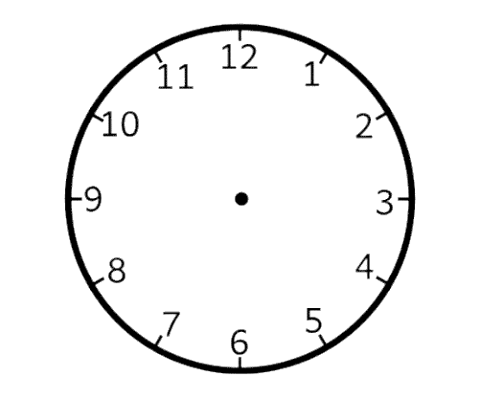
  - 6:00 pm
180°
  - 11:00 pm
30°
  - 4:00 am
120°
  - 3:30 pm
75°

- How many degrees does the hour hand of a clock turn in:
- 12 hours?  360$°$ | - 24 hours?  $$720°$$ | - 6 hours?  $$180°$$
- 1 hour?  $$30°$$ | - 30 minutes?  $$15°$$ | - 1 minute?  $$0.5°$$

- Suppose A, B and C are three points on a line, in that order. If ∠ABX = 40°, then find ∠CBX.

∠ABX + ∠CBX = 180° (angles on straight line ABC)
40° + ∠CBX = 180°
∠CBX = 140°

- Lines AB and CD intersect at O. If ∠AOD = 60°, then find ∠BOC.

∠BOC = ∠AOD = 60°
(vertically opposite angles)

- Suppose ∠ABC is obtuse. What type of angle is ∠DEF, given that ∠ABC = 2∠DEF?

$$∠ABC is obtuse, so 90° < ∠ABC < 180°$$
$$∠ABC = 2∠DEF$$
$$∴ ∠DEF =\frac{∠ABC}{2}$$
$$45° < ∠DEF < 90°$$
$$∠DEF is acute$$
- Determine the missing angle in each diagram in terms of $x$ or $y$.
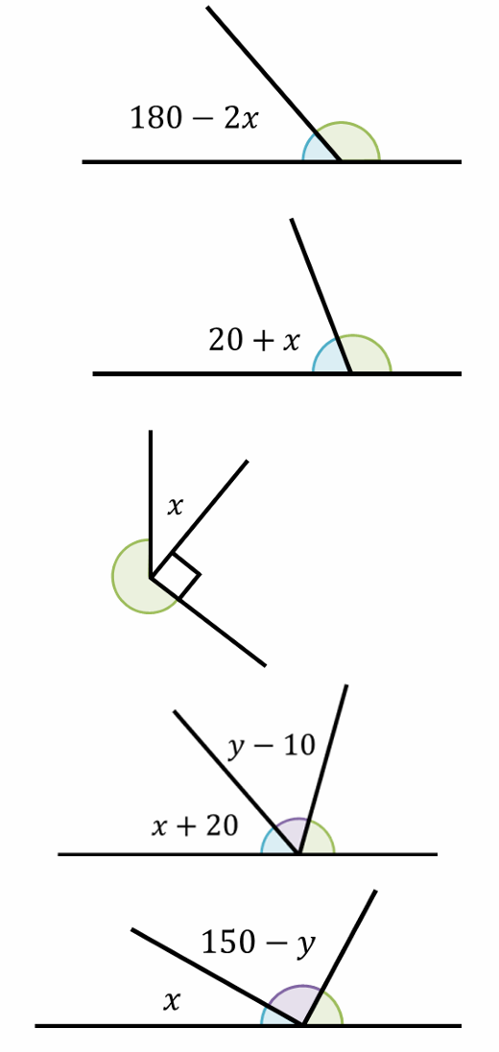  $$2x$$ | $$160-x$$ | $$270-x$$
$$170-x-y$$ | $$30-x+y$$

- Suppose ∠ABC is obtuse. What type of angle is ∠DEF, given that ∠DEF = 2∠ABC?

$$∠ABC is obtuse, so 90° < ∠ABC < 180°$$
$$∠DEF = 2∠ABC$$
$$∴ 180° < ∠DEF < 360°$$
$$∠DEF is reflex$$
- Calculate the unknown angle.
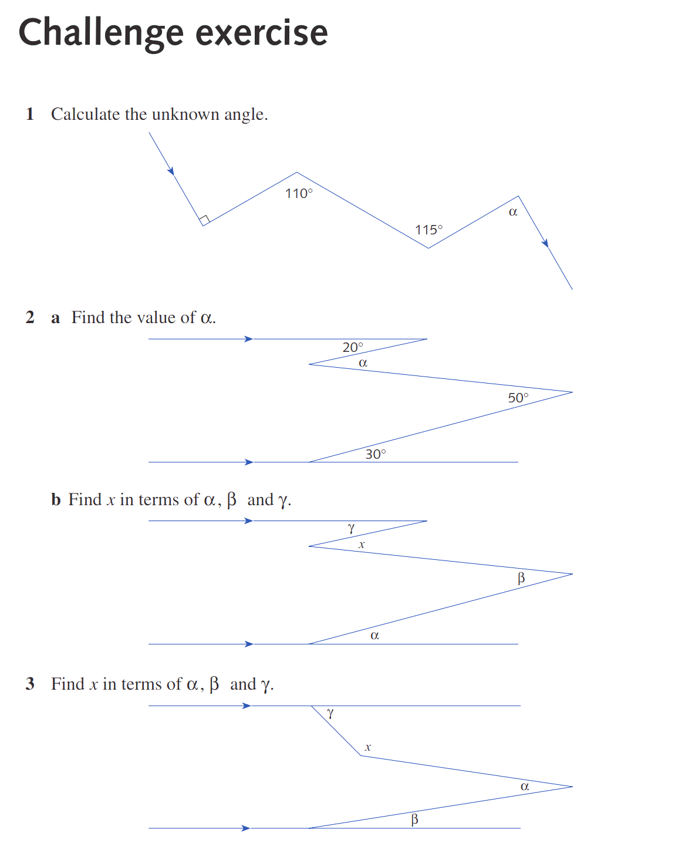

95°

  - Find the value of $α$.

40°
- Determine the angle between the hour hand and minute hand of a clock at
- 10:10 am  115° | - 4:45 am  127.5° | - 7:15 am  127.5° | - 2:35 p.m  132.5°

- Benji thinks that the angle between the hands of a clock at 6:30 pm is 0°.
Explain why Benji is wrong and find the correct angle.
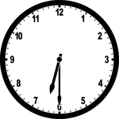

The hour hand is not at 6 when it is 6:30.
The two hands are 1/24th of a revolution apart, so $\frac{360}{24}$ $=15°$

- You are a mouse. How many mini-cheeses will fit into this container?
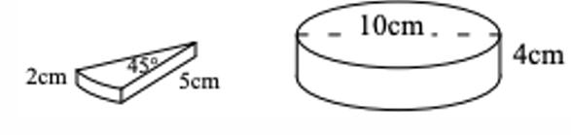

Each layer has $360°÷45°=8$ cheeses
2 layers of 8, so 16 mini cheeses

- This regular 12-sided shape has a number at each vertex.
Ben turns the pointer from zero, clockwise through 150°.
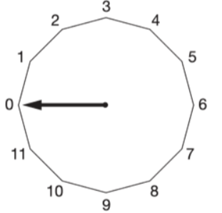
Which number will the pointer now be at?

Each section is $360°÷12=30°$
$150°÷30°=5$, so number 5.
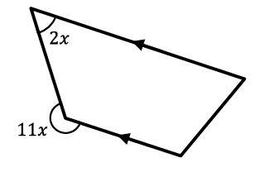
- Find the value of $x$.
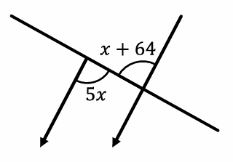  $$5x=x+64$$  $$4x=64$$  $$x=16$$ | $$2x+\left(360-11x\right)=180°$$  $$-9x=-180°$$  $$x=20°$$

- In the figure below, $∠AOC=50°$, $∠BOD=50°$ and $∠AOD=80°$.
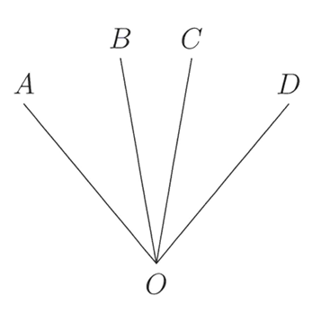
Find $∠BOC$.

$$∠AOC+∠BOC=100°$$
But $∠AOD=80°$
So the overlap must be 20°

$$x=γ+β-α$$
- Find $x$ in terms of $α, β$ and $γ$.

$$x=180°-γ+α-β$$

- $AB$ is parallel to $CD$ and $PQRS$ is a transversal.
If $y=3x$, find the size of all angles, giving reasons.
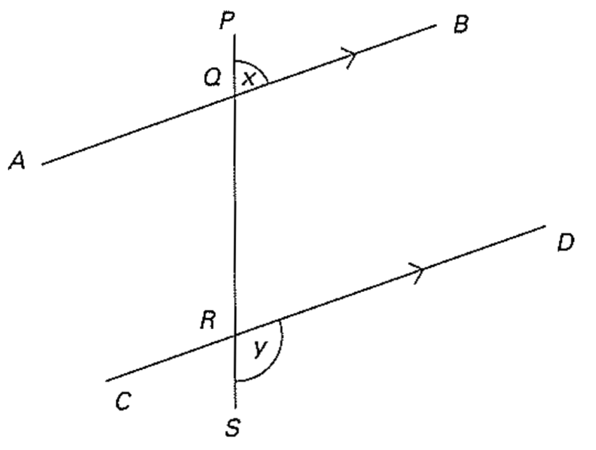

$∠PQB = ∠QRD = x$ (alternate angles since AB//CD)
$∠QRD + ∠DRS = 180$ (angle sum on straight line QRS)
$$x + 3x = 180$$
$$x = 45 and 3x = 135$$
So all angles are either 45° or 135°

- The angle between the two hands of a clock at 9:35 a.m. is $77.5°$
Explain why. (hint: how much does the hour hand move in 5 minutes?)
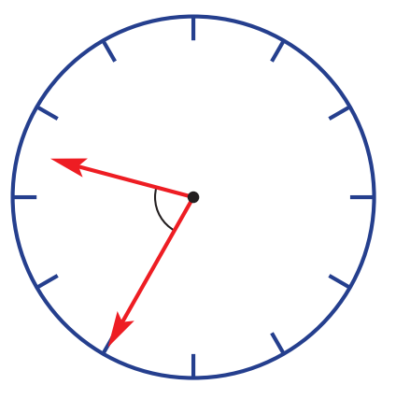

Minute hand is at position (180 + 30) = 210°
Hour hand is at position (270 + 35 $×$ 0.5) = 287.5°
The difference between the two hands is 77.5°

- What is the obtuse angle between the hands of a clock at 6 minutes past 8 o’clock?

At 8, the angle between the hands is 120°
In the following 6 minutes, the minute hand turns 36° while the hour hand turns through an angle of 3° in the same direction.
So the obtuse angle between the hands increases by 33°

So all angles are either 45° or 135°

  - Prove that $α+β+γ=180°$, that is, prove that the sum of the angles in any triangle is 180°
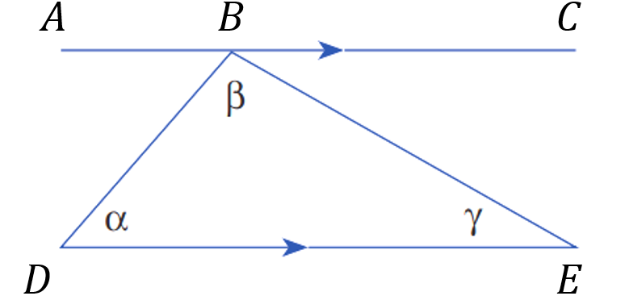

$∠ABD=α$ (alternate angles on || lines)
$∠CBE=γ$ (alternate angles on || lines)
Consider line $∠ABC$:
$α+β+γ=180°$ (angles on a straight line sum to 180°)
  - By dividing the quadrilateral below into two triangles, show that the angle sum in a quadrilateral is 360°
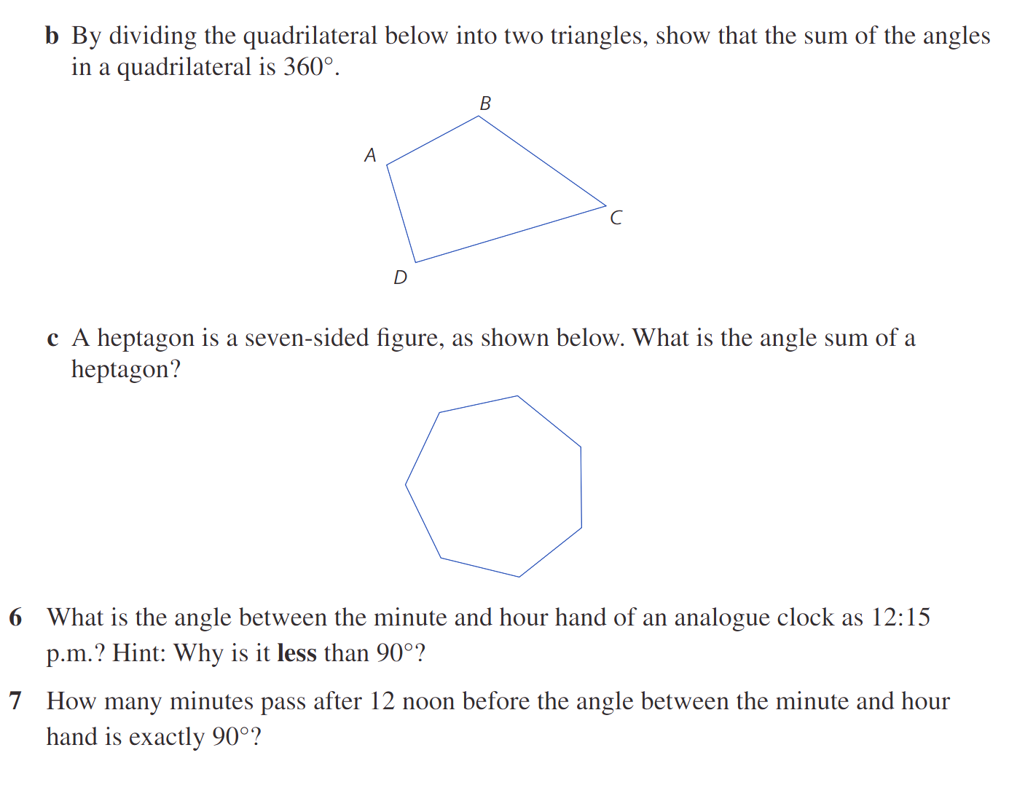

  - A heptagon is a seven-sided figure, as shown below.
What is the angle sum of a heptagon?

Split the heptagon into 5 triangles. 180 $×$ 5 = 900°
- How many minutes pass after 12 noon before the angle between the minute and hour hand is exactly 90°?

At time $t$ minutes after 12 noon:
The minute hand moves 6° per minute, so its angle is $6t°$
The hour hand moves 0.5° per minute, so its angle is $0.5t°$

The angle between them is $6t - 0.5t = 5.5t°$
For the first 90° angle occurrence after noon:
$$5.5t = 90$$
$$t =\frac{90}{5.5}=\frac{180}{11}= 16\frac{4}{11}$$
16 $\frac{4}{11}$ minutes (or 16 minutes 22 seconds)
- In this diagram ∠AOB = ∠BOC and ∠COD = ∠DOE. Give reasons why ∠BOD = 90°
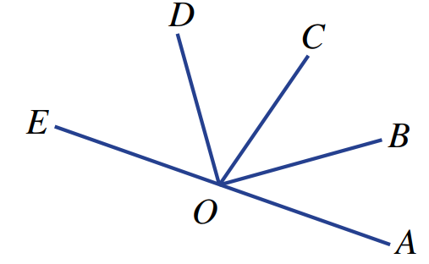

$∠AOB+∠BOC+∠COD+∠DOE=180°$ (angles on a straight line)
Since $∠AOB=∠BOC$ and $∠COD=∠DOE$, we can write
$$2∠BOC+2∠COD=180°$$
$$∠AOB+∠COD=90°$$
$$∴∠BOD=90°$$
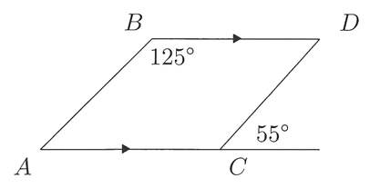
- Prove that AB || CD.

$∠BDC =55°$ (alt. angles, BD || AC)
Therefore, $∠B + ∠B = 125° + 55° = 180°.$
Therefore, the co-interior angles are supplementary. So AB || BC.

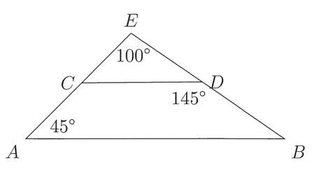
- Prove that AB || CD.

$$∠BCA= 180°-45°-100° = 35°.$$
Therefore, $∠DEC + ∠ACE = 145° + 35° = 180°.$
Therefore, the corresponding angles are equal. So AB || CD.
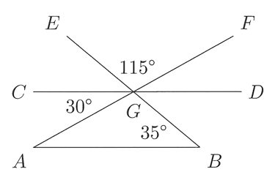
- Prove that AB || CD.

$$∠EGC = 180°-30°-115° = 35°.$$
Now note that $∠EGC = ∠GBA= 35°.$
Therefore, the corresponding angles are equal. So AB || CD.
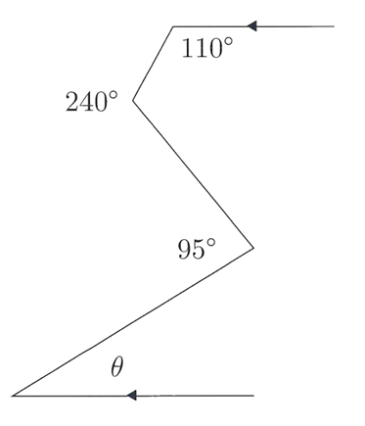
- Find the value of $θ$.

Sketch two horizontal parallel lines.
$θ=45°$

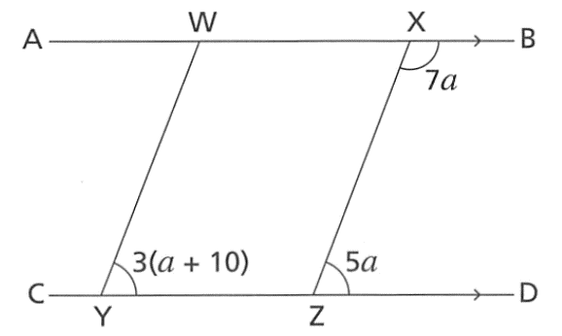
- AB is parallel to CD. Prove that WY is parallel to XZ.

If parallel, then both these equations must be true:
$3\left(a+10\right)=5a$ (corresponding angles on || lines) and
$5a+7a=180$ (co-interior angles in || lines)
After we solve for the value of $a$ in the first equation, if this value also works for the second equation, then the lines must be parallel
By solving $3\left(a+10\right)=5a$ we get $a=15$
$a=15$works for $5a+7a=180$, so both lines are parallel
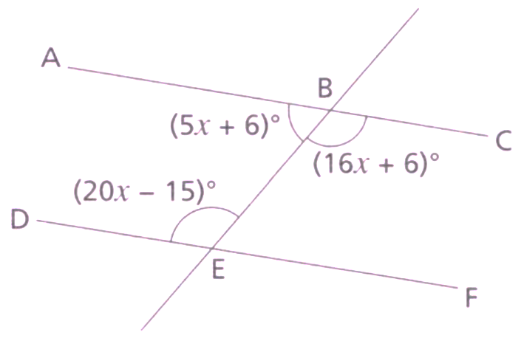
- ABC is a straight line. DEF is a straight line. Is ABC parallel to DEF?
Show working to explain how you know.

If parallel, then both these equations must be true:
$20x-15=16x+6$ (alternate angles on || lines) and
$20x-15+5x+6=180$ (co-interior angles in || lines)
By solving $20x-15=16x+6$, we get $a=$ $\frac{21}{4}$
$a=$ $\frac{21}{4}$ does not satisfy $20x-15+5x+6=180$, so not parallel.

